Autumn Newsletter

September – November 2020

Message from Revd Dan Haylett,
Superintendent Minister

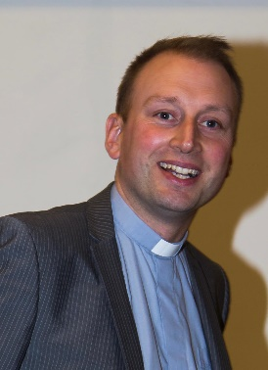
Dear friends,
In his Conference address, the newly elected President of the Methodist Conference, Revd. Richard Teal looked ahead to how we might adapt to serve this present age. He envisaged:
“Not a return to the same old same old but a church which has the reputation for transformation, for recreation and for empowerment of what we are living through in the present in response to a faithful God who redeems history and promises the brightest of futures.”
I wonder how far that “reputation for transformation” truly characterises our churches and our own lives? I wonder who has, other than our own members and adherents, really noticed that the doors of our buildings have been closed? I am sure there has been much that we have missed about physically gathering for fellowship, prayer and worship and that there are groups and individuals who have found life to be less full because of what we have endured. But what, as our new President challenges us to consider, will a return for us look like? What difference will it make to the world and communities around us?
I’ve been struck in recent months by the prospect and power of new beginnings. The lectionary readings that have been explored in our Circuit worship and in our Podcast series dwelt heavily for a time on the parables that Jesus told. So many of these stories centre around the seemingly small and insignificant; the humble yeast or tiny mustard seed. They are stories all about transformation and of hope forged in the faith of a God who works through every circumstance and whose love is never in question or doubt.
In a real way in the Enfield Circuit we are living in a moment when the treasure of truth within those parables is most important. We are welcoming two new staff members into the team: Deacon Jacqueline Esma-John and a new Pastoral Worker, Helen Lunn. There are changes to the way we are working, seeking to grow in our understanding of what sharing ministry across all boundaries is about. We are seeking to recommit ourselves to our priorities of work to redevelop Edmonton Methodist Church, to build the SPACE, to grow our work with Children and Young People, to build on our links with MHA and to do this as we find ways to share ministry in its fullest together.
In all that has been hardest about this time, some surprising and parable-like stories have emerged. You can read about some of those within this newsletter. May these priorities that you are committed to, and these stories of transformation inspire you to cultivate your own “reputation for transformation” as God’s people in Enfield and beyond.

Peace

Further Reflections of Revd Tim Swindell, the Connexional Treasurer!
Many of you will know that each year Methodist People come together to meet as “The Methodist Conference”, the formal governing body of The Methodist Church in Britain. As a church we have a bit of a reputation for liking our committees, and if that is the case, then Conference is the biggest of them all – 306 members (including representatives from all around the country and also from overseas), along with support staff and observers! I have the privilege to be one of that number.
Usually we meet in a big conference centre. However, as we know, this is anything but a usual year.
And so, this year we met electronically – the biggest ‘Zoom’ meeting I’m ever likely to attend. We had people sitting on their beds, in kitchens, and in gardens; some even seemed to have smart studies! We had people as far apart as Shetland, the Channel Islands, and Cornwall, also visitors from Venezuela, Zambia and Fiji. All brought together onto our computer screens by a core team at Cliff College in Derbyshire.
My reason for attending the Conference is that I am the ‘Lead Connexional Treasurer’ for the Methodist Church in Britain. That means that I am responsible for advising on some of the financial policies of the wider Church– making sure we spend money appropriately and using our reserves wisely. I have to propose budgets and advise on the financial implications of any decisions that we make.
This year, that role proved to be a particularly difficult one because of the challenging financial circumstances that we find ourselves in resulting from Covid-19. Sadly, I had to announce that all grant-giving from the Church’s Mission in Britain Funds has been suspended for the coming year – we have been hit by a huge loss of income from investments that normally fund grants. I also had to say that all non-essential expenditure will be cut from central funds. Unfortunately, that means that an agreed new strategy to promote evangelism and growth, “God for All”, has had to be slowed down.
Within all this scaling back, however, there are many signs of HOPE. We must all be reassured that “The best of all is, God is with us”, and these words of John Wesley were the central message shared by this year’s President of Conference, Rev’d Richard Teal.
There was HOPE shared that although our children and young people will not be able to physically meet in their annual gathering 3Generate, nevertheless even more will be able to engage through 3Generate365, launched as a year-round youth initiative by the Youth President, Thelma Commey.
There is HOPE too, for all of us as we anticipate further work on a Methodist Way of Life that encourages all of us to embed our Christian beliefs into our everyday lives.
HOPE, because we know that although some individual local churches are struggling to survive financially, others are showing their love where they have ample reserves and are stepping forward to share God’s abundance with those in need. There is huge generosity also shown in our peoples’ commitment to serving in their communities. HOPE, because many of us share the belief that God hasn’t
done with the Methodist Church yet, though recognising its need to respond in new ways.
The Methodist Church Annual Conference was certainly different this year, and I look forward in HOPE to next year when, God willing, we will physically meet again in Birmingham.
T o C S - Together our Community Survives

At the end of April, Anne Fairchild was approached by a group called ToCS (Together our Community Survives) to see if we were willing to open Edmonton Church on Saturday afternoons to enable their food distribution service to continue to operate to the elderly and vulnerable across our community during lockdown. ToCS are affiliated with the Enfield Caribbean Association and started to distribute food at the start of the lockdown to people who could not leave their homes. At its peak, this service was reaching over 100 people with 30+ volunteers making it happen.
Revd Dedji gave his permission for the Church to be used and the first distribution from Edmonton Church was on Saturday 9th May. Anne Fairchild and Sam Agyei were on site to supervise and were both impressed with the organisation of the operation. There were about 10 volunteers picking and packing the food bags and 20 volunteers driving the food to the elderly and vulnerable as well as someone from the Council checking that social distancing procedures were in place. Fresh fruit and vegetables, tinned food, bread/rice/pasta was largely donated along with a small amount of cooked food. Anything not donated was purchased so the group are also working hard to raise funds.
At the end of that first Saturday, Anne rallied in the troupes and we were on board. I was extremely impressed with the professional manner of the organisers plus their welcoming approach to everyone. We all had to don the full PPE before we entered into the main hall and then on to the second hall where the food was laid out.
I’m proud to say that the news of this travelled very fast around the Enfield Circuit and we were joined by three Presbyters two of whom were delivery drivers and one soon became a fully experienced ‘picker and packer’. There were members from Trinity, Southgate and several of the Edmonton members joined as both “pickers and packers’ as well as delivery drivers and of course Anne had both roles.
(Anne learned the difference between a green banana used as a vegetable and the more commonly known ripe-yellow banana used as a fruit).
The programme ended on 25th July by which time it had amassed to feeding 200 elders weekly, 60 volunteers and 500 befriending/engagement hours per week with elders.
These three months of helping to serve the community was a welcomed release to being in lock-down. The atmosphere was vibrant, the testimonials from the volunteers and the thank you letters (via What’s App) from the recipients and celebrity messages from Rudolph Walker OBE and David Grant MBE.
Although the group was established purely to meet a need during lockdown, it identified that there is a real need for foodbank help. Now that lockdown has finished, we have identified other services for which our community is in need. Edmonton Church has therefore decided to take over and continue to expand the scope of this project.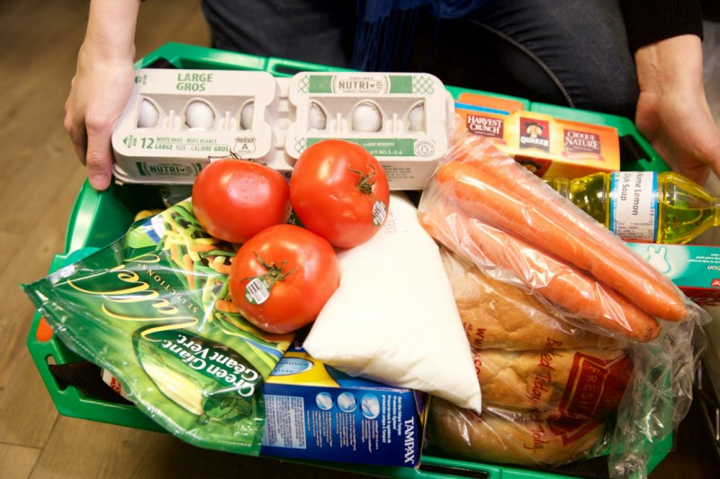

The service managed by Edmonton will have 4 major strands:
1) Even though lock-down has finished, many of the elderly are housebound in need of a food delivery service. Starting with those from the lock-down list, we aim to gradually grow this delivery service.
2) Many people are facing financial difficulty and homelessness. On Saturday 2nd August Edmonton hosted to the first weekly “walk-in” foodhub providing food, personal hygiene and some household items to those in need.
3) The elderly and vulnerable we were delivering to during lockdown were often lonely and appreciated the calls and visits just as much as the food. Therefore, working closing with MHA
Live at Home Scheme Manager Toni Fielding, we will be growing a “phone a friend” service to provide regular chats for people struggling with social isolation.
4) Finally, with lockdown lifted the elderly and vulnerable can start to go out again. However, many are expressing concern and hesitation about doing this. We have started a trial “chaperone” service to pick up and take people out shopping or to other activities. We supply PPE and walk with them as they regain their confidence and independence.
Edmonton have formed a small committee consisting of Anne Fairchild, Roz Rutty, Sam Agyei and Deacon Jacqueline Esme-John to oversee how all these services will operate. Many members of Edmonton Church have expressed interest in helping and we would also welcome help from across the Circuit.
There are 9 different ways in which you can help:
- We take a large food delivery from FELIX on a Friday afternoon – we need help to unload and sort the food.
- The foodhub is open 2pm to 4pm every Saturday – we need help serving food and managing the operation.
- We phone the people we deliver to on a Thursday to see if they would like a delivery that week. This normally involves a 15-minute chat – we need volunteers for this.
- We deliver the food on a Saturday late morning – we need volunteers with cars for this.
- The chaperone service needs volunteers, with cars, to help people re-enter the world.
- The “phone a friend” service needs volunteers who are willing to make regular contact with a few people each week and form a friendship.
- We need food and other items – if you can donate, know others who will donate or know people who own shops and cafes and might donate on a larger scale please let us know.
- We will need to buy certain items each week so financial donations would be most welcome.
- Finally, we need your prayers that we can reach the people in most need and find volunteers to give what they can.
The foodhub will operate in conjunction with 7 other foodbanks across Edmonton so a location will be open every day of the week. It also means there will be multiple locations so we can reach more people. Finally, by working together, perishable items can be passed on to the foodbank opening the following day so resources are used efficiently.
This has been, and will be an amazing way to serve during these challenging times. I feel very blessed to be involved.
Roz Rutty/Anne Fairchild

The Circuit website continues to offer weekly services, podcasts and extra resources
www.enfieldmethodistcircuit.co.uk

Some of our local churches are beginning to meet together on Sundays, complying with all the government and Methodist Church guidelines. If you would like to attend a service, please contact the Circuit office for information so we can closely monitor numbers of people attending.
We recognise that not everyone will feel ready to make this return, and not all churches are reopening yet for public worship. We continue to provide the weekly service and material on line or by post.
‘Knowing me, knowing you’ … Julia’s life and ministry swansong
Those who’ve heard something of my story before know that I am the second (and eldest daughter) of 6 children born to a staunch Scottish Plymouth Brethren mother and a Polish Roman Catholic father. I grew up in a lively, noisy household and experienced diverse Christian belief and practice and not inconsiderable argument about the same.
My Dad worked as a coal miner and, with a group of fellow Poles, moved to England to stay in employment when the pits started closing in Scotland in the 60s. My first contact with Methodism came two years later when our family joined him to live in rural West Yorkshire. Faced otherwise with ‘high church’ Anglicanism (sung eucharist, robed choir, and incense), my mother promptly sent us to Sunday School at the (ex-Primitive) Methodist Chapel where we received a warm welcome. Within a year of our move, my father was diagnosed with cancer and, without the support, help, and care of those good folks throughout his illness and untimely death a few years later, we would have been bereft in a strange land.
Throughout my grammar school days I was a Chapel regular, enjoying the singing as much as the preaching and warm fellowship, yet firmly declined the cajoling of two successive ministers to become a member. I knew I was a Christian, but - given my parents’ very different Christian backgrounds - felt I needed to see more of the world and the church before commitment to a particular denomination.

Whilst studying Chemical Sciences at the University of East Anglia, UEA, in Norwich, I was a member of an ecumenical Christian group. We thrived on a mix of prayer, scripture reflection, discussion, and social action, accompanying one another to worship at Quaker Meeting and Roman Catholic Mass and all else on offer. Challenging study and discussion of Bonhoeffer’s ‘The Cost of Discipleship’ led to a call to ministry aged 20. Not having been baptised as a child, I was baptised, confirmed, and received ‘a note to preach’ in the Methodist Church. This was about belonging - where I felt most ‘at home’ - and honouring the ‘best of both’ my parents’ traditions as well as being enthused by Methodism’s commitment to social justice. I remain deeply thankful that the church saw some potential in me, affirmed my call to ministry, and helped me to grow and develop as a person and a presbyter.
Wherever I have lived and worked during my 40 years of ministry since going into circuit in 1980 I have sought to bring an openness to listen to and learn from others, something of my own faith and spirituality - a sense of the holy and of God in our midst - and a readiness to welcome diversity and difference and celebrate their enrichment of community. For me, ministry is always about engaging with people where they are and finding a language where we can share each other’s stories, reflect on life together, and grow through experience. It’s about pastoral/spiritual care not only in the ‘everyday’ but also when needs are complex/acute/critical. Study of scripture and preparation of worship and preaching starts with context and is part of that care, endeavouring - and sometimes struggling - to understand how the God of compassion and justice we see and know in Jesus connects with and transforms our experience.
Much of my time in hospital chaplaincy over 17 years from September 1998 was spent alongside people experiencing profound change/loss and being with them as they explored what was happening to them, tried to connect with their feelings and make sense of their journeys and transitions and what it meant to live as people of faith or seemingly with no faith at all. This was both emotionally and spiritually demanding and would have been impossible without the mutual support of colleagues - employed chaplains and volunteers of all faiths - team reflective practice and theological/ethical discussion.
Around my 60th birthday in 2014 I offered to return to circuit ministry in September 2015 for a final appointment before ‘sitting down’. This was partly a response of gratitude to the Methodist Church for having given me permission to serve as a healthcare chaplain. And, whilst having no doubt at all about the value of what chaplains offer, it was also because I sensed the huge impact on me of living daily with pain and suffering, dying and death and grief meant that I was losing sight of life and light.
And so I come to these last 5 years. I thank the Enfield Circuit for welcoming a care-worn but not (I hope) quite washed-up minister. I thank you for the privilege of working with you, for the joy and sense of continuity that comes from being able to share in the whole cycle of human life in pastoral ministry and worship and preaching, for the opportunity to encourage/enable spiritual growth, gifts/skills, and leadership in others, for connection/engagement with people within and beyond the gathered church - where they are, whoever they are, and whatever their situation - and our working together to seek to build and sustain inclusive, welcoming communities.
May God continue to bless you, challenge you, and lead you with love in all that lies ahead. Julia
Written by Eileen Nicholls from Grange Park Methodist……
who wrote this poem for a poetry competition in the Blake Court Residential homes. There are 8 of them in the South East. Much to her surprise she won first prize!!! Congratulations Eileen!

You must stay in they tell me
No longer leave your flat
For the virus is all round us
Unseen, unheard, it’s as simple as that.

The hours drag on so slowly,
What shall Ii do today?
Phone friends, write letters,
TV, or think, and pray?

But, looking through my window
At the blossom on the tree
It tells me that even now
Life goes on in mystery.

The doctors and the nurses
Are working day and night
Continuously, selflessly, hopefully
Taking up the fight.

With lockdown instituted
We’re staying safe, staying home.
Looking to the future
When we can once more roam.

We think of those whose life
Has been taken by this virus.
Of those whose jobs are threatened
And could maybe lose their status.
In Blake Court we are so lucky
Our needs are fully met,
Even though we have to stay at home,
There is nothing for us to fret.

Our staff, they are so willing
We shower them with praise
For the way they’re looking after us
Every minute, every hour, all the days.

We will come through this journey
Once more we’ll laugh and play.
Many things we will remember
Thanking God for each new day.

Our lives will then begin again,
We’ll meet our friends once more.
Our families will visit us
It should continue as before.

Thank you for your care

A Pilgrimage to The Holy Land with the Chairs of the London District
Tuesday 16th – Tuesday 23rd March 2021 8 Days Based in Jerusalem & Galilee
Cost: £1,795 (shared) and £2,220 (single). Cost includes return flights, full board and en-suite accommodation except travel insurance.
You are invited to join the London District as part of Woven, its theme for 2019 – 2021 to discover for yourselves the setting of some of the most important events in the life and ministry of our Lord, Jesus Christ: in Jerusalem, the surrounding area and further north in Galilee.
To make a reservation, visit methodistlondon.org.uk/pilgrimage or contact Fola Oyeleye on 020 7654 3845.
In the event of cancellation due to Foreign Office advice, our group will be offered an alternative date to travel or the opportunity for a full refund.

