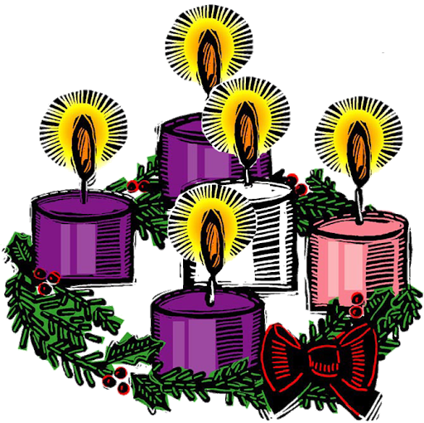

Advent Liturgy

First Candle – The Candle of Hope
The Patriarchs, Abraham, the Old Testament Ancestors of Jesus

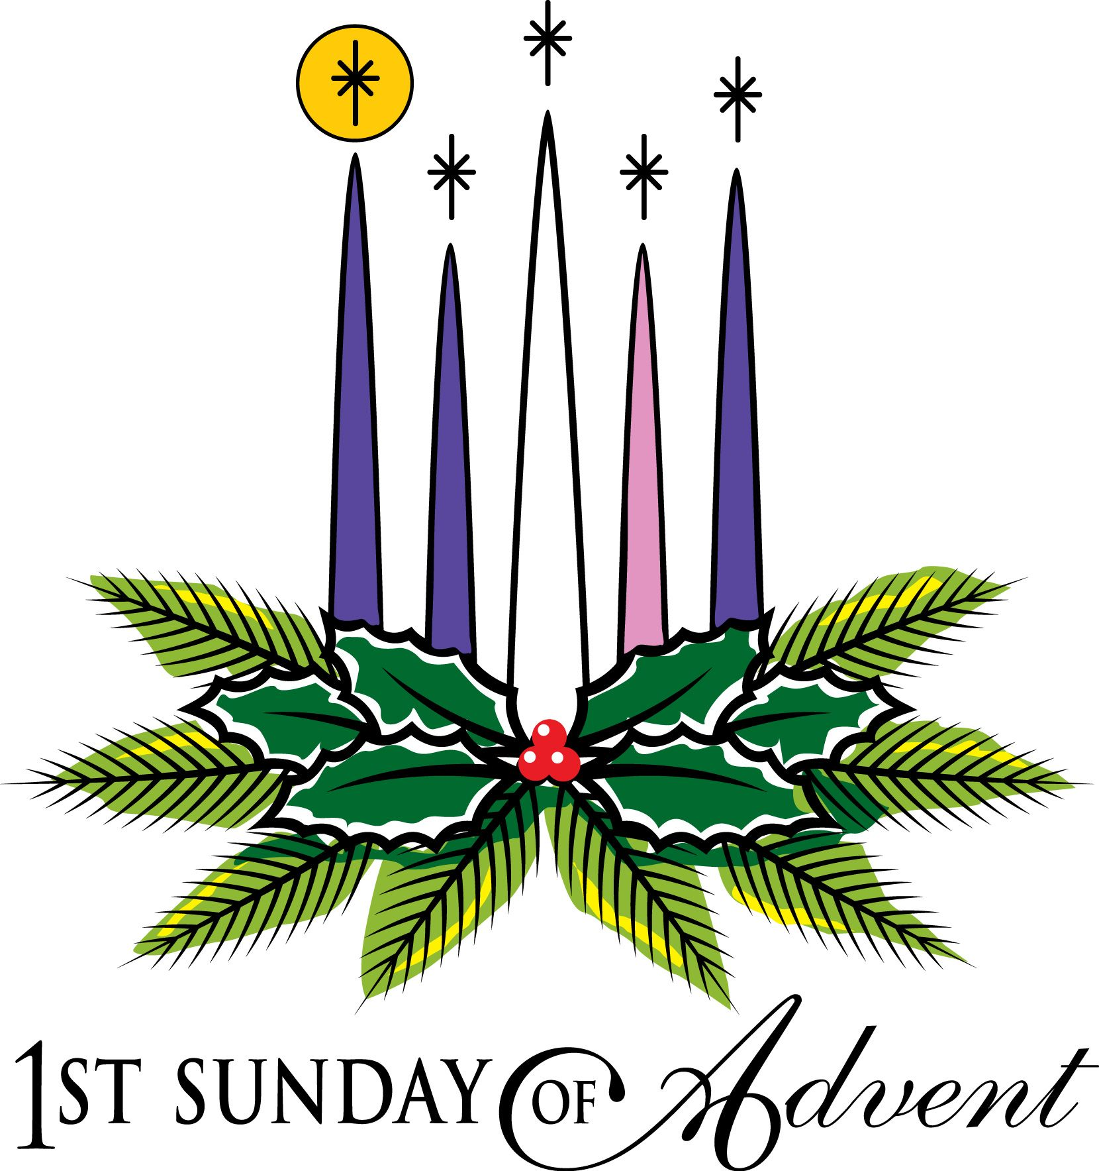

Leader: Light and peace, in Jesus Christ our Lord
All: Thanks be to God

Leader: Today is the First Sunday of Advent, in which we recall the hope we have in Christ.

God told Abraham that through him all the nations of the world would be blessed, because he trusted and put his hope in God. The Old Testament spoke of the coming of Christ, of how a Saviour would be born, a king in the line of King David. He would rule the world wisely and bless all the nations. We too believe in God's promise to send Jesus again to this world to establish his kingdom upon the earth.

(A person lights the First Candle here)

Hope is like a light shining in a dark place. As we look at the light of this candle we celebrate the hope we have in Jesus Christ.

Leader: Let us pray:
All: God of Abraham and Sarah and all the Patriarchs of old, you are our Father too. Your love is revealed to us in Jesus Christ, Son of God, and Son of David. Help us in preparing to celebrate his birth, to make our hearts ready and to place our hope in you. Help us today and every day to worship you, to hear your word, and to do your will by sharing your hope with others. We ask it in the name of the one who was born in Bethlehem. Amen.

Second Candle – The Candle of Peace
The prophets who foretold the birth of Jesus

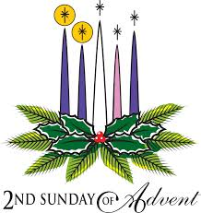

Leader: Light and peace, in Jesus Christ our Lord
All: Thanks be to God

Leader: Today is the Second Sunday of Advent and we will light the Candle of Peace.

Last Sunday we lit the First Candle in our Advent Wreath, and celebrated the patriarchs, this First Candle reminded us of our hope in Christ. We light it again as we remember our Saviour, born a king in the line of King David. Jesus was born in Bethlehem, and we believe that he will come again to fulfil all of God's promises to us, to rule the world wisely and bless all nations.

(A person lights the First Candle, the Candle of Hope)

Today we light the Second Candle of Advent, the Candle of Peace. We remember the prophets who spoke of the coming of Christ, of how a Saviour would be born, a king in the line of King David. The prophet Isaiah called Christ "the Prince of Peace". They told us how he would rule the world wisely and bless all the nations.

When Jesus came he taught people the importance of being peace-makers. He said that those who make peace shall be called the children of God. When Christ comes to us he brings us peace and he will bring everlasting peace when he comes again. We light the Candle of Peace to remind us that Jesus is the Prince of Peace and that through him peace is found.

(A person lights Second Candle, the Candle of Peace)

Peace is like a light shining in a dark place. As we look at this candle we celebrate the peace we find in Jesus Christ.

Leader: Let us pray:
All: Lord Jesus, Light of the World, the prophets said you would bring peace and save your people from trouble. Give peace in our hearts at Christmastide. We ask that as we wait for you to come again, that you would remain present with us. Help us today, and every day to worship you, to hear your word, and to do your will by sharing your peace with each other. We ask it in the name of the one who was born in Bethlehem. Amen.

Third Candle – The Candle of Love
John the Baptist

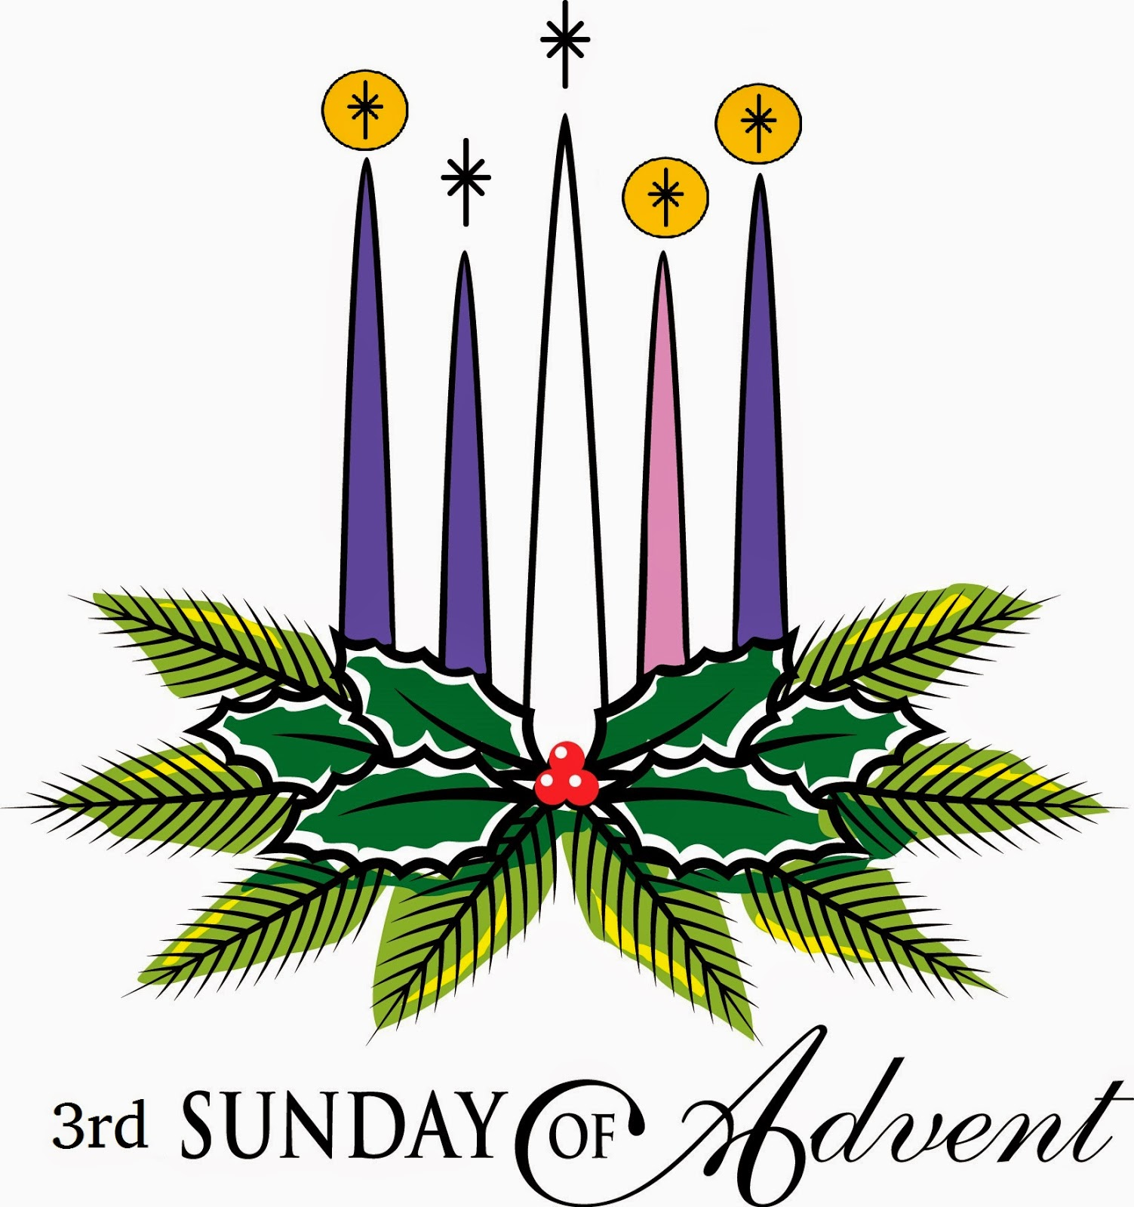

Leader: Light and peace, in Jesus Christ our Lord
All: Thanks be to God

Leader: Last Sunday we lit the Candle of Peace. We light it and the Candle of Hope again as we remember Jesus, born in Bethlehem, our hope and our peace.

(A person lights the Candles of Hope, and Peace.)

Today we light the Third Candle of Advent, the Candle of Love. In their old age God gave to Zechariah and Elisabeth a son called John. John spoke to the people bravely in the desert denying his own comforts and prepared to die for what he believed. John taught that we should share what we have with others, treat each other kindly and show Gods love. He did this because he cared for people and wanted them to repent and find God's forgiveness.

(A person lights the Third Candle, the Candle of Love here)

Love is like a candle shining in a dark place. As we look at the light of this candle we celebrate the love we have in Christ.

Leader: Let us pray:
All: Lord God, Your witness John the Baptist grew up strong in spirit and prepared people for the coming of the Lord. He loved your people and baptized them in the River Jordan to wash away their sins. Help us to have the same love that we would be witnesses to him and spread the good news of your love. As Christmas draws closer day by day, help us to be ready to welcome him. Amen

Fourth Candle – The Candle of Joy
Mary the Mother of Jesus

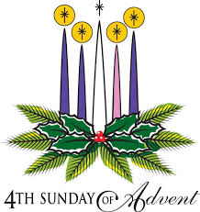

Leader: Light and peace, in Jesus Christ our Lord
All: Thanks be to God

Leader: Last Sunday we lit the Candle of Love. We light it and the Candles of Hope and Peace again as we remember that Jesus, born in Bethlehem, will come again to fulfil all of God's promises and bring us everlasting peace and joy.

(A person lights the Candles of Hope, Peace, and Love)

Today we light the Fourth Candle of Advent, the Candle of Joy. When the angel Gabriel told Mary that a special child would be born to her she was filled with joy. She sang a song that began with the words: "My soul magnifies the Lord; my spirit rejoices in God my Saviour. Just as the birth of Jesus gave great joy to his mother, so his presence in the world gave joy to those who had none before. He healed them and gave them hope and peace when they believed in him.
From hope, peace, and love grows joy.

We light the Candle of Joy to remind us that when Jesus is born in us we have joy and that through him there will be everlasting joy on earth.

(A person lights the Fourth Candle the Candle of Joy)

Joy is like a light shining in a dark place. As we look at this candle we celebrate the joy we find in Jesus Christ.

Leader: Let us pray:
All: Thank you God for the joy you give us. We ask that as we wait for all your promises to come true, and for Christ to come again, that you would remain present with us. Help us today, and every day to worship you, to hear your word, and to do your will by sharing your joy with each other. We ask it in the name of the one who was born in Bethlehem. Amen

The Last Candle – The Birth of Christ
Christmas Day

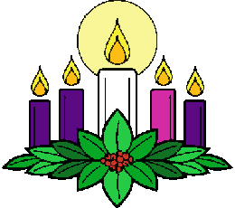

Leader: Light and peace, in Jesus Christ our Lord
All: Thanks be to God

Leader: Today is Christmas Day, in which we recall the hope we have in Christ. Today we light again the candles of hope, peace, love and joy.

(Each candle will be lit as the leader speaks)

First Candle We speak of hope - because God keeps his promises to us.

Second Candle We work for peace - because Jesus is the ‘Prince of Peace’ and he calls his children to work for peace in his name.

Third Candle We show love - because Jesus gave everything for us and led us to know the forgiveness of God.

Fourth Candle We share joy - because the Holy Spirit fills our hearts and minds with the presence the God

Last Candle (Christmas Day) Now we light our last candle to remember the birth of our Lord and Saviour Jesus Christ. As the prophets promised so long ago, you have come to us once again; and with the shepherds, we are filled with wonder and amazement.

(Light the white Christ candle now.)

Lord, you come as a tiny, fragile baby; yet we know that you are God and you are with us. May the flame of this candle remind us that you are the light of the world and that if we follow you, we will never walk in darkness, but will have the true light of life.

(All): Come, Lord Jesus, come. Amen.

