Enfield Methodist Circuit
Advent resources 2020

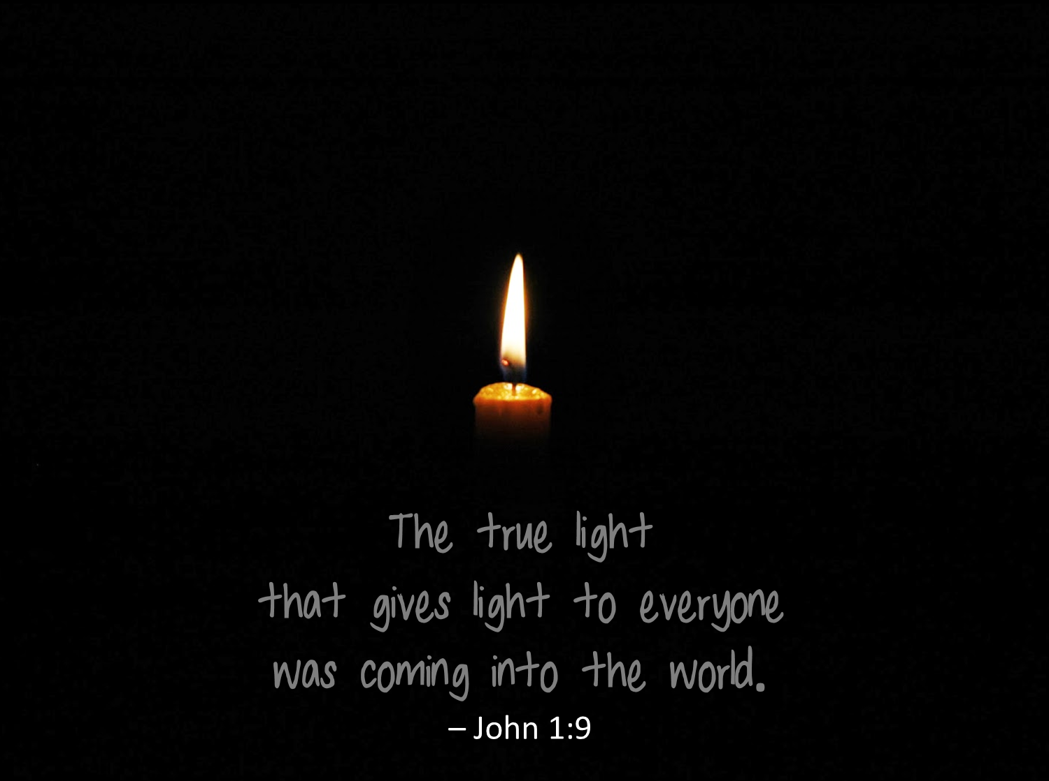

Advent gives us all the opportunity
to celebrate God’s light coming
even in the hardest times and places.
The material in this booklet is offered to help you think, pray and act in the light of Jesus’ coming.
How to use this material:
* You could use this booklet on your own, or with those you live with.
* You could take time each week to call, email, zoom or write to someone sharing your ideas and reflections.
* You could take part in a weekly zoom call, on each Sunday in Advent at 4pm to engage with others: to receive an invite for this, email: emc.online@mail.uk

Each session is designed to help us reflect on the theme of light this Advent. In such a difficult context of uncertainty and of not being able to gather together, we hope this material can help you share with those around you this Advent.
Each week, we are led through:
Thought
Prayer
Action
You might find it helpful to light a candle to use as a focus as you engage in this time of prayer each week
God of hope, who brings light into this world,
be the love that dwells between us.
God of love, who brings peace into this world,
be the peace that dwells between us.
God of peace, who brings joy into our lives,
be the joy that dwells between us.
God of joy, the rock upon which we stand,
be the centre, the focus of our lives
always, and particularly in this Advent time.
In Jesus’ name. Amen.
Week 1: The true light of God

In this week of Advent we celebrate the light that has already been given to us and anticipate the light of Christ breaking more fully into our world, our homes, our Church, and our hearts.
Thought:
Read Genesis 1:1-5 NRSV
In the beginning when God created the heavens and the earth, the earth was a formless void and darkness covered the face of the deep, while a wind from God swept over the face of the waters. Then God said, “Let there be light”; and there was light. And God saw that the light was good; and God separated the light from the darkness. God called the light Day, and the darkness he called Night. And there was evening and there was morning, the first day.

Read John 1:1-9 NRSV
In the beginning was the Word, and the Word was with God, and the Word was God. He was in the beginning with God. All things came into being through him, and without him not one thing came into being. What has come into being in him was life, and the life was the light of all people. The light shines in the darkness, and the darkness did not overcome it. There was a man sent from God, whose name was John. He came as a witness to testify to the light, so that all might believe through him. He himself was not the light, but he came to testify to the light. The true light, which enlightens everyone, was coming into the world.

“In the beginning….”, the famous opening words to Genesis, at the start of a series of stories about beginnings and connectedness. These words are echoed in the opening to the fourth Gospel, where a new creation is envisaged as the Word comes to be among us, as one of us.
In both accounts of God’s continual creating, redeeming and loving work we are shown that this is God’s nature. It is not just that the giving of light or the incarnation are somehow side effects of God’s love for us – we find God within. them.
It is important to remember that God is not absent in the darkness, as Psalm 139:12 says, ‘even the darkness is not dark to you; the night is as bright as the day, for darkness is as light to you’. But in the creation accounts, God’s creative intention includes the offering of light that helps to bring order and rhythm into what might otherwise be an eternal night. The giving of light is part of the chain of separation that the authors of Genesis imagine must have been part of the primordial experience of what we think of as creation, or the Big Bang. The precise scientific processes at work “in the beginning” are of course not the focus of the text in Genesis, this is theology and story. What is being told through these important stories is that the giving and bringing of light is part and parcel of God’s intention towards human beings.

In the fourth Gospel too, light plays an equally important role. John the Baptist comes to point towards the light of God, but he himself acknowledges that he was not the brightest or fullest expression of that light. The “true light”, Jesus, was coming into the world and at Advent we both celebrate that coming and anticipate more light that is yet to come.
In both accounts, God’s offer and gift of light is for all, as it comes in ways which “enlightens everyone”. This is a clearly inclusive, empowering and enriching gift of God that helps those who are ready to see the reality of God in Christ.

Prayer: Give thanks to God for the difference that light makes to us: that morning comes after the longest night; that the smallest of sparks can help us find our way and that light guides us away from danger and protects us from fear.

All age activity:
- Together with those around you, make a list or draw the ways that light makes a difference to us: e.g The sun, a lighthouse….
How many examples can you think of?
- Paint a jam jar or glass to hold your advent candle. Paint one side dark to represent the night and day, then see how even looking through the dark side, the light is still visible.
- Or make containers for four candles, painted in a way that makes the light grow brighter each week.

Advent Wreath Colouring

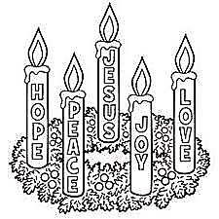

Week 2: Learning to live in the promise

In this week of Advent we give thanks for the light of God that shines like a laser, shining brightly and with great clarity into every part of the world and into our lives.
Thought:
Read Isaiah 60:1-5
Arise, shine; for your light has come, and the glory of the Lord has risen upon you.
For darkness shall cover the earth, and thick darkness the peoples; but the Lord will arise upon you, and his glory will appear over you.
Nations shall come to your light, and kings to the brightness of your dawn.
Lift up your eyes and look around; they all gather together, they come to you; your sons shall come from far away, and your daughters shall be carried on their nurses’ arms.
Then you shall see and be radiant; your heart shall thrill and rejoice, because the abundance of the sea shall be brought to you, the wealth of the nations shall come to you.
Isaiah’s vision is of a “new normal” after the darkness of exile. Isaiah’s audience are the returned exiles who must rejoice in the promise of God while still facing conflict and the political struggle to rebuild relations within the community. On top of that, there is also the struggle of faith in such a challenging context. Where was God in their dark hours, and how can they trust and live in the new dawn? Was this experience of a “new normal” the fullest expression of God’s promise? Surely there was more to come?
We might recognise some similar challenges and questions in our context today today. Isaiah’s prophetic message comes as a light that shines brightly and dazingly into the gloom. Like a laser, it focuses on the promise of God, that the seemingly overwhelming darkness would not diminish the brightness of the dawn to come. There will be a time when gathering can happen, a renewing of the ties that bound the community together: families would be reunited; those who had to be apart for a time would be reconciled.
The prophetic imagination throughout the Hebrew Bible shines as light into the reality of all that God’s people face. Nothing is hidden from the glare of that true light. That light reveals who we really are and brings out even those parts of us we thought we had hidden. As light that challenges, it is inescapable. As light that promises, it is full of glory.
God’s prophets in their own ways brought that light until the true light of Jesus comes to help us see the truth about God, about ourselves and the world around us. Then Jesus, present in our lives, helps us to live with the promise of fulfilment in all the challenges we face.

Prayer:
There is much of the ‘now and not yet’ that requires faith in God’s promises. Take time to let God’s light shine in you – what do you learn about yourself and about God’s love? What do you hope for? Can you see the first signs of it dawning?

All age activity:
- Can you think of a time when having a light really made the difference for you? A torch light to guide you in the dark night? The traffic light stuck on red? The light that needs to be on in the hallway in the night time.
- Could you think of a promise you could make to someone now that would help them to look forward?
- Design a Christmas card that expresses hope and write an appropriate message.

Word Search

u r d o n k e y l q q c j  j h p r o p h e t s h a o  e r e j o i c e b h c n o  s j b t v z n e v e p d j  u o e m b s y h f p e l o  s y t a m u t l a h a e s  g y h n a l y o i e c k e  l m l g r l v v t r e i p  i m e e y r r e h d g n h  g y h r h u y e y s k g d  h f e c h r i s t m a s o  t g m a d v e n t h z y v  f g o d l c h o p e g n e | Advent Bethlehem Candle Christmas Donkey Dove Faith God Hope Jesus Joseph Joy Kings Light Love Manger Mary Peace Prophets Rejoice Shepherds

Week 3: The light of God leads to fullness of life

As God’s light is offered to everyone as a challenge, it comes also as healing. God’s light brings truth and leads us into ways that are best for us.
Thought:
Read 1 John 1:1-5:
We declare to you what was from the beginning, what we have heard, what we have seen with our eyes, what we have looked at and touched with our hands, concerning the word of life— this life was revealed, and we have seen it and testify to it, and declare to you the eternal life that was with the Father and was revealed to us— we declare to you what we have seen and heard so that you also may have fellowship with us; and truly our fellowship is with the Father and with his Son Jesus Christ. We are writing these things so that our joy may be complete. This is the message we have heard from him and proclaim to you, that God is light and in him there is no darkness at all.

The word of life was revealed to us in Jesus Christ. The passage reminds us that we find that life most fully in relationship (“fellowship”) with God and with one another. Full healing is “shalom” and so involves us playing a full part in the community and the world around us. The passage links the rich themes of wholeness, fellowship and joy. All of that is rooted in God.
During Advent, traditionally we recall stories of those whose lives were turned upside down by God’s coming in Christ. Zechariah and Elizabeth are caught up in the excitement and potential of this birth; Mary and Joseph have visions and dreams of what this child will come to do. Later, shepherds and learned seekers alike are going to be drawn to celebrate the birth of Jesus. All sections of society are affected and challenged in equal measure – joy at the birth of a child becomes bound up with hope for a renewed future where healing for all is found, alongside the deep questions of living with the thought, ’How can these things be?’ Those who accept the light of God’s coming and are prepared to “walk in it” find real life.
Prayer:
Take time this week to hold before God what has happened this year; the good things and the profoundly hard, along with the in-between times. Note down any events or situations where you have found God to be particularly absent or present. What or who made the difference in those times?

All age activity
- Can you name people in the Bible who find healing and wholeness? What stories can you remember? Why do they stand out?
- Discover more about a charity near you that is providing help for families – and make a donation, or give extra donations of food to a local Food Bank.

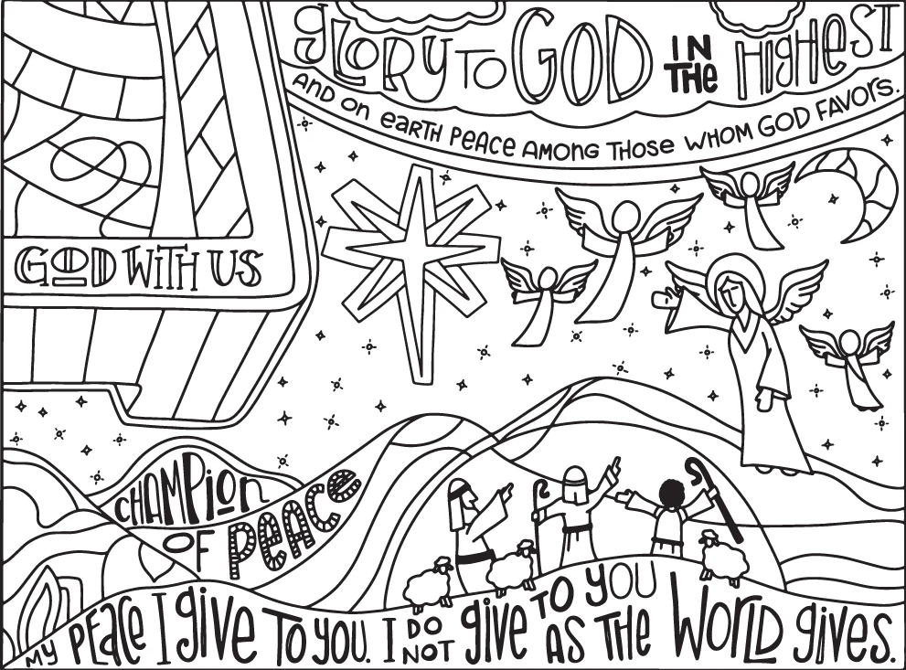

Week 4: The light of life

In these last days of Advent, the anticipation and excitement mounts in the stories that we tell, in the hymns we would usually be singing and in the celebrations we keep with those we love. Although so much of this will be different for us this year, we celebrate the light of life given for us.

Thought:
Read Isaiah 9:2-7
The people who walked in darkness have seen a great light; those who lived in a land of deep darkness—on them light has shined.
You have multiplied the nation, you have increased its joy;
they rejoice before you as with joy at the harvest,
as people exult when dividing plunder.
For the yoke of their burden, and the bar across their shoulders, the rod of their oppressor, you have broken as on the day of Midian.
For all the boots of the tramping warriors and all the garments rolled in blood shall be burned as fuel for the fire.
For a child has been born for us, a son given to us;
authority rests upon his shoulders;
and he is Wonderful Counsellor, Mighty God, Everlasting Father,
Prince of Peace.
His authority shall grow continually, and there shall be endless peace for the throne of David and his kingdom.
He will establish and uphold it with justice and with righteousness from this time onward and forevermore.
The zeal of the Lord of hosts will do this.

The birth of any child turns lives upside down. The child’s needs take centre stage and we wonder how such a small person can cause such big adjustments! Of course, as we mark Advent we remember the wonder and joy of Mary and Joseph. Yet all the while we are given hints that this joy is not just the inward focussed awe and love of this family alone. The birth of Jesus has implications for one and all: as Isaiah imagines light dawning on a people living in deep darkness.
The child that is to be born brings joy to many: but will also shine a light on the oppression and injustice that the world has suffered under. The child will be the Prince of Peace, in whom we see God and find, at last, God with us; and this may well be during the conflict, as well as after it.
This year the President of the Methodist Conference, Revd. Richard Teal, has taken the reported last words of John Wesley as his theme for the year, “The best of all is God is with us”. The light of life is that for us: that we find the greatest blessing of knowing that God is with us in all we face, now and for ever.

Prayer:
Try praying over these words this week, from the Magnificat, as Mary praises God for what God will do and is doing.
“My soul magnifies the Lord
And my spirit rejoices in God my Saviour;
Because He has regarded the lowliness of His handmaid;
For behold, henceforth all generations shall call me blessed;
Because He who is mighty has done great things for me,
and holy is His name;
And His mercy is from generation to generation
on those who fear Him.”

Take time to give thanks for what God is bringing to birth in you and in the world at this time.

All age activity
- If you are not able to have the usual celebrations at Christmas, how will you make Christmas day special?
Place your Advent candle, or the four candles, where they can be seen from outside your home.

