Winter Newsletter
2021

Message from Revd Dan Haylett,
Superintendent Minister

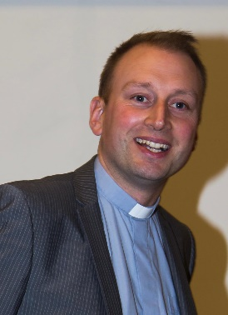
Dear friends,
Most of us in reflecting on the year that has gone will probably be happy to welcome the new beginning that the new year promises. Someone was heard to remark on New Year’s Eve that they only bothered to stay up to welcome in the new year to make sure 2020 was really over!
Usually at the start of the new year we would be gathering together in worship to renew our covenant with God. It is an opportunity for reflection on the year that has been and also a moment of true repentance – from the Greek word metanoia – a complete change, turning and renewal. It’s a moment that reminds us that all of our attempts to grow and move on are rooted in the love of God in Christ. We are invited to enter willingly into a covenant relationship; in a way of life more akin to a marriage than a business contract.
This is precisely what St. Paul has in mind as he writes about the potential of such a moment, in our renewed openness to God’s will:
“I appeal to you therefore, brothers and sisters, by the mercies of God, to present your bodies as a living sacrifice, holy and acceptable to God, which is your spiritual worship. ² Do not be conformed to this world, but be transformed by the renewing of your minds, so that you may discern what is the will of God—what is good and acceptable and perfect”. (Romans 12:1-2 NRSV)
That seems to strike a chord for us in 2021 in a new way. We have
been learning more about what our “spiritual worship” of God really means as we do not have the opportunity to gather collectively in ways that we would want to in order to worship. We are challenged not to be conformed in ways that see us fall into patterns set for us by others, but rather to be transformed in our growing into the likeness of Christ.
Perhaps we need to be transformed in a renewed sense of hope in God. Maybe we need to rediscover what it is to offer what we are and have in response to Christ’s coming among us. It could simply be that we need to recall simply that God’s perfect will for us is to be drawn closer, and deeper into God’s love, peace and joy. In these ways we find our lives transformed by the living presence of Christ, as we seek to do God’s will.
The covenant prayer invites us to surrender who we have been, and in God’s love to be renewed:
I am no longer my own but yours.
Put me to what you will, rank me with whom you will;
put me to doing, put me to suffering;
let me be employed for you, or laid aside for you,
exalted for you, or brought low for you;
let me be full, let me be empty,
let me have all things, let me have nothing:
I freely and wholeheartedly yield all things to your pleasure and disposal.
And now, glorious and blessed God, Father, Son and Holy Spirit,
you are mine and I am yours. So be it. And the covenant now made on earth, let it be ratified in heaven.
As we find ways to seek God’s renewing and transforming power in our lives, make this prayer your own. You could write this prayer out for yourself in an attempt to own these words. You might spend more time than usual prayerfully considering how these words might be turned into action this year.
In these continuing times of uncertainty, may you know God’s blessing as you seek to do God’s perfect will.
Peace

Woven – A Lent Course

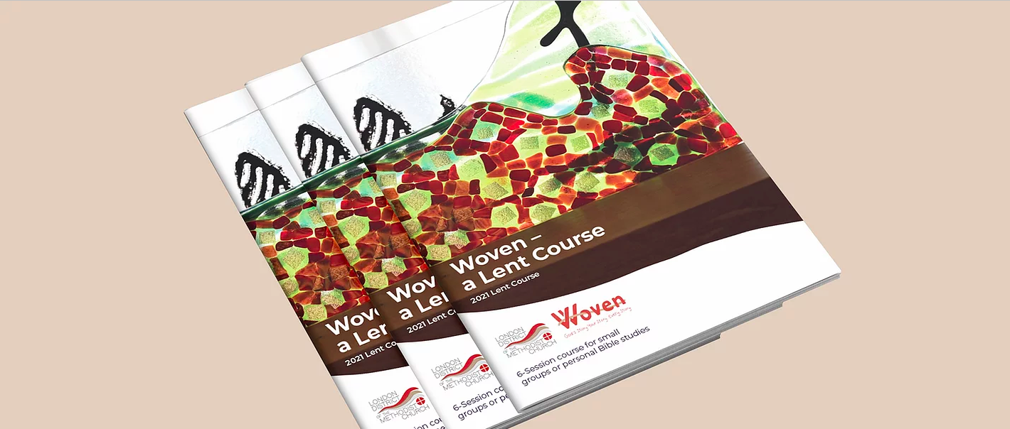

We may have only just got past Christmas but it is not time to put Jesus back in the box for another year with our decorations. On Wednesday 17th February 2021 we begin the journey to Easter as our journey through Lent begins.

Lent is the season during which we reflect on our own personal relationship with God and also our responsibility to engage with the world that we are part of as our story and God’s story are woven together.
The London Methodist District have produced a six session Lent course which has been produced by Revd Michaela Youngson one of the London District Chairs. The course will guide us through shared study on a journey of personal reflection towards living love in action.

We will remember that Jesus travelled a journey from his baptism, through the wilderness and beyond, to a ministry of teaching and healing, of challenging injustice and of holding the powerful to account. We will remember the cost that Jesus paid for standing up for those who were most vulnerable and we will look towards the eternal hope that lies beyond the sacrifice.

Every circuit member will be receiving a copy of the Lent course in either printed or PDF form in the near future, so that as a circuit we will be able to journey towards Lent together. More details of how we will do this will be available soon.

Helen Lunn Pastoral Worker

Circuit Website www.enfieldmethodistcircuit.co.uk
Circuit Office enfieldcircuitoffice@yahoo.com
020 8367 1338

Embracing Diversity -Revd Valentin Dedji

Have you heard? Are you ready for this? Have you taken note?
To be more precise, ‘Embracing Diversity: Seeing the other from God’s Perspective’ is the theme of the forthcoming seminar organized by our Circuit’s ‘Equality, Diversity and Equality’ Steering Group.
Saturday 6th February 2021, 10am – 1pm
(Register at https://qrgo.page.link/6b4vy)
Setting the Scene
I have always been stimulated and challenged by verses from Psalm 133 that go:
‘How wonderful, how beautiful, when brothers and sisters get along! ... Yes, that’s where God commands the blessing, ordains eternal life.’ (Psalm 133: 1 & 3, ‘The Message’).

The words here-above quoted from the psalmist, King David may be in a nutshell, the motivation as well as the challenge for the
newly constituted steering group in charge of promoting ‘Equality, Diversity and Inclusion’ in our Enfield Circuit. That was approved recently by the Circuit Meeting on the 3rd December 2020.
As such, this is no longer a task assigned to some few enthusiasts. No! This should now become our common vision, our common goal and our common rallying cry that need our common coordinated actions. The harmony of our Circuit, the recovery of our sense of belonging and our God-Given blessing depend on this. It is a common journey during which, respecting each other, listening to and learning from one another would be essential. Above all, this is a mutual educational process. That’s why the ‘Equality, Diversity and Inclusion’ Steering Group has chosen as its motto:
‘Respectful Listening – Reciprocal Learning’.
Churches in general and the Methodist Church in particular have not been spared by stories of ‘institutional discrimination’, prejudices and injustice perpetrated against some categories of people within our communities. The current pandemic crisis has also uncovered a number of deep-seated issues of social inequalities, loneliness, mental abuse and domestic violence. We have also witnessed numerous acts of violence and discrimination against people from the so-called BAME origins.
As local churches gathered in our Enfield Circuit, we have the mandate to fulfil our calling as ‘salt and light’ for the world in which we all live.
That’s why, instead of letting our voices and Christian identity being drown into the clatter of practices surrounding us, we want to live up to our calling. Our ambition is to ‘rise above the storm’. We invite you personally to join us on the open platform that we have initiated for all of us. This will be the first of a series of seminars.
Let’s come together to talk, discuss, share our stories and bridge the gaps…
A Panel of distinguished Speakers
The following distinguished speakers have been invited to initiate our conversations and discussions through their key-note presentations:
Speaker 1: Revd Sonia Hicks - ‘British, Black and Belonging: Singing the Lord's Song in a Strange Land’
Sonia Hicks has been a Methodist Presbyter for 30 years. She has served in the Methodist Church in Ireland (Dublin District) and in the Methodist Church in the Caribbean and Americas (Jamaica District). Presently Sonia is serving in the Wembley Circuit as Superintendent Minister. She is the first woman from a BAME background to be the President-Designate of the British Methodist Conference.
Speaker 2: Mr Richard Reddie - "Why we should be interested in racial justice" Richard Reddie is a writer, researcher, broadcaster and a religious and cultural commentator. He is currently working on the book “Race for Justice” (Lion) which will explore racial justice in Britain’s churches.
He is the current Director of Justice and Inclusion for Churches Together in Britain and Ireland.’
Speaker 3: Gabriel Dedji - ‘Creating Utopia: Understanding the language of a youthful uprising’ In 2018, when he was only 16 years’ old, Gabriel was elected Young MP for the London Borough of Enfield. He is the Chair of Enfield Methodist Circuit Youth Group.
In 2019 at the age of 17 Gabriel published his first book ‘The Escape: A Tale of Change and Revolution’ (Austin Macauley, 2019), which featured on ITV News on 2nd January 2020. Gabriel is currently student in Politics and International Relations at UCL.
Update of Circuit Projects
Winchmore Hill
Following the disappointing withdrawal of the buyer in September 2020, the Church has now been remarketed by the agent and there has been a good response from new potential buyers. Viewings will start again before the end of January and we all pray that another buyer will be found soon.

Edmonton
After over 3 years of work, the new Edmonton Church and residential flats received planning permission from Enfield Council in December. This is wonderful news for everyone involved and for the whole community. A solicitor has been appointed to work with the Council on some of their conditions attached to the planning decision. The next steps are for the Architect to turn the plans into a detailed building tender – which will take several months. In the meantime, the Circuit and Edmonton will be working to secure commercial loans with the hope that building work can start later his year.
We have been working with a professional grant writer who has produced a detailed report identifying the most suitable grants to apply for and the information we will need to provide for the applications. Around £4m of grants have been identified and the grant writer feels a success rate of 1 in 4 should be attainable. With planning permission already granted, the steering group are now looking at the resources needed to move ahead with these applications. In the meantime, a project committee has been established to engage community involvement which will shape what is needed from the new building when completed.

Ponders End
Phase one of the refurbishment project is finished. This has included a lot of the groundworks and structural changes along with the extension. In order to move forward with the next stage, we are working with another Circuit to secure the loan (approval for which was given at the last Circuit Meeting). We hope the timings will work out so that the building work can continue uninterrupted and the remaining work can be completed before the Summer.

Anne Fairchild – Circuit Executive Officer

Weekly recorded services continue to be available online at: www.enfieldmethodistcircuit.co.uk, along with other resources to read and do. Remember that printed copies can be posted or emailed; please contact the Circuit Office if you would like to be added to the circulation list. The Circuit Office continues to help with picking up shopping, posting mail or a phone conversation. Please call on 020 8367 1338 if you or someone you know needs support.

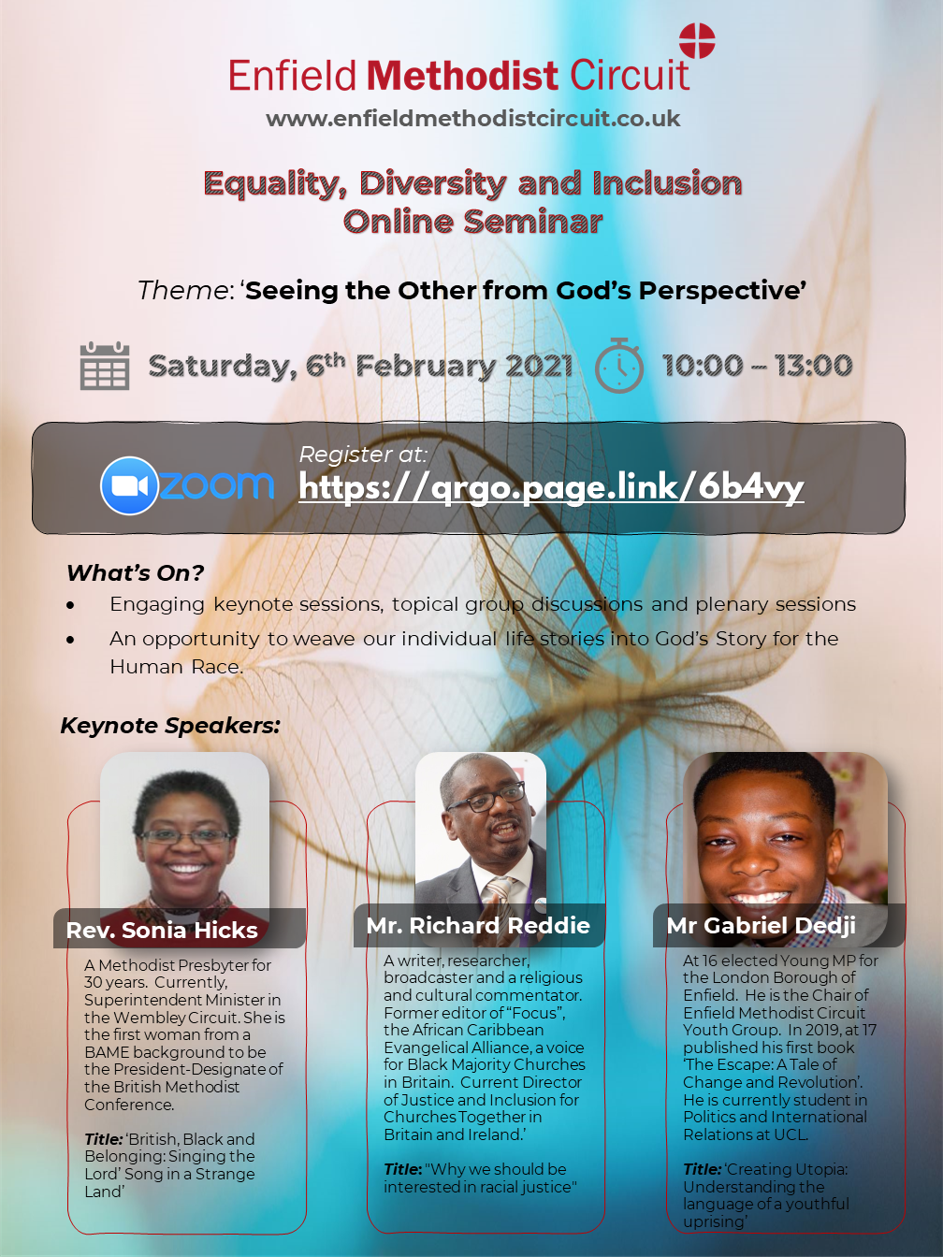
Ponders End: Outreach project – Deacon Jacqueline Esama-John
It has been an incredible four months of starting a new appointment in a pandemic, getting to know people, and living out my calling as a deacon in the Enfield circuit.
I am reminded of Paul’s prayer for the believers in Ephesus that “…the God of our Lord Jesus Christ, the Father of glory, may give you a spirit of wisdom and revelation in the knowledge of him, having the eyes of your hearts enlightened that you may know what is the hope to which he has called you...” (Ephesians 1: 15-19).
It is this hope to which God has called me that has become my reality now more than ever before. Jesus lived in a time of great turbulence. The early Christians lived in a time of intense turmoil. There is great resilience and determination, and we are seeing tremendous results in the multiple ways in which the church is living out its calling in this present age.
Our Methodist way of life commits us to pray daily and to practice hospitality and generosity- the pandemic has given us an unprecedented opportunity to do just that. I thank God that even in this time of so many losses, we have also seen a lot of compassion, innovation, and creativity and all because of this hope to which God has called us.
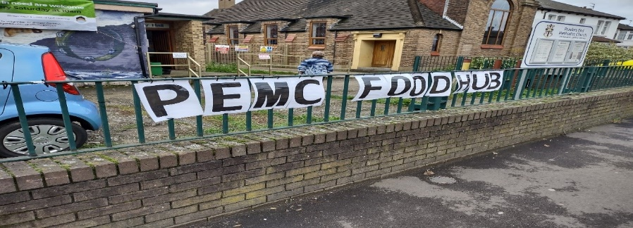
Amid tremendous challenge, we opened the new Ponders End Methodist Church (PEMC) food hub at Wesley Hall on 21st November 2020 with food donations from the Felix project via TOCS and the Edmonton food hub. In addition to this, and through the great lobbying skills of our CEO Anne Fairchild and in agreement with our circuit treasurer Roz Rutty, the circuit gave us a loan of £2000 to set up the project and buy some more basic food, groceries, and hygiene products.
Before Covid-19, Wesley Hall was home to the Ponders End children’s centre and baby clinic. Annually, it served as a polling station during the May elections. It hosted two Pentecostal churches on a weekly basis and was also a meeting place for three Alcoholic Anonymous groups.
Today, Wesley hall has been transformed into a food hub in response to the growing need of people experiencing food poverty in this community which has been heightened by the pandemic.
Through the hard work of a dedicated team from the congregation at PEMC, we hand out food parcels to an average of 40 people on a weekly basis who come through the church gates every Saturday between 10am -12pm.
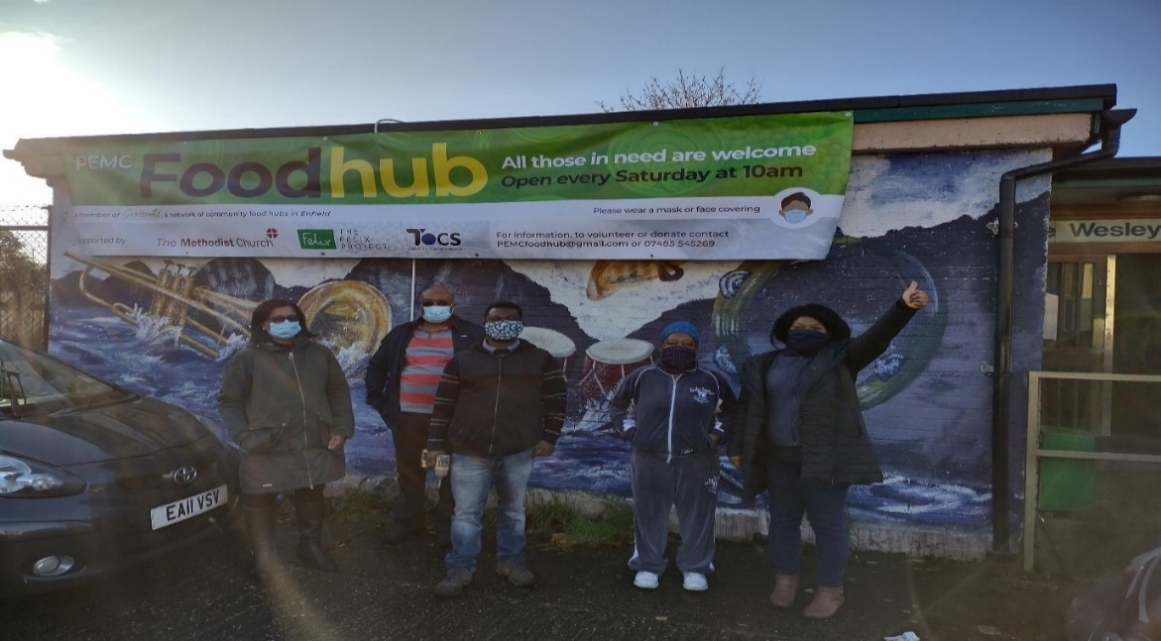
This project has been an occasion of grace, dealing with broken lives and trying to restore dignity and we are committed to helping our community in these difficult times. We hand out fresh fruits and vegetables as well as groceries, personal hygiene, clothing, baby food and other baby essentials. Additionally, we offer nutritious ready meals to those who are homeless or without access to cooking equipment.

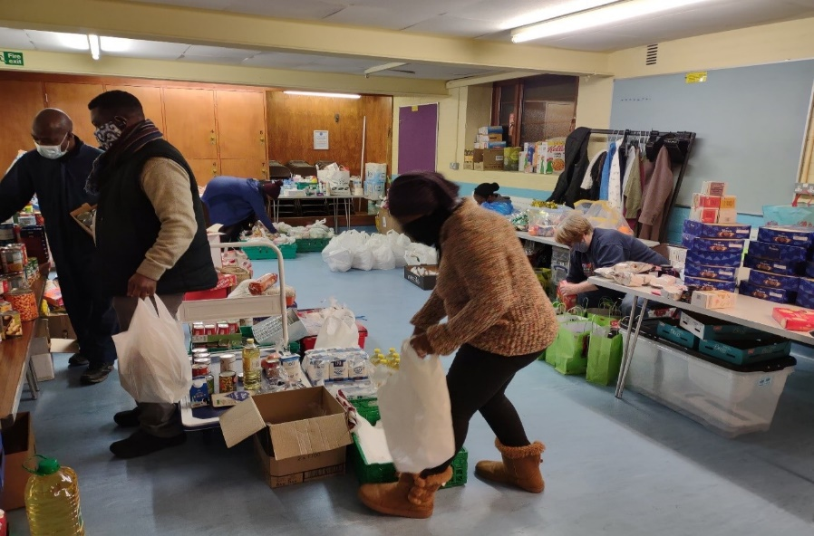

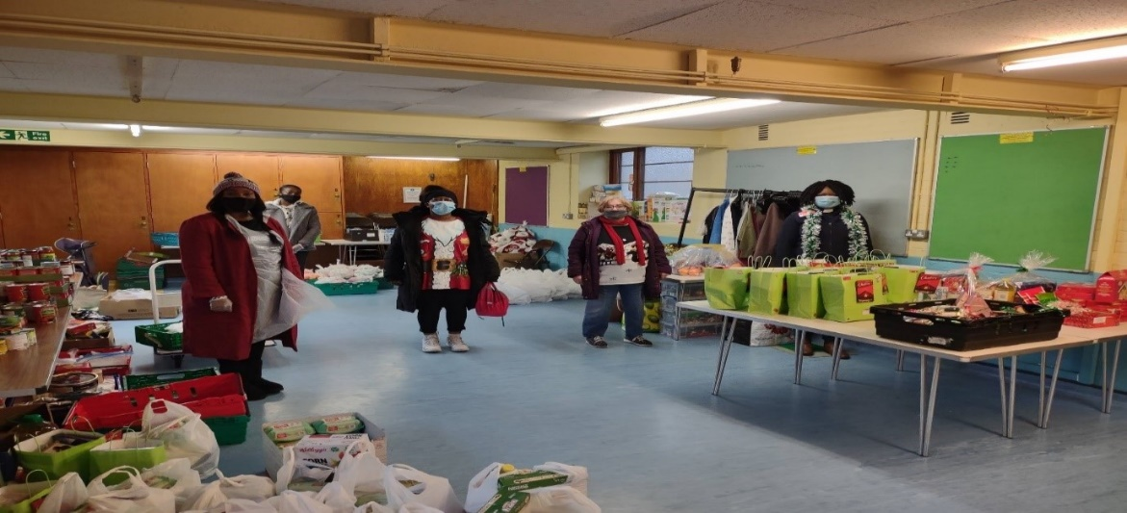

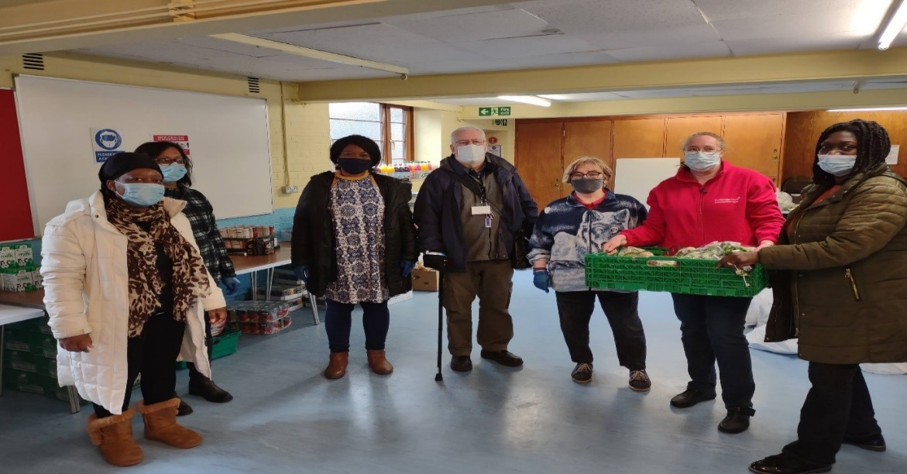

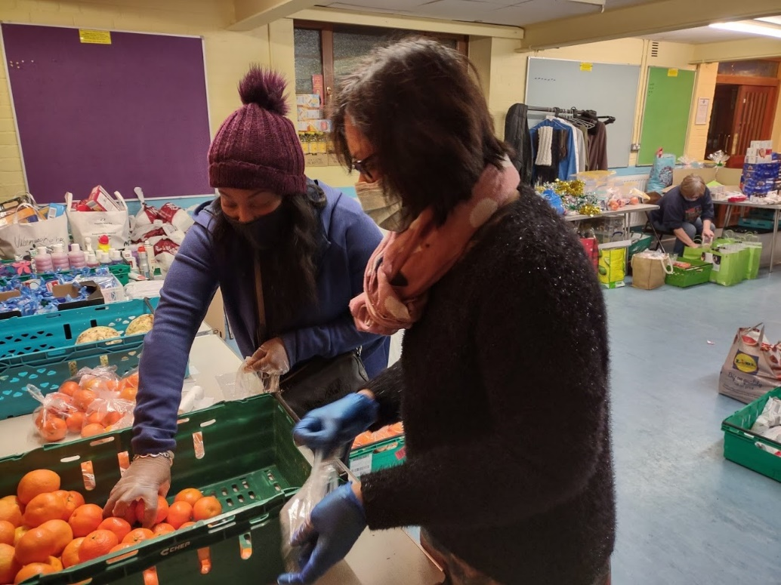

It is apparent that there is a huge need in this community as Covid-19 has further exacerbated economic inequalities.
A lot of people are losing their jobs and livelihoods and the cost of living is rising exponentially. Consequently, food poverty is at an all-time high and the food hub is part of how we can care for our community.
We thank God that even in lockdown, we were able to celebrate the coming of light and love, the great gift of God with us - the Emmanuel.
On 18th December 2020, in addition to the food parcels, we gave out 50 Christmas gift bags as well, with a special Christmas booklet published by the Methodist Church which tells the story of the nativity of our Lord and saviour Jesus Christ.
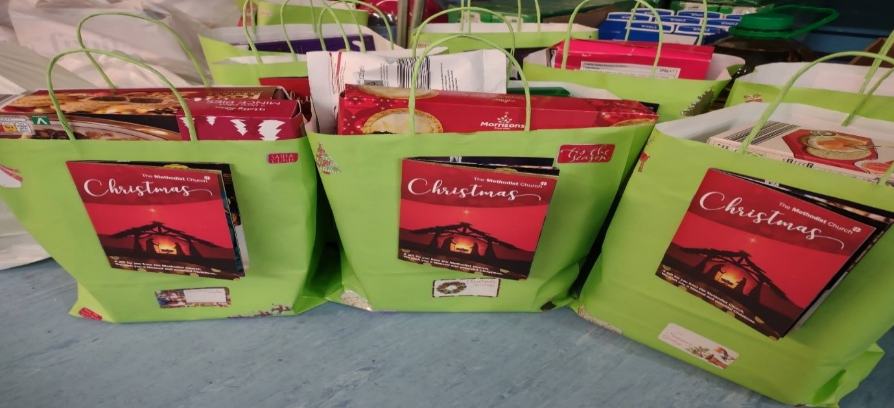

Deacon Jacqueline, Margaret & family, Sandra, Rosalie, Christian, Andy, Rosie and Justice.
Appeal
We welcome donations of tin foods, packets of pasta and rice, long-life milk, sugar, cooking oil, tea, coffee, personal hygiene products, baby food and essentials, as well as cash donations (this is not an exhaustive list so please get in touch via the circuit office if you would like to donate).

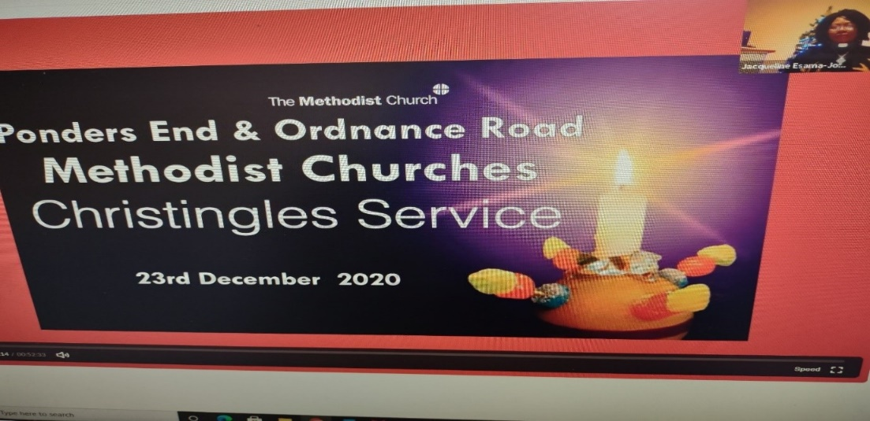
Ponders End: Looking inwards - Christingle service
We are thankful for the children and their families at PEMC and Ordnance Road who, like everyone else, have had to endure the challenges of home-schooling and lockdowns of various levels, but nevertheless passionate about growing spiritually.
Through a dedicated team from Ponders End, Ordnance Road and Edmonton churches, we hosted a lovely Christingle service with children and their families over Zoom on 23rd December.
The Christingle is a very simple way to remind us that Christ is the light who came to the world at Christmas.
We put together bags full of materials for the Christingle service, which was either distributed to, or collected by, individual families to enable them to participate in making the Christingles.
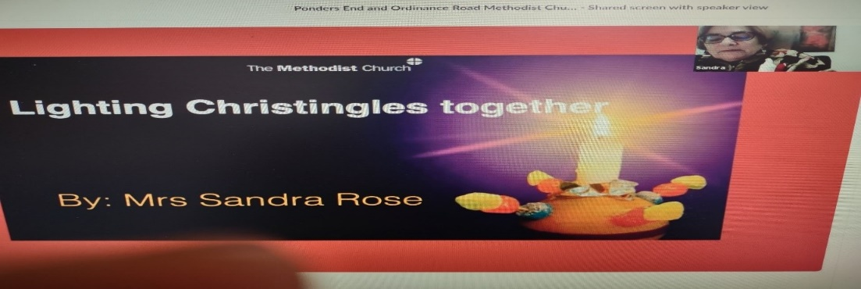
Sandra led us in making the Christingles, explaining the significance of each item: the orange represents the world, the red ribbon symbolises the blood of Jesus, four cocktail sticks with haribos on each stick signifies the four seasons and the fruit of the earth, and the candle in the middle, representing Christ, the light of the world. It was lovely to see all the children and their families engaging with it and making their own Christingle.

There was good collaboration between the Sunday school superintendent at PEMC, Paula, the children and youth leaders at Ordnance road, Georgina and Comfort, our circuit youth worker Isata, together with my presbyter colleague, Revd Papa.
Our team is grateful for this community of faith, seeking to be God’s family even though we cannot gather in person.
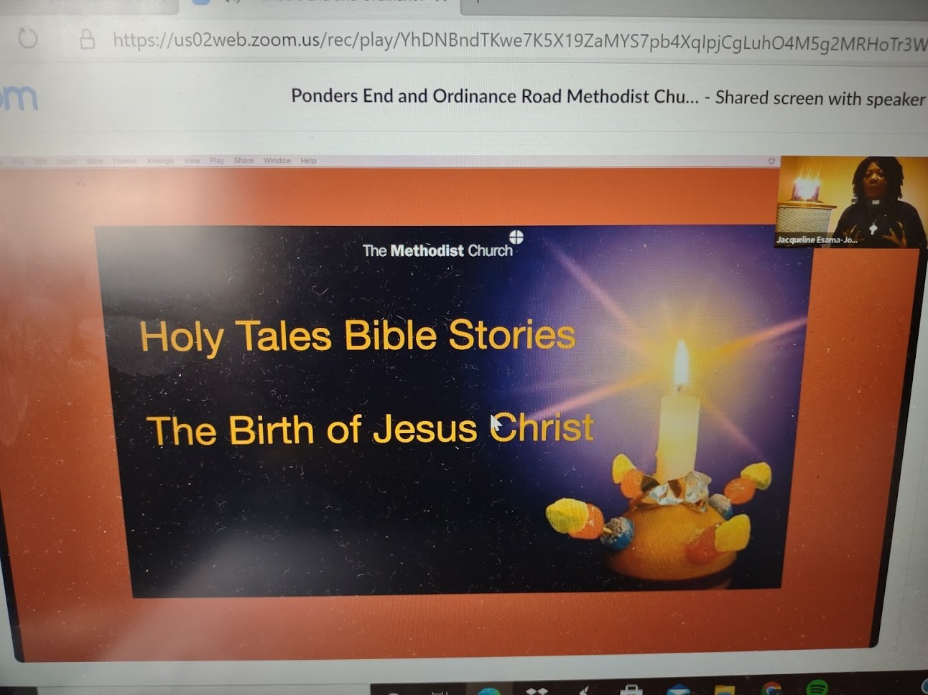
Also, included in the service, was a short video clip of the Nativity story for the benefit of the children, who, due to the pandemic, could not participate in their school or church nativity plays and Christmas carols as they would normally do.
All of this is helping us to think about the practicalities of starting a virtual Messy Church, sourcing materials, and delivering them to families - inspiring mums, dads, grandparents, extended family members and friends to join in the fun.
One of the key values in Messy Church is that it is intergenerational. Everyone is encouraged, equipped, and empowered to use their God-given gifts and skills.

Appeal
We are looking for volunteers from across the circuit to join our team. Could this be you? Maybe you enjoy arts and crafts, talking to families, singing or dancing, or just good at telling stories? Donations of money are also welcome as we need to buy all the materials needed to host a session.
For more information, please get in touch – details will be on the circuit website.

Deacon Jacqueline, Paula French, Georgina Langma, Isata Jalloh, Comfort Osare, Sandra Rose

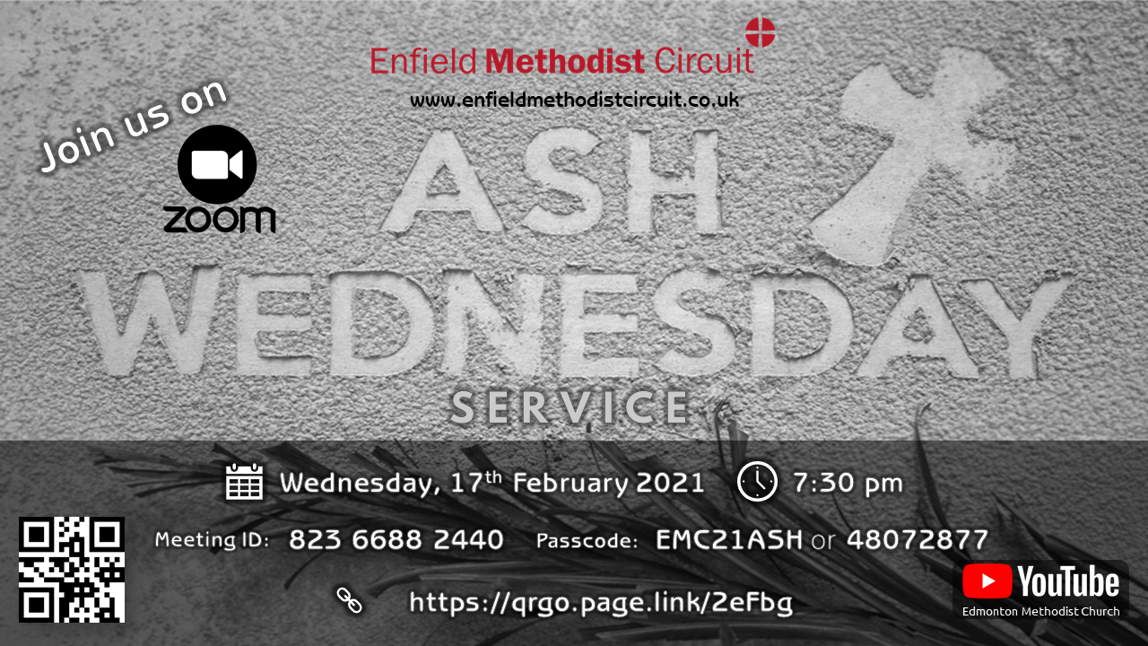

Eileen Nicholls, a member of Grange Park Methodist Church wrote a book during the first lockdown:
“It is my autobiography and called 90 Glorious Years And More! The book is 200 pages long with photographs going back to my birth in Yorkshire 90years ago. I describe my childhood pre-war, the war years in school, living in Bedford, building up a new church in Bedford. Living in Edinburgh and loving the opportunity for music there. In London my work for Mencap and teaching as well as time spent for the Methodist Church”
The cost of the book is estimated to be approximately £16 and Eileen will donate £5 from each sale to the North London Hospice.
If you would like to order a copy, please contact Hilary in the Circuit Office.
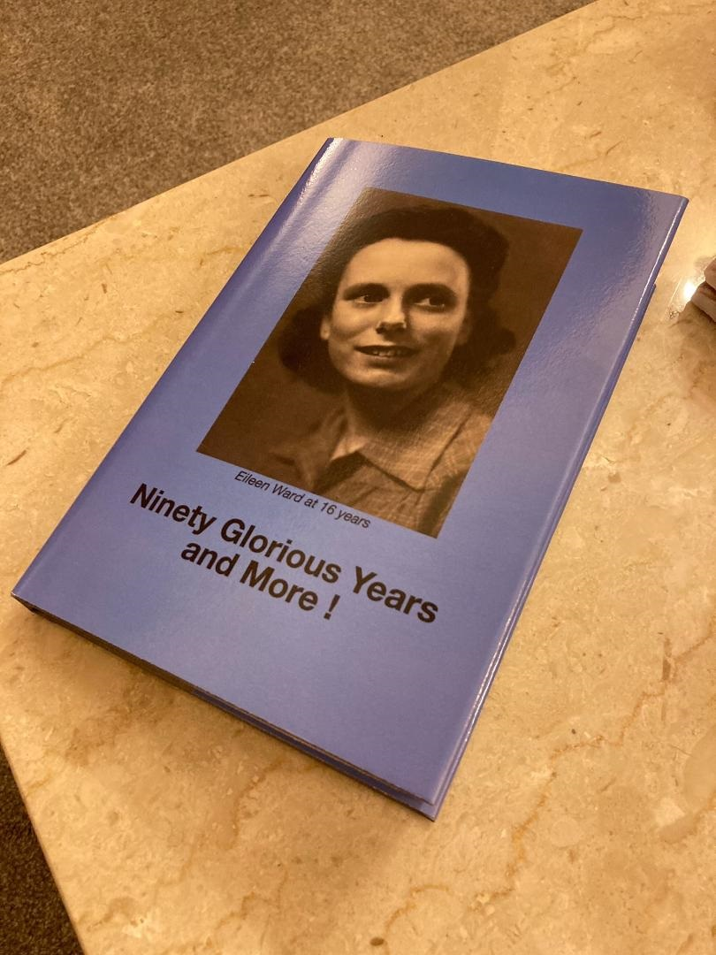

Fore Street Food Hub

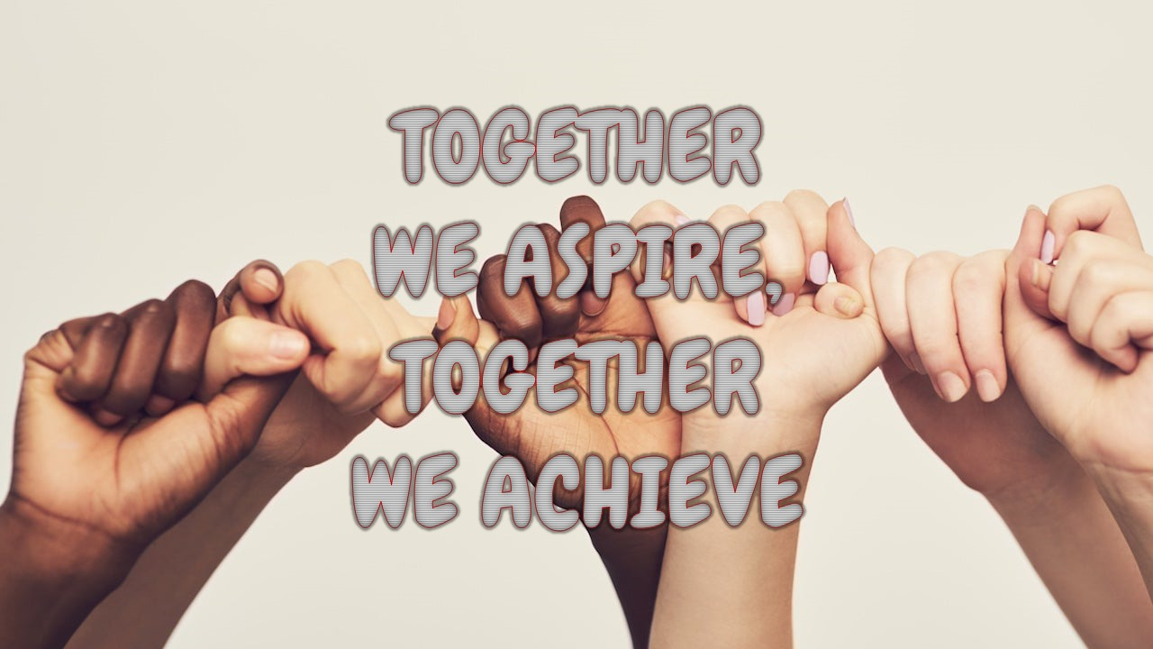

Fore Street Food Hub started on 1st August and is growing by strength weekly.
It has a wealth of volunteers both from Edmonton Methodist Church and around the Circuit. This includes delivery drivers and pickers and packers. It has continued the Saturday morning delivery service to the elderly and to those who are continuing to shield.
Saturday afternoon is opened to the public with a bag and collect system.
We continue to receive food from the Felix project twice weekly under the banner of Grassroots and also purchase certain food items which is more acceptable to certain members of the community and to replenish our stores.
We have received several monetary donations and food items from members of Edmonton and around the entire circuit. We had a large delivery of food items from a New River Church (not part of any circuit) who heard of what we were doing in the community and offered their help. Wow. It was like receiving a Felix delivery.
Two other organisations with members based at Edmonton Church also donated large volumes of food and money. We felt truly blessed as all these were received in time for distribution for Christmas.
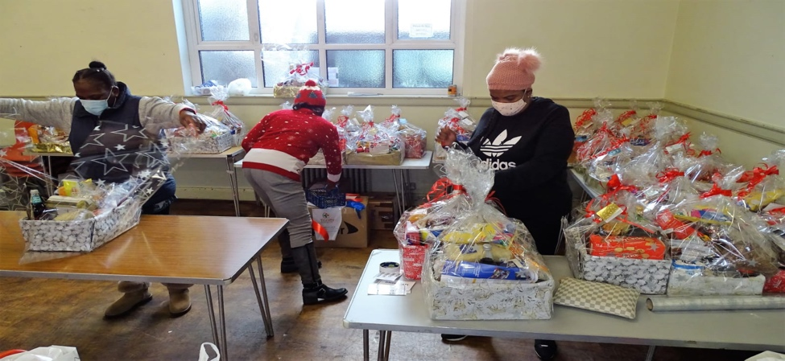

Special thanks to the Ghana Nurses Association (UK) and Trinity Healthcare Plus.
The two weeks prior to Christmas was very exciting as homemade hampers were prepared by the volunteers.

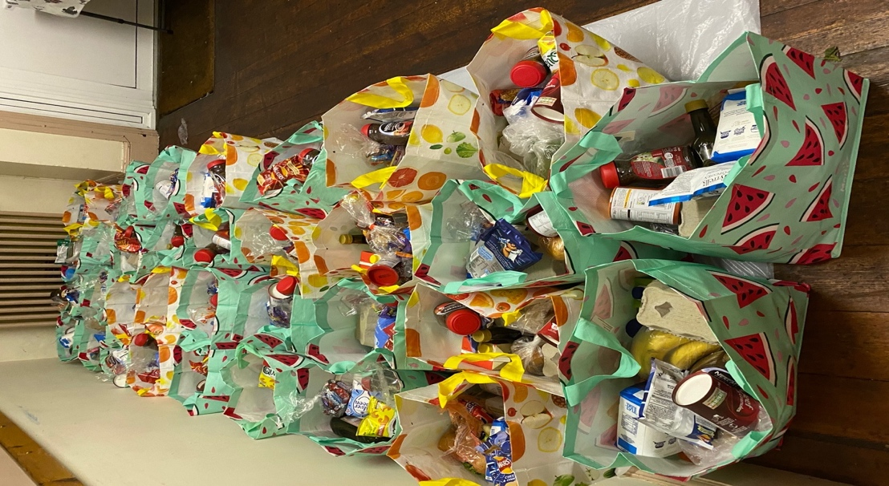
Some of the Edmonton members drop in frequently to assist with certain tasks and to enjoy the vibrant atmosphere in the Hub. Special bags were also prepared for the afternoon session.

The final Saturday was amazing and all the volunteers participated with Christmas Jumpers, Santa hats and Christmas face masks. The clientele enjoyed the atmosphere and the children received gifts.

On behalf of the Food Hub, I thank everyone for their continued support and wish everyone a healthy 2021. God’s blessings always.

Roz Rutty, Project Manager

Celebrating Black History Month with Judith Turkson - Baidoo
Judith is a member of Grange Park Methodist Church and was interviewed recently by the National Autistic Society.

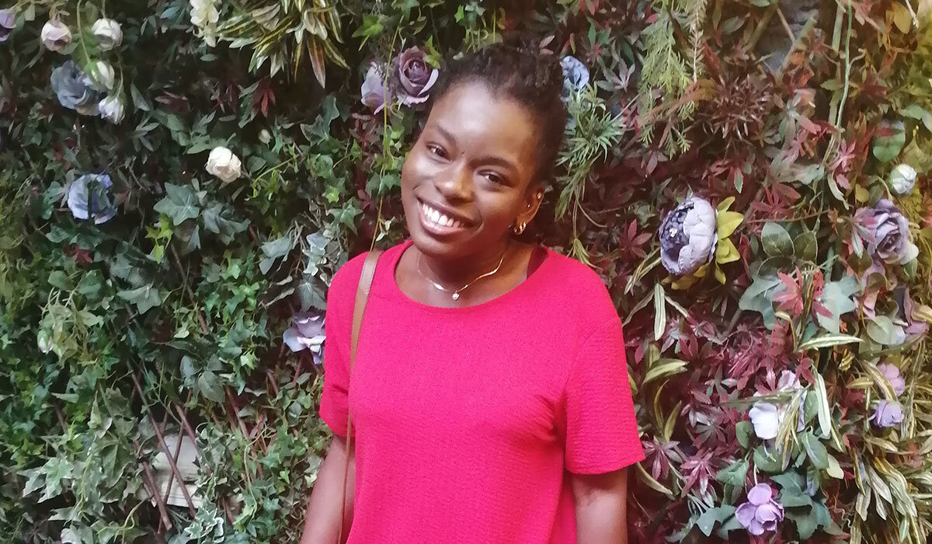
"I sometimes feel that disability is treated as a secondary matter in society, and something needs to be done about this."

Judith Turkson-Baidoo, autistic woman and Fine Art graduate, currently works for a charity that provides educational support for children and young people. Her Judith talks about her experiences as a black autistic woman and what Black History Month and the Black Lives Matter movement means to her.
Judith also shared her diagnosis story, responding to being told ‘you don’t look autistic’, and why being weird is a wonderful thing!
When were you diagnosed as autistic? I was diagnosed at four-years-old.
When I was three, I went to stay with my aunt in America. My aunt is a former teacher, who had worked with children with special educational needs. She noticed that I wasn’t really making eye-contact or communicating as much as other children my age. My aunt had a feeling that I might be autistic. When I went back home, she called my mum to suggest looking into a diagnosis.
It was quite a process, but I was eventually diagnosed with a speech and language disorder as well as autism.
What is being autistic like for you? Being autistic does have its challenges, but it has also shaped me as a person.
When I was 10 or 11, I started to feel very different from my peer group.
It took me a lot of time to make new friends, I often felt very isolated and left out, and struggled to fit in.
I was afraid of being judged. People told me that I was ‘weird’ or ‘unusual’ and called me ‘stupid’. Those words do kind of hurt you. I ended up masking a lot to hide my true identity.
I started to understand more about my own autism diagnosis when I was 14. I started to do more research, although I mostly kept it to myself. I spoke to my mum about my diagnosis, to try and find out more.
I always found learning very difficult. However, I did excel in creative subjects, like art, music, and design and technology. I passed my A Levels and ended up doing a foundation diploma in Art and Design. I then went to university and got a degree in Fine Art, so it did work out in the end.

You mentioned you would like to talk about Black Lives Matter, and your experience as a black autistic woman. Would you be able to tell us more about this and what it means for you?
With everything going on at the moment, it’s important to recognise that racism is everywhere, and that it isn’t just a black and white issue. Black people have been discriminated against for centuries. Even though there is still a lot of work to be done, especially in the coronavirus pandemic era, the Black Lives Matter protests (in response to the murder of George Floyd by a police officer) was a serious wake up call for a lot of people. Of course, as a black person, I was very angry. I think a lot of non-black people were angry too.
It was great to see non-black people being allies and being supportive. It opened up conversations and allowed me to share resources on social media and talk about what was happening.
I then discovered Autistic Tyla, a black autistic YouTuber. I started following her on social media. It was amazing to be able to connect with another autistic person who looked like me, and to have someone I could look up to.
I was really pleased when the National Autistic Society posted about Black Lives Matter on social media, sharing their commitment to improving support for BAME autistic people.
There have been people who have not responded positively to the Black Lives Matter movement. Of course, all lives matter, but we have to pay attention to what’s happening in society at the moment, and recognise that things aren’t equal when it comes to race, and to do something about it.

Why do you think there is a lack of representation or support of BAME autistic people in the UK and why is representation so important?
I think it’s partly due to the demographics.

From personal experience, being both black and autistic means that people don’t always seem to understand me. I sometimes feel that disability is treated as a secondary matter in our society, and something needs to be done about this.

What could society do to support black autistic people better?
I think it would be great if people in the UK were to find out more about the experiences of BAME autistic people, as it would help them understand cultural differences. It would be great if the autistic community as a whole could be a unit and uplift one another.
It would be great if black autistic people could be provided with the support they need. We deserve recognition and credit for the work we do. There just needs to be more understanding.

If you could remove one myth or stereotype about autism, what would it be?
The ‘you don’t look autistic’ comment. First of all, what does that even mean? What does an autistic person have to ‘look like’? It’s very ignorant. There needs to be more understanding of disability and differences in general, ranging from physical disabilities to differences in social communication and there needs to be more knowledge and understanding of autism in all parts of society
I also don’t like the stereotype that all autistic people are weird. We’re unique and talented, and very creative in our own way and if that sometimes seems weird, it’s good to be weird! We need to be given an opportunity to shine.
To view Judith’s interview online, please go to https://www.autism.org.uk/advice-and-guidance/stories/stories-from-the-spectrum-judith-turkson-baidoo

For further information on the National Autistic Society, please visit www.autism.org.uk

Sunday Services Bible Studies & Prayer Meetings
Whatever local church you are from - all are welcome!
Sunday services:
Goffs Oak – 10.15 (online) Edmonton – 10.45 -12 noon (online) Zoom ID: 917 086 670 Ponders End – 11am (online) Ordnance Road – 11am (Church open)
Bible Studies:
Edmonton – Tuesdays, 7.30 - 8.30pm (online)
Zoom ID: 843 560 03537

Prayer Meetings:
Goffs Oak – Tuesdays, 11am (online) Edmonton - (First and Last Friday of each month), 7.30 – 8.30pm (online) Zoom ID: 848 394 66258 Ordnance Road – Fridays, 7.30 - 8.30pm (online)

For details of online services and prayers meetings at Goffs Oak, Ordnance Road and Ponders End churches, please contact Revd Papa Owusu.

A weekly prayer resource is also sent out via email by Revd. Dan, please email or ring to be added to the list.

