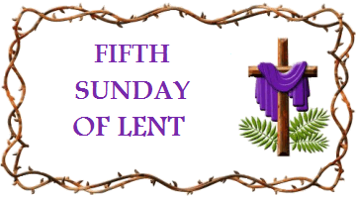
This short act of worship has been produced for you by Revd Jonathan Dean. If you are well enough and able, why not spend a few moments with God, perhaps at a time when you would normally be sharing with others in church and pray for them as they pray for you.

Passion Sunday
Call to Worship: Psalm 100
O shout to the Lord in triumph, all the earth:
serve the Lord with gladness,
and come before God’s face with songs of joy.
Know that the Lord is God:
it is God who has made us, and we belong to God;
we are God’s people and the sheep of the Lord’s pasture.

Come into the gates with thanksgiving,
and into the courts with praise:
give thanks to God! Bless God’s holy name!

For the Lord is good, and God’s loving mercy is for ever:
God’s faithfulness throughout all generations.

Opening Hymn: Father, in whom we live (Singing the Faith 5)
Sing / read / pray / proclaim the words or listen to it here
https://www.youtube.com/watch?v=Q3S9rG05tks

Father, in whom we live,
in whom we are, and move,
glory and power and praise receive
of thy creating love.
Let all the angel throng
give thanks to God on high;
while earth repeats the joyful song,
and echoes to the sky.

Incarnate Deity,
let all the ransomed race
render in thanks their lives to thee,
for thy redeeming grace.
The grace to sinners showed
ye heavenly choirs proclaim,
and cry: ’Salvation to our God,
salvation to the Lamb!’

Spirit of holiness,
let all thy saints adore
thy sacred energy, and bless
thy heart-renewing power.
Not angel tongues can tell
thy love’s ecstatic height,
the glorious joy unspeakable,
the beatific sight.

Eternal, triune Lord!
let all the hosts of men, record
and dwell upon thy love.
When heaven and earth are fled
before thy glorious face,
sing all the saints thy love has made
thine everlasting praise.
Charles Wesley (1707-1788)

Prayers
God of Life and Grace,
we praise you for the wonder of your goodness to us.
For the splendour of Creation, the diverse beauty of all you have made,
and the rich variety of the human race,
which all declare and display your Wisdom and your Love.

We praise you too for the unlikely Wisdom, which you have revealed in Jesus:
for the ways in which the Gospel confounds the worldly values by which we live, often all too unthinkingly;
for his life, ministry, teaching, and death, which reveal to us a more excellent way;
for his resurrection, by which you vindicate him as your Son, and bring all Creation to new birth.

We praise you for the Holy Spirit, who breathes new life into us, and makes of us your people, the Church.
As we worship, may she continue to inspire us and renew us,
challenge us and convict us,
remould us and reshape us,
that our lives too may be patterned upon that of Jesus,
who makes our wisdom foolish, and redeems our folly by your self-giving love.

In the silence, we repent of our own resistance to the way of Christ, and ask for God’s forgiveness. [Silence]
Hear God’s word of grace: “your sins are forgiven”.
Amen! Thanks be to God!
A prayer for Passion Sunday:
Almighty God, whose most dear Son went not up to joy but first he suffered pain,
and entered not into glory before he was crucified:
mercifully grant that we, walking in the way of the cross,
may find it none other than the way of life and peace;
through Jesus Christ our Lord: Amen.

First Reading: Hebrews 5: 5-10
So also Christ did not glorify himself in becoming a high priest, but was appointed by the one who said to him,
‘You are my Son,
today I have begotten you’;
as he says also in another place,
‘You are a priest for ever,
according to the order of Melchizedek.’
In the days of his flesh, Jesus offered up prayers and supplications, with loud cries and tears, to the one who was able to save him from death, and he was heard because of his reverent submission. Although he was a Son, he learned obedience through what he suffered; and having been made perfect, he became the source of eternal salvation for all who obey him, having been designated by God a high priest according to the order of Melchizedek.

Second Reading: John 12: 20-33
Now among those who went up to worship at the festival were some Greeks. They came to Philip, who was from Bethsaida in Galilee, and said to him, ‘Sir, we wish to see Jesus.’ Philip went and told Andrew; then Andrew and Philip went and told Jesus. Jesus answered them, ‘The hour has come for the Son of Man to be glorified. Very truly, I tell you, unless a grain of wheat falls into the earth and dies, it remains just a single grain; but if it dies, it bears much fruit. Those who love their life lose it, and those who hate their life in this world will keep it for eternal life. Whoever serves me must follow me, and where I am, there will my servant be also. Whoever serves me, the Father will honour.

‘Now my soul is troubled. And what should I say—“Father, save me from this hour”? No, it is for this reason that I have come to this hour. Father, glorify your name.’ Then a voice came from heaven, ‘I have glorified it, and I will glorify it again.’ The crowd standing there heard it and said that it was thunder. Others said, ‘An angel has spoken to him.’ Jesus answered, ‘This voice has come for your sake, not for mine. Now is the judgement of this world; now the ruler of this world will be driven out. And I, when I am lifted up from the earth, will draw all people to myself.’ He said this to indicate the kind of death he was to die.

Second Hymn O Precious Sight (The Wonder of the Cross) (Singing the Faith 279)
Sing / read / pray / proclaim the words or listen to it here
https://www.youtube.com/watch?v=UCstpSI5Ys4

O precious sight, my Saviour stands,
Dying for me with outstretched hands
O precious sight; I love to gaze,
remembering salvation day,
remembering salvation day.

Though my eyes linger on this scene,
may passing time and years not steal
the power with which it impacts me,
the freshness of its mystery,
the freshness of its mystery.

May I never lose the wonder,
the wonder of the cross.
May I see it like the first time,
standing as a sinner lost.
Undone by mercy and left speechless,
watching wide-eyed at the cost.
May I never lose the wonder,
the wonder of the cross.

Behold, the God-Man crucified,
the perfect sinless sacrifice.
As blood ran down those nails and wood,
history was split in two,
history was split in two.

Behold, the empty wooden tree,
his body gone, alive and free.
We sing with everlasting joy
for sin and death have been destroyed,
sin and death have been destroyed.

May I never lose the wonder,
the wonder of the cross.
May I see it like the first time,
standing as a sinner lost.
Undone by mercy and left speechless,
watching wide-eyed at the cost.
May I never lose the wonder,
the wonder of the cross. Vicky Beeching
Reflection on the Readings
I’ve always preferred the Christmas crackers that had riddles in them, rather than jokes. Here’s a few I’ve gathered over the years.

What comes once in a minute, twice in a moment, but never in a thousand years?

Need help? It’s the letter ‘M’. How about this one:
The more you take of me, the more you leave behind. What am I?

That one is ‘footsteps’. Here’s the final one for now:
I am not alive, but I grow; I don't have lungs, but I need air; I don't have a mouth, but water kills me. What am I?

Got it? It’s Fire. And why am I telling you this, if not purely for your entertainment? Well, because, like a lot of spiritual teachers, Jesus, along with parables, uses riddles. And today, Passion Sunday, we come to the riddle at the very heart of his life and mission, and at the very heart of the Christian faith. It’s revealed in its clearest form when some Greeks come to see this religious celebrity in Jerusalem, where he is by now at work. Their being Greek is no purely incidental detail: they represent the human search for wisdom, for the meaning of life itself, something which a lot of Greeks had been very famous for exploring in the centuries right before this. They are non-Jews, coming to this Jewish rabbi because they have a sense that he can reveal to them the secret of life, the universe, and everything.

It’s not clear whether Jesus actually gives his answer directly to the Greeks, but he gives an answer. And it’s extraordinary: in order to live, you must die. In order to find fulfilment, you must give yourself away. In order to know the fullness of God’s kingdom, you must experience the emptiness of self-giving. But he goes on to say: don’t just take my word for it. Watch me. Walk with me. Follow me, into the coming days, into the confrontations ahead, into the events I’m about to enact and initiate. I won’t just tell you about the truth of what I teach. I’ll live it out. Are you coming? Are you watching?

Today, Passion Sunday, is a critical ‘hinge point’ for us. It’s a day when, with Jesus, we must now turn our eyes towards Jerusalem, and to what’s going to unfold there, in the next few days. It’s a day when we set our sights on staying close to him, that we might both hear the words he offers us, and also watch carefully what he does. That we might do likewise. That our lives might follow the pattern of his. That we might begin to have the so-called ‘wisdom’ by which we live set on its head as we learn to live by what Paul called the “foolishness of God”, which turns out to be the wisest and best way of all to live. The riddle which Jesus repeats for the Greeks is about to be lived out, right in front of our eyes.

I spend a lot of my time teaching, and with teachers. I’m a school governor here in Enfield too, and a couple of weeks ago I did some observations of teaching. The teachers in my school were working online at that point, but with a few children also in the classroom. Watching them, attentive to children who were physically present, and to children who were at home on laptops, weaving the two groups together across the space, leading the lesson and yet also responsive to their questions, was an education in itself. It was a lesson in selflessness, in simply being there for others and their needs. Those teachers were stretching themselves, in every way, to enable those children to grow and to flourish: at the edge of their comfort, their energy and their expertise, but pushing in further, to bring life to others. I was very moved, just by watching them be the fullest version of themselves for those children, and in the realisation that doing was costly for them, demanding their all.

And we all know, don’t we, that the best teachers teach by how they live as well as, and perhaps more than, by the knowledge the convey. The best teachers give of themselves, that their students might be full, and fulfilled. Like the teacher I had, who gave up her lunchtimes and hours after school to enable those of us who wanted to, to learn languages that weren’t on the curriculum. Or the ones who gave up their own time to take us to plays and concerts, or on trips, or who simply saw and nurtured in us gifts which we had no idea of for ourselves. In them too we see something of the kind of teacher Jesus is, and of the kind of teaching he speaks and lives out: you find life when you give it away.

There’s another little riddle on our readings today. It’s the riddle of our strange little passage from an early Christian document, the Letter to the Hebrews, and of an obscure priest who is also a king. Melchizedek. Why do we meet him today? What part does he play in Jesus’s strange, riddling wisdom?

There’s a special prize for anyone who knows where Melchizedek appears before this: it’s in Genesis 14. Why is he so important to that early Christian author? Well, the one little story we have of him in Genesis is a beautiful snapshot of self-giving kindness and generosity. Abram, at this point just a sort of spiritual nomad, far from home, a long way from settling anywhere, a stranger and a wanderer on the earth, is met by this mysterious figure. Melchizedek, a priest and a king, greets him, and they exchange gifts with one another, across their differences of culture, race, religion and birth. It’s a touching little moment of self-giving, amid all the tribalism and violence and danger of Abram’s life.

Later on, the writer of Hebrews finds him a really helpful parallel for Jesus. He was a priest, but outside the normal order of priests: just like Jesus. He was a King, but a very unusual one, who gave things away instead of grasping more for his own Empire: just like Jesus. And he was someone who showed Abram, the eternal seeker after truth, something of the depth of God’s love and life, through welcome, through giving himself in kindness, and through overcoming all barriers and boundaries to offer a stranger a blessing. A pattern clearly at work in Jesus too. Writing to Jewish Christians without a Temple, without sacrifices, without an established priesthood, and searching for a way to live and to worship, Melchizedek seemed an ideal precursor to Jesus, and a model for him – and all of us – to follow.

The strange Wisdom of God, summed up in a puzzling riddle: if you want to find your life, you must give it away. And, says Jesus, if you don’t believe the lesson when it’s offered in the classroom, follow me out into the world, and watch.

I’m grateful for those saints, from Melchizedek on, who show me something of the shape of a genuinely Christian life. I’ve mentioned many of the ones who most speak to me in your company before, the people who lead a cross-shaped life, and confront the folly of the world when required – Oscar Romero, Martin Luther King, Nelson Mandela, Mother Teresa. We need the people in whose lives we can find the strange, riddling Wisdom of Jesus not only spoken, but lived out. There’s a danger though, that looking only to people like them can make following Jesus seem too hard for us: somehow beyond our abilities. And I like to imagine whether those Greeks were persuaded by what they heard, and saw, and how they went on to live as a result. If they were changed, their unrecorded lives might look a little like yours and mine: because every day, unheralded people like us can follow Jesus too, can shape our lives around the pattern of his life, and find the hidden treasure he pointed us towards.

I’ve been moved this last year by one of my neighbours in this regard. She lives just down my street. Some of you will know her: she is one of those people who lead a cross-shaped life. During the first lockdown, she organised food distribution to vulnerable folk in Edmonton. In our neighbourhood, she works to ensure that we’re connected to one another, and updated about the needs around us. She gives tirelessly of herself, that others may live more fully.

Or, I think of a now elderly couple who were in the first congregation I was ever minister of. They have written to me every month since I left that church, which is now almost twenty years. Their letters have been fixed points of kindness and care for me through all the changing scenes of life and ministry, across five appointments, four cities and two countries. They show me what faithfulness, and giving ourselves in love, might look like, in precious yet everyday ways even I can aspire to.
And so, we follow Jesus. Towards Jerusalem. Towards an end which we know is coming but which still ought to shock us. And towards a crisis, and a cross, which will unlock the secret of life for us, when seen backlit in the glory of a resurrection. You’ve heard the wisdom spoken: but are you ready now to watch it lived out, and, like those Greeks, to ‘see Jesus’ more fully, even if he shakes you and shocks you and scandalises you: that you might follow him, and shape your life like his and in his strength? It’s foolishness to the world, but to us who are being saved, it is – he is – the power and the wisdom of God.

Or, as W. H. Vanstone expresses it in his stunning Hymn to the Creator:
Drained is love in making full;
bound in setting others free;
poor in making many rich;
weak in giving power to be.

Therefore, he who thee reveals,
hangs, O Lord, upon that Tree,
helpless – and the nails and thorns
tell of what thy love must be.

Thou art God: no monarch thou,
throned in easy state to reign;
thou art God, whose arms of love
aching, spent, the world sustain. [StF 12]

[You can find a beautiful 15th Century painting of Abram meeting Melchizedek here]
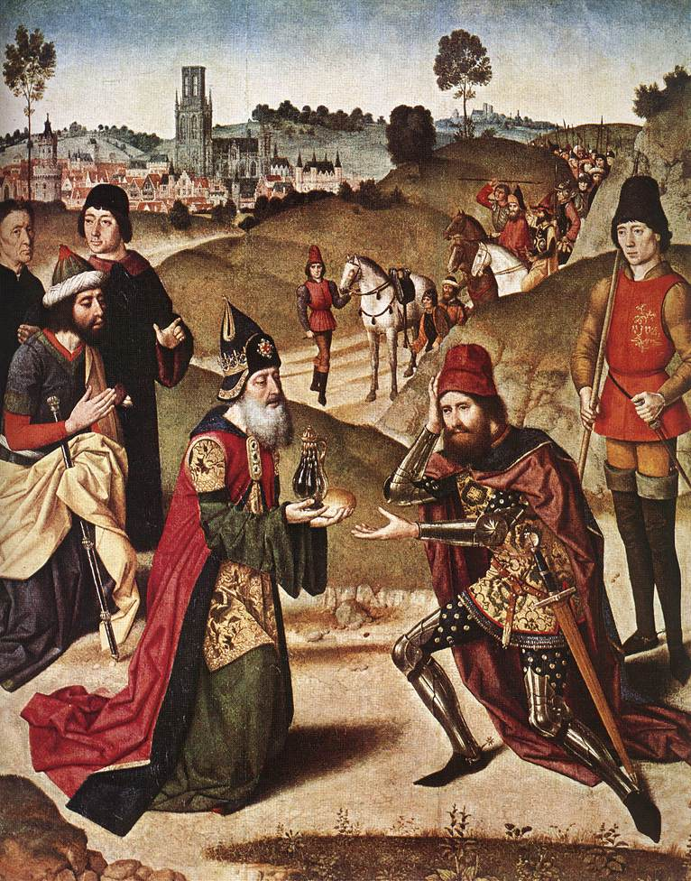

A Time of Prayer (using StF 277)

My song is love unknown,
My Saviour’s love to me;
Love to the loveless shown,
That they might lovely be.
O who am I,
That for my sake
My Lord should take
Frail flesh, and die?

We pray for the world God loves: for those needing an assurance of love, of God’s presence, that they are not alone. [Silence]

He came from His blest throne
Salvation to bestow;
But men made strange, and none
The longed-for Christ would know:
But oh, my Friend,
My Friend indeed,
Who at my need
His life did spend.

We pray for our world, in sorrow for the ways we reject the offer of love and peace and reconciliation. We remember places of warfare, situations of violence, abuse and exploitation, and for the divisions in our world which impoverish our common life and disregard God’s image in us all. We pray for all who suffer today because of human frailty and selfishness. [Silence]

In life, no house, no home
My Lord on earth might have;
In death, no friendly tomb,
But what a stranger gave.
What may I say?
Heav’n was His home;
But mine the tomb
Wherein He lay.

We pray for our communities, that they may be places of friendship and hope. We ask that we may no longer be strangers to one another, but recognise that we are children of the same Parent. We give thanks for all who gives of themselves, in the pattern of Jesus, to build community, support the vulnerable and foster vision. We pray for all those facing illness and death, and for those who care for them. And we remember all who mourn at this time, especially as we mark the one year anniversary of the first Covid-19 lockdown. [Silence]

Here might I stay and sing,
No story so divine;
Never was love, dear King,
Never was grief like Thine.
This is my Friend,
In whose sweet praise
I all my days
Could gladly spend.

We offer our lives to you, O God. Re-make us after the example of your son, Jesus. Let our small offerings play a role in his redemption of the world. And, as we journey with him towards Jerusalem, help us to follow with humility, openness and grace.
Amen.

The Lord’s Prayer
Our Father in heaven, hallowed be your name,
your kingdom come, your will be done,
on earth as in heaven.
Give us today our daily bread.
Forgive us our sins
as we forgive those who sin against us.
Lead us not into temptation
but deliver us from evil.
For the kingdom, the power,
and the glory are yours
now and for ever.
Amen.

Closing Hymn: Christ Triumphant (Singing the Faith 319)
Sing / read / pray / proclaim the words or listen to it here
https://www.youtube.com/watch?v=jnsbOCH6S1Y

Christ triumphant, ever reigning,
Saviour, Master, King!
Lord of heaven, our lives sustaining,
hear us as we sing:
Yours the glory and the crown,
the high renown, the eternal name.

Word incarnate, truth revealing,
Son of Man on earth!
Power and majesty concealing
by your humble birth:
Yours the glory and the crown, the high renown, the eternal name!

Suffering servant, scorned, ill-treated,
victim crucified!
death is through the cross defeated,
sinners justified:
Yours the glory and the crown, the high renown, the eternal name!

Priestly king, enthroned for ever
high in heaven above!
sin and death and hell shall never
stifle hymns of love:
Yours the glory and the crown, the high renown, the eternal name!

So, our hearts and voices raising
through the ages long,
ceaselessly upon you gazing,
this shall be our song:
Yours the glory and the crown, the high renown, the eternal name!
Michael Saward (b 1932)
© Michael Saward/Jubilate Hymns

Closing Responses and Blessing
Where Christ walks,
We will follow.

Where Christ stumbles,
We will stop.

Where Christ cries,
We will listen.

Where Christ suffers,
We will hurt.

When Christ dies,
We will bow our heads in sorrow.

When Christ rises again in glory,
We will share his endless joy.

There is no other way:
Christ is our Way, and the Truth, and the Life.

[The closing responses are adapted from the Iona Community and are mostly © 1998 Wild Goose Resource Group, Glasgow]

