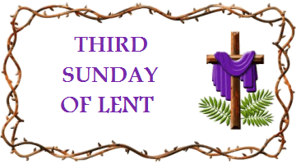

This short act of worship has been produced for you by Mrs Nancy Hands. If you are well enough and able, why not spend a few moments with God, perhaps at a time when you would normally be sharing with others in church and pray for them as they pray for you.

Welcome to our worship this morning - the third Sunday in Lent, but also a service for the annual World Day of Prayer. In normal times, this would have been held two days ago, on the first Friday of March. Each year, a service is prepared by the women of a different country, highlighting struggles and joys of that nation and expressing its needs. This year, it is the turn of the women of Vanuatu, an archipelago of 80 islands, 2000 miles east of Australia, stretching over 560 miles in the South Pacific Ocean.

We begin with the Lenten Prayer from our Lent Study Course, ‘Woven’.
Let us pray.

God who calls us on our journey, as we remember Jesus’ time in the wilderness, help us to cast aside those things that get in the way of hearing your word. Help us to seek you in the places of bounteous beauty and of barren bleakness. Help us to seek you in the faces of friends and in the smiles of strangers. Help our devotion to be made real in the actions of our lives.
When we have looked deep into our own hearts and struggled with who we are, send angels to minister to us and draw us out from our own wilderness to fulfil our calling to serve you. In Christ’s name. Amen.
The reading from John chapter 2 in the lectionary for today (which we are not using) is the account of Jesus cleansing the Temple. Jesus’ anger in that story was kindled by the injustice of exploitation of the poor, at the hands of the approved money changers in the Temple precincts. The accepted system, even in the context of worship, had become abusive. We will come back to that thought.
Today, we will learn something of the experience of injustice suffered by the people of Vanuatu, as well as their steadfastness and faith. Our Bible reading is Jesus’ story of building on a firm foundation, but first we will sing.

Hymn: It is God who holds the nations in the hollow of his hand (Singing the Faith 705)
Sing / read / pray / proclaim the words or listen to it here
https://www.youtube.com/watch?v=DU1tV7CSuVg

It is God who holds the nations in the hollow of his hand;
it is God whose light is shining in the darkness of the land;
it is God who builds the City on the Rock and not on sand:
may the living God be praised!

It is God whose purpose summons us to use the present hour;
who recalls us to our senses when a nation’s life turns sour;
in the discipline of freedom we shall know God’s saving power:
may the living God be praised!

When a thankful nation looking back, has cause to celebrate
those who win our admiration by their service to the state;
when self-giving is a measure of the greatness of the great:
may the living God be praised!

God reminds us every sunrise that the world is ours on lease;
for the sake of life tomorrow may our love for it increase;
may all races live together, share its riches, be at peace:
may the living God be praised!
Fred Pratt Green (1903-2000)

Prayers of Adoration, Thanksgiving and Confession
O Lord of majestic mountain and roaring sea,
O Lord of astonishing beauty and outlandish loveliness,
O Lord of the minuscule, the overlooked and the never seen,
O Lord of the extraordinary and the everyday,
Open our eyes to see your presence, our ears to hear the whisper of your voice and, realising you in every place and every moment of our existence, may we live with justice, peace, care and hope. Amen
(Helen Kirk, Chester and Stoke-on-Trent District Chair)

Holy God, Creator of the heavens and the earth and all that is in them:
we join with the Christian women in Vanuatu in praise to you: for fertile land and fresh air; for the sweet melody of the birds; for land animals and the mysterious creatures of the deep and for the sounds of children playing.
We thank you for the example of Christian women of Vanuatu for their trust in you; for their fortitude as they struggle to provide food for their families and education for their children: things that we in this country so often take for granted.

We ask your forgiveness for our thoughtlessness, our carelessness and our lack of foresight which has led to the pollution of the environment and the current climate emergency, which is causing irrevocable damage to Vanuatu and to other low-lying Pacific Islands.

We pray that you will help us to listen more carefully to your Word; to build our homes and communities on its strong foundations, and to work together towards a world where resources are used more sustainably, where justice and peace reign, and where all your creatures can live in safety and harmony.
We pray in the name of Jesus, Amen.
A Prayer for Vanuatu 2021 by Elizabeth Burroughs

Vanuatu
Imagine the tropical island of your dreams: lush forests, spectacular cascades, exquisite flowers, abundant fruit, exotic birds, vibrant fish, intricate coral reefs, palm fringed white sandy beaches, lapped by a warm clear, turquoise sea; no scary large animals, poisonous spiders or venomous snakes. That could be one of the 80 islands of Vanuatu, 65 of which are inhabited.
But this tropical paradise may not be the utopia it seems. It suffers frequent earthquakes, violent volcanic eruptions, devastating tsunamis and catastrophic cyclones. In 2015, Cyclone Pam destroyed 96% of crops and made 75,000 people homeless. Cyclone Harold hit in April 2020, during the state of emergency of the Covid-19 pandemic. Over 2,000 seismic events are recorded each year.
Rising sea levels threaten to erode their land and the environment is being damaged by air and sea pollution, and plastic waste.
To the people of Vanuatu, land is very important - to be honoured and tended, not exploited or owned. Traditionally, they lived in small self-sufficient communities, with their chiefs and ways of worship, with reverence given to a creator in the heavens. However, in 1606, Spanish explorers came, followed by the French and British. In 1774, Captain Cook named the Islands ‘The New Hebrides’. After the explorers, came the traders, bringing with them guns, knives, and alcohol - and diseases which killed thousands. Slave traders came, who kidnapped islanders and removed them, to work on sugar and cotton plantations in Queensland, Fiji and Hawaii. Missionaries arrived with the Gospel - and ending cannibalism - but seriously impacting the way of life and customs, moving the islanders from their scattered villages into central locations. In 1906, France and Britain took joint ownership and control of the islands, imposing their administration, systems and language. The islanders became stateless and without any land rights or voice. This imperialism lasted until 1980, when Vanuatu at last achieved independence, with a parliamentary democracy. The name Vanuatu, which they chose, means ‘Country that stands up’ and the motto they adopted is ‘In God we stand’. In spite of hardship and the legacy of discrimination, these are resourceful, generous, thankful people who trust their God, the Rock of Ages.
The theme they have chosen for this service is ‘Build on a Strong Foundation’.

We sing together, listen or read the words to

Song: My hope is built on nothing less (Cornerstone)
https://www.youtube.com/watch?v=izrk-erhDdk

My hope is built on nothing less
Than Jesus blood and righteousness
I dare not trust the sweetest friend
But wholly trust in Jesus name.

My hope is built on nothing less
Than Jesus blood and righteousness
I dare not trust the sweetest friend
But wholly trust in Jesus name.

Christ alone
Cornerstone
Weak made strong
In the Saviour's love
Through the storm
He is Lord
Lord of all

When darkness seems to hide His face
I rest on His unchanging grace
In every high and stormy gale
My anchor holds within the veil
My anchor holds within the veil.

Christ alone
Cornerstone
Weak made strong
In the Saviour's love
Through the storm
He is Lord
Lord of all

He is Lord
Lord of all (Chorus x2 more)

When He shall come with trumpet sound
Oh, may I then in Him be found
Dressed in His righteousness alone
Faultless stand before the throne.

Christ alone
Cornerstone
Weak made strong
In the Saviour's love
Through the storm
He is Lord
Lord of all (Chorus x 2 more)

Hillsong

Psalm 127 begins, ‘Unless the Lord builds the house, those who build it labour in vain. Unless the Lord guards the city, the guard keeps watch in vain’.

Reading: Matthew 7: 24-27. NRSV

24 “Everyone then who hears these words of mine and acts on them will be like a wise man who built his house on rock. 25 The rain fell, the floods came, and the winds blew and beat on that house, but it did not fall, because it had been founded on rock. 26 And everyone who hears these words of mine and does not act on them will be like a foolish man who built his house on sand. 27 The rain fell, and the floods came, and the winds blew and beat against that house, and it fell—and great was its fall!”

Reflection
This story of Jesus concludes the Sermon on the Mount in Matthew: three chapters setting out the principles and the expected behaviour (with examples) of someone who believes in God and follows Jesus. The teaching could be summarised as dependence on God, justice, compassion, mercy, forgiveness, grace, honesty, faithfulness, integrity, humility. In chapter 22 of Matthew, Jesus condenses all laws into loving God and loving each other.
We can see how these qualities were missing in the money changers and religious leaders, when Jesus made his whip of cords and cleared the Temple precincts in John 2:13-22.
We can see too, how they were missing from the explorers, traders and even missionaries, for centuries in The New Hebrides - the islands now known as Vanuatu. As for so many other nations of the world, the arrogant, white ‘civilised’ west invaded, colonised and dominated: disempowering, disenfranchising and dehumanising.
‘What has that to do with Jesus’ story of the two builders?’, you may ask. Jesus introduction was, ‘Everyone then who hears these words of mine and acts on them will be like a wise man who built his house on a rock.’ I think sometimes we forget that bit. “These words of mine” are those three chapters, 5-7, of how to live in a godly way, in an ungodly world. In the Contemporary English Version, the first Beatitude in chapter 5 is translated as ‘God blesses those people who depend only on him. They belong to the kingdom of Heaven’. Dependence on God is where we start, as equal and loved children of God, whoever we are and wherever we come from. Our dependence and trust is necessary in order to curb our power-hungry egos, our controlling and acquisitive natures, our self-righteousness and our self-interest, and to be able to listen to his voice.
On Ash Wednesday, Revd Jonathan Dean spoke about Sin and the Structures of Sin, which have plagued - and continue to plague - humanity, as being what we are called to acknowledge and face during Lent. Life with God is about freedom for all, goodness, creativity, community, shared love and joy. The Structure of Sin in our political, economic and social systems, globally and locally, has led to diminishing, depriving and demeaning others; to discrimination, suspicion and hatred, prejudice and persecution; to the gross misuse of power and wealth: structures that have maybe become so ‘normal’, we are not even aware of them, unless we are the victims.
The motto for the World Day of Prayer is ‘Informed Prayer, Prayerful Action’. Jesus shows us the way of love lived out. To follow in his Way is the wisdom of building our lives on the solid foundation of the Word of God. It is knowing that we are all interconnected and interdependent on this fragile Planet which is being so abused - whether we are in the western hemisphere, or in the South Pacific. It is being bothered about what is happening on the other side of the world. It is wanting to act for women of Vanuatu who lost their dignity and equal status when they became ‘civilised’ and westernised in the 17th century; for girls deprived of education; for children trying to survive on the streets; for babies dying of malnutrition. It is being bothered about the quality of air, land and water - not just here, but everywhere. It is about striving for justice and dignity for every member of the human family, because when we love God, we learn to see and love like God.
Nick Fawcett writes as one who was listening to Jesus’ Sermon on the Mount, and hearing this story of the wise and foolish man.
‘As I listened to his teaching and marvelled at his ministry, as I saw for myself lives transformed: broken, battered individuals healed, renewed, forgiven, I decided that here was what life was all about, and I rejoiced in his message of love and forgiveness. I drank in his every word, determined to make the blessings he spoke of mine, confident of experiencing the joys of his kingdom.
Only then it came, just as he’d warned it would do -
The rain fell, the floods rose, the wind blew and beat against me - and with a sickening crash, I fell. That’s right, you heard me, I fell! Why? Because I thought I had obeyed, and I hadn’t; I thought I’d been wise, and I’d been a fool; I thought I’d listened, and I’d barely heard, ignoring the one thing that really mattered. “Everyone”, he said, “who hears these words of mine and acts upon them will be like a wise man who built his house on rock.”
I’d done the first but not the second: the faith I professed was all words and no actions, and now, when the moment came, I was found wanting: life crumbling into the sand after all. I’d come close, yet not close enough: recognising that Jesus was the way, the truth and the life, but accepting it only with my head, not my heart. Don’t make my mistake. Don’t sit back believing you’ve done all that needs doing, or - like me - you may be in for an unwelcome surprise. It’s not hearing his words that matters, not even accepting they are true; it’s whether they make a difference to who you are, whether they change the way you live, whether you hear and act upon them.’
Amen

Prayers of Intercession (Responses are in bold type.)
Let us be united in prayer with Vanuatu and the world. Let us pray

Everlasting God, the God on whom Vanuatu stands, we ask you to help us stand for peace in our families and our nations. We commit the leaders and people of Vanuatu into your wise hands. We want to stand against the forces of injustice present in our nations. Give us this authority over our islands and nations. We pray that we can live in unity, love and peace in the context of ethnic and cultural diversity like Vanuatu and so many other places around the world.

Help us depend on you, our Rock and our Salvation

We pray for young women in Vanuatu who search for work and meaning, especially those who, hoping for a better life, move to the towns and cities, away from family and friends. May they develop the skills they need to find work, live wisely and fulfil their dreams.

We pray for the children of Vanuatu who do not have the opportunity to attend school, and for those on the streets who feel unloved and unwanted. May they find safe shelter and nourishment in their communities and in the embrace of God.

Help us depend on you, our Rock and our Salvation

We remember people living in places prone to natural disasters and the hazards of earthquakes, cyclones, hurricanes and volcanoes. May comfort, support and assistance be generously offered, to make new starts.

Help us depend on you, our Rock and our Salvation

We pray for the Christian community in Vanuatu, - and all Christian communities around the world - that they may extend God’s justice and love to everyone, and be a living example of a community built on the strong foundation of Christ.

Help us depend on you, our Rock and our Salvation.

We pray for the sick, the suffering, the anxious, the lonely and the bereaved, and all who care for them, show compassion and offer healing love.

We join together in the Lord’s Prayer
Our Father, who art in heaven, hallowed be thy name; thy kingdom come, thy will be done on earth as it is in heaven. Give us this day our daily bread and forgive us our trespasses, as we forgive those who trespass against us. Lead us not into temptation, but deliver us from evil. For thine is the kingdom, the power and the glory, for ever and ever, Amen.

Continuing with our building analogies, we sing/listen/read

Hymn Let us build a house (Singing the Faith 409)
https://www.youtube.com/watch?v=gKJgcv8SdnQ

Let us build a house where love can dwell
and all can safely live,
a place where saints and children tell
how hearts learn to forgive.
Built of hopes and dreams and visions,
rock of faith and vault of grace;
here the love of Christ shall end divisions:
all are welcome, all are welcome
all are welcome in this place.

Let us build a house where prophets speak,
and words are strong and true,
where all God's children dare to seek
to dream God's reign anew.
Here the cross shall stand as witness
and as symbol of God's grace;
here as one we claim the faith of Jesus:
all are welcome, all are welcome
all are welcome in this place.

Let us build a house where love is found
In water, wine and wheat:
a banquet hall on holy ground
where peace and justice meet.
Here the love of God, through Jesus
is revealed in time and space;
as we share in Christ the feast that frees us:
all are welcome, all are welcome
all are welcome in this place.

Let us build a house where hands will reach
beyond the wood and stone
to heal and strengthen, serve and teach,
and live the Word they’ve known.
Here the outcast and the stranger
bear the image of God’s face;
let us bring an end to fear and danger:
all are welcome, all are welcome,
all are welcome in this place.

Let us build a house where all are named,
their songs and visions heard
and loved and treasured, taught and claimed
as words within the Word.
Built of tears and cries and laughter,
prayers of faith and songs of grace,
let this house proclaim from floor to rafter:
all are welcome, all are welcome,
all are welcome in this place.
Marty Haugen (b.1950

Blessing
May God be the beginning and end of our story.
May Christ be the centre and foundation of our story.
May the Spirit be the spark that brings our story to life
We go to love and serve the Lord in our homes, our communities and the world.
And the blessing of God, Father, Son and Holy Spirit, be with us all now and always.

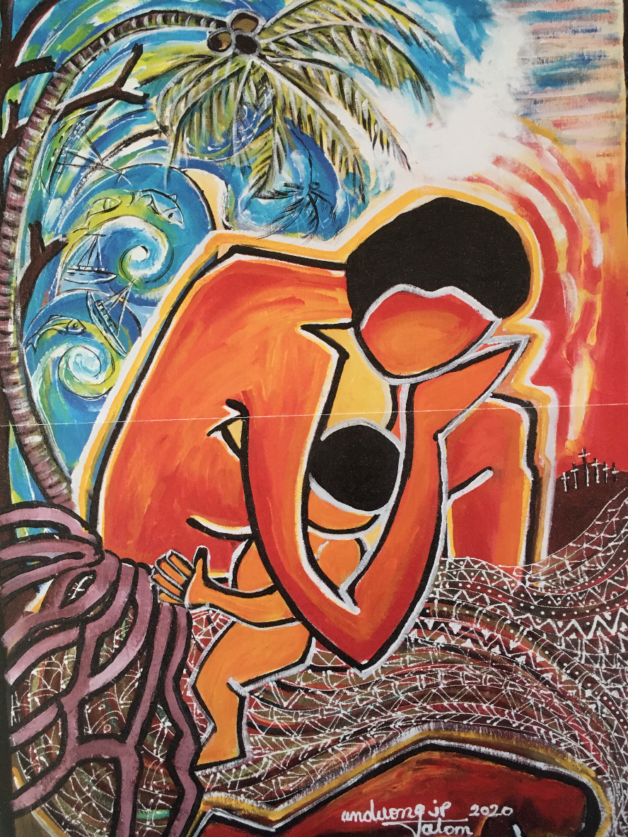

Painting by Juliette Pita, the most well known artist in Vanuatu, entitled ‘Cyclone Pam II :13th March 2015’. A mother is bending and praying over her child as the waves crash over her. The palm tree leans protectively over them, its strong roots enabling it to withstand the furious wind. The small crosses on the right horizon commemorate those who died.

Resources: ‘Together in Prayer’ and service booklet for World Day of Prayer 2021.
‘No Ordinary Stories: Meditations and worship material on The Parables’ by Nick Fawcett

For personal worship
‘We could change the world’ by Matt Redman
https://www.youtube.com/watch?v=KwpuHQlqUPM

