EASTER DAY

This short act of worship has been produced for you by Revd Kathleen Richardson. If you are well enough and able, why not spend a few moments with God, perhaps at a time when you would normally be sharing with others in church and pray for them as they pray for you.

CALL TO WORSHIP
Christ is risen!
He is risen indeed. Alleluia
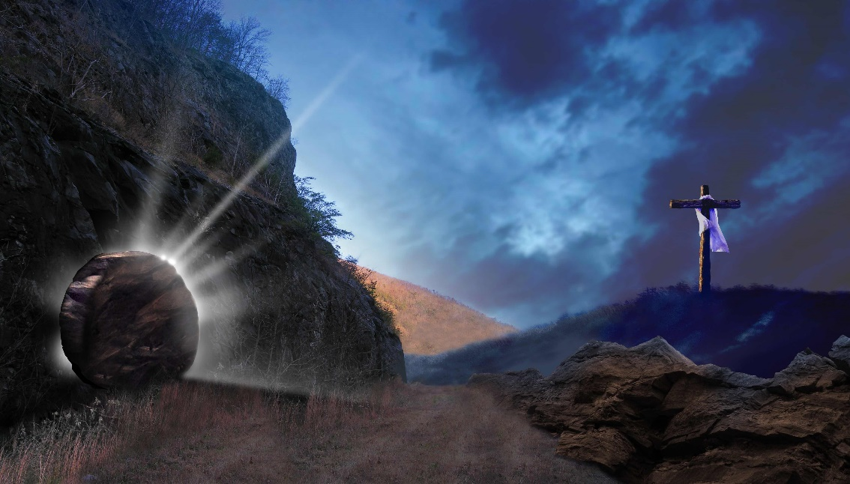
God of all creation, for the life which springs up, beyond our dreams or our deserving:
We adore you. Alleluia
God of saving power, for the love that is stronger than death and destruction:
We adore you. Alleluia
God of healing mercy, for the grace that is given to bring all things into harmony in Christ:
We praise your holy name. Alleluia

HYMN See what a morning (Singing the Faith 309)
Sing / read / pray / proclaim the words or listen to it here
https://www.youtube.com/watch?v=6xM-fpXayUg

See, what a morning, gloriously bright,
with the dawning of hope in Jerusalem;
folded the graveclothes, tomb filled with light,
as the angels announce Christ is risen!
See God’s salvation plan,
wrought in love, borne in pain, paid in sacrifice,
fulfilled in Christ, the Man,
for he lives: Christ is risen from the dead

See Mary weeping, ‘Where is he laid?’
as in sorrow she turns from the empty tomb;
hears a voice speaking, calling her name;
it’s the Master, the Lord raised to life again!
The voice that spans the years,
speaking life, stirring hope, bringing peace to us,
will sound till he appears,
for he lives: Christ is risen from the dead!

One with the Father, Ancient of Days,
through the Spirit who clothes faith with certainty;
honour and blessing, glory and praise
to the King crowned with power and authority!
And we are raised with him,
death is dead, love has won, Christ has conquered;
and we shall reign with him,
for he lives: Christ is risen from the dead!
Stuart Townend (b 1963) and Keith Getty (b 1974)

PRAYER OF ADORATION AND THANKSGIVING
Christ is risen! And our words cannot express your power and your love, and our sense of awe.
Christ is risen! You, O God, raised him from the dead, and all blessing and honour,
glory and power be yours.
For in raising Christ from death, you set us free from the power of sin and death,
and nothing can separate us from your loving purposes for all your creation.
We thank you, God, for the certainty of the apostles,
that the Lord, who had been crucified, was alive.
Thank you for all who followed them in faith,
living their lives in the conviction that life is stronger than death and that love is stronger than wickedness.

Thank you for every believer in the world today
who still witnesses to Christ alive and love triumphant.

Mighty God, we have no words that can express your power and our awe,
but with adoring hearts we affirm again:
Christ is risen! He is risen indeed! Alleluia.

PRAYER OF CONFESSION
If, in the light of this, our affirmation of faith, we have still fallen into despair,
Lord, forgive us.
If we have failed to hope in you,
Lord, forgive us.
If we have been fearful of death,
Lord, forgive us.
If we have forgotten the victory of Christ,
Lord, forgive us.

May the living God raise us from despair,
Give us victory over sin,
And set us free in Christ. Amen

THE COLLECT FOR EASTER DAY
Lord of all life and power,
Who, through the mighty resurrection of your Son,
overcame the old order of sin and death,
to make all things new in him:
grant that we, being dead to sin
and alive to you in Jesus Christ,
may reign with him in glory;
to whom with you in the unity of the Holy Spirit
be praise and honour,
glory and might,
now and in all eternity. Amen.

HYMN
Having joined in a new(ish) hymn, and since today is a day for singing, we turn to Charles Wesley to help us to sing our faith - Christ the Lord is Risen Today (Singing the Faith 298)
https://www.youtube.com/watch?v=rMwPEmUMP7U

Christ the Lord is risen today; Alleluia!
All creation joins to say: Alleluia!
Raise your joys and triumphs high; Alleluia!
Sing, you heavens; let earth reply; Alleluia!

Love’s redeeming work is done; Alleluia!
Fought the fight, the battle won; Alleluia!
Vain the stone, the watch, the seal: Alleluia!
Christ has burst the gates of hell; Alleluia!

Lives again our glorious King; Alleluia!
Where, O death, is now your sting? Alleluia!
Once he died our souls to save; Alleluia!
Where’s your victory, boasting grave? Alleluia!

Soar we now where Christ has led, Alleluia!
Following our exalted Head; Alleluia!
Made like him, like him we rise; Alleluia!
Ours the cross, the grave, the skies: Alleluia!

King of Glory! Soul of bliss! Alleluia!
Everlasting life is this, Alleluia!
You to know, your power to prove, Alleluia!
Thus to sing and thus to love: Alleluia!
Charles Wesley (1707 – 1788)

READING Mark 16:1-8

When the Sabbath was over, Mary Magdalene, and Mary the mother of James, and Salome bought spices so that they might go and anoint him. And very early on the first day of the week,

when the sun had risen, they went to the tomb.

They had been saying to one another, “Who will roll away the stone for us from the entrance to the tomb?” When they looked up, they saw that the stone, which was very large, had
already been rolled back. As they entered the tomb, they saw a young man, dressed in a white robe, sitting on the right side; and they were alarmed. But he said to them, “Do not be alarmed; you are looking for Jesus of Nazareth, who was crucified. He has been raised; he is not here. Look, there is the place they laid him. But go, tell his disciples and Peter that he is going ahead of you to Galilee; there you will see him, just as he told you.”

So they went out and fled from the tomb, for terror and amazement had seized them; and they said nothing to anyone, for they were afraid.

REFLECTION

There has been on television recently and too frequently, an irritating trailer for Jane McDonald’s programme on cruising. She starts, ‘So big you can’t get it all in the picture’, before handing over to the cameraman who does manage to get into the picture the cruise ship, and the fiord and the mountains and the sky.

Much like the gospel reading for today from Mark’s gospel. It doesn’t feel like the full picture – do we have to wait for the other gospels to be written to see what happened on Easter Day?

I can quite understand how the early scribes, copying scrolls to be read in the emerging Christian churches, felt the need to add to the manuscript of Mark – two of their attempts are printed today in our Bibles – a shorter ending of Mark, and a longer ending of Mark.

As I say, I can understand that they may have thought the ‘proper’ ending had been detached and lost, and they didn’t want its readers to be short-changed; but I think they do the gospel a disservice. I believe the way Mark stopped writing is where he intended his document to finish – after all he began by describing his gospel as, ‘The beginning of the good news of Jesus Christ, the Son of God’ – he obviously did not think that the good news ended with the disciples seeing the risen Christ. There is no ending to the good news that could be written in Mark’s lifetime, or in the lifetimes of those who saw the risen Christ.

The resurrection is not Jesus coming back to the old life for a bit longer, then leaving again. It is the disciples of Jesus coming to believe that although they witnessed his death, it was not
the end of his living presence in the world. Mark ends not with a conclusion, but an invitation. The women are told to tell the disciples and Peter what they have seen, but out of both fear and amazement they said nothing. But it was not the end of the story, for the story is not yet over – our part in it has yet to be written.
The other reading suggested for today is the account Paul gives in 1 Corinthians 15:3-10, written by a man who had not witnessed either the death or resurrection of Jesus, and had persecuted those who claimed to have done so; but who had then come to a living faith.

Paul writes:
‘I handed on to you as of first importance what I, in turn, had received; that Christ died for our sins in accordance with the scriptures, and that he was buried, and that he was raised on the third day in accordance with the scriptures, and that he appeared to Cephas, then to the twelve. Then he appeared to more than five hundred brothers and sisters at one time, most of whom are still alive, though some have died. Then he appeared to James, then to all the apostles. Last of all, as to one untimely born, he appeared also to me. For I am the least of the apostles, unfit to be called an apostle, because I persecuted the church of God. But by the grace of God, I am what I am, and his grace toward me has not been in vain.’

But let us go back to what Mark has to share with us.
Three times in Mark’s gospel he records that Jesus told the disciples of what was to come – that the Son of God would die and be raised to life; and each time it led to the disciples arguing and being confused. The first time Peter took him on
one side and rebuked him for saying such things, but Jesus called him Satan and told him to get behind him. On another occasion Jesus said he would be betrayed and killed, and they were afraid to ask what he meant. On the third time Jesus gave more details, ‘The son of man will be handed over to the chief priests and the scribes, he will be handed over to gentiles and they will mock him, spit on him and flog him and kill him – and after three days he will rise again – and this just led to a squabble among the disciples on who would sit near Jesus in his kingdom.
Then in the Garden of Gethsemane Jesus told them that after his death they would desert him, but he would be raised up and go before them into Galilee and meet them there. They protested that they would never desert him or deny him but then went to sleep.

Though there were, in Mark’s gospel, some who recognised the truth of what Jesus was saying but who would have been regarded as unreliable witnesses – demons who Jesus told to keep silent; women, one of whom, Mary, anointed Jesus and Jesus said it was for his burial; and a Roman soldier saying,

‘truly this man was God’s Son’.

After the crucifixion, the women who came early to the tomb on the third day are named as Mary Magdalen, Mary the mother of James and Salome. They were concerned about
three things – to buy spices for the embalming, to get to the tomb early, and who they could get to move the stone from the mouth of the tomb. They found the stone moved and the body no longer there. A young man in white robes told them not to be afraid and to tell his disciples and Peter that Jesus would see them in Galilee. They were afraid and amazed and said nothing to anyone. It does not seem to be the good news story that we would have liked.

But in his last chapter Mark tells us all that we, the readers, need to hear – Jesus of Nazareth was crucified, but the Son of God is risen; the tomb is empty; Jesus will go before us and will meet us in places familiar to us. The good news of the living Son of God is entrusted to us. It is up to us to continue the good news, not concluded until all his purposes have been fulfilled.

Was Paul right to say that he was the last person who had an experience of the risen Christ? Can you say differently? Have you told others about it? If not, have you not dared to tell anyone because you were afraid? Of what? - of appearing boastful? - of being ridiculed? Of your life not living up to the experience?

I think most of us could identify moments when the living presence of God became real for us, but we have found it
difficult to tell others. At least perhaps we can all say with Paul ‘by the grace of God, I am what I am, and his grace toward me has not been in vain.’

Easter Day was the traditional time for candidates to be confirmed into the church. In the Methodist Order for confirmation the minister says: (Name), at your Baptism into Christ, God offered you the gifts of his grace and has constantly been at work in your life. In this moment God offers to strengthen you by his Spirit and invites you to respond’. The response is ‘I thank God, and ask to be confirmed’.

We thank God, for being brought to this Easter Day, with its promise of life eternal and the knowledge of God’s power and love; and we ask to be confirmed again in our faith and to be ready to become another chapter of the never-ending gospel of God’s love. Thanks be to God.

PRAYERS OF INTERCESSION
Eternal God, we come on this Easter Day to the mystery of the empty tomb so that we may see and believe and go back to

our everyday lives in the confidence of renewed faith.
When hope fades, when joy is missing, when life seems to lose its purpose, be there for us, to open our eyes to your life renewed in every place of loss and death.

When sorrow and loss is too great for us,
or when the darkness of other people’s pain overwhelms us,
keep us aware of your light,
which no darkness can ever overcome.

Where people live in fear, uncertainty, threat and loneliness,
may they experience the comfort, strength and freedom of the living Christ.

May your whole Church know your power and be a sign that Christ is risen.

May the whole earth be transformed by mercy and rejoice in hope.

And may all your children receive grace and light according to their needs and come at last to share with all the saints in life eternal. AMEN

We say together the prayer that Jesus gave us:
Our Father in heaven,
hallowed be your Name,
your kingdom come,
your will be done,
on earth as in heaven.
Give us today our daily bread.
Forgive us our sins as we forgive those
who sin against us.
Save us from the time of trial and deliver us from evil.
For the kingdom, the power and the glory are yours,
now and for ever. AMEN

HYMN This joyful Eastertide (Singing the Faith 314)
Sing / read / pray / proclaim the words or listen to it here
https://www.youtube.com/watch?v=XPR_UqjCnfw

This joyful Eastertide,
what need is there for grieving?
Cast all your cares aside
and be not unbelieving:

Come, share our Easter joy
that death could not imprison,
nor any power destroy,
our Christ who is arisen!

No work for him is vain,
no faith in him mistaken,
for Easter makes it plain
his kingdom is not shaken:

Come, share our Easter joy
that death could not imprison,
nor any power destroy,
our Christ who is arisen!

Then put your trust in Christ,
in waking and in sleeping.
His grace on earth sufficed;
he’ll never quit his keeping:

Come, share our Easter joy
that death could not imprison,
nor any power destroy,
our Christ who is arisen!

Fred Pratt Green (1903-2000)

BLESSING
God the Father, by whose glory Christ was raised from the dead,
strengthen us to walk with him in his risen life;

and may almighty God bless us,
the Father, the Son and the Holy Spirit. Amen.

Go in joy and peace to love and serve the Lord.
In the name of Christ. Alleluia!

