Summer Newsletter

June-August 2021

Message from Revd Dan Haylett,
Superintendent Minister

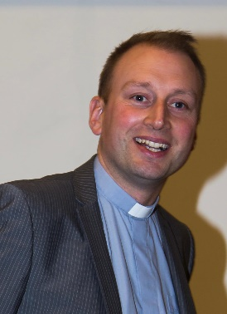
²² By contrast, the fruit of the Spirit is love, joy, peace, patience, kindness, generosity, faithfulness, ²³ gentleness, and self-control. There is no law against such things. ²⁴ And those who belong to Christ Jesus have crucified the flesh with its passions and desires. ²⁵ If we live by the Spirit, let us also be guided by the Spirit. ²⁶ Let us not become conceited, competing against one another, envying one another.
(Galatians 5:22-26 NRSV)
Dear friends,
As restrictions begin to ease in these months, it’s a time for us to think carefully about that which “there is no law against”. Understandably enough, sometimes our entire focus has been on getting back to doing and enjoying the things that we used to do that sustained us and gave life meaning. Seeing family, friends and gathering together are so important to us all, and we continue to walk the careful path of enjoying those freedoms and keeping one another safe.
St. Paul offers us a different perspective into the things we have often assumed to somehow be ours by right. There is freedom in Christ; but that freedom is hard won and it is a freedom to allow the life of God to flourish within us and to bear fruit. To bear the fruit of the Spirit is our freedom and more than that it is our calling. Maybe even more than in this last year we will now need to embody that love, joy, peace, patience, kindness, generosity, faithfulness, gentleness and self-control to and for one another in these changing times.
Part of that is the need to accept we are all in different places as we respond to the proposed changes to the restrictions on us. Some will need space and time to gain confidence again, others are desperate to enter into new patterns of life, mission and ministry. Being “guided by the Spirit” means that we are held together in unity even if we find ourselves necessarily travelling at different speeds sometimes.
Underpinning all of this is the assurance that God continues to hold and work through us wherever we find ourselves, and in all sorts of circumstances. We are often reminded of this by some special people in our midst.
One of those special people was the Revd. Reg Hancock. We have given thanks for Reg’s life and ministry following his death in April. Reg’s encouragement and faithfulness down the years across the Connexion, including here in Enfield have been so valued by many. Reg and Sylvia together shared a life that was filled with love and laughter, friendship, faith and fellowship. They were an encouragement to so many and Reg will be much missed, even as we know he finds rest and peace after his long life and ministry. We give thanks to God for Reg and entrust him into God’s eternal care.
Another very special person in our midst is Revd. Kathleen Richardson. Kathleen is planning to move home over the summer in order to be closer to the family near Brighton. This will be a significant change for Kathleen of course, as well as for us in Circuit. It seems very hard to imagine life in the Enfield Circuit without Kathleen’s vision and drive that has been coupled with her inimitable wisdom and care. She will be much missed here, and by
many more than we realise. Having lived and worked here for over 25 years, Kathleen’s ministry has left a lasting impact on people across many different communities. We will have an opportunity to say thank you and goodbye to Kathleen at a service of celebration on 4th July at 3pm at Southgate.
In the midst of these changes and adjustments, we need St. Paul’s encouragement to help us on our way, “If we live by the Spirit, let us also be guided by the Spirit.”. May God’s Spirit continue to guide, bringing the fruit of the Spirit to bear within us.
Every blessing

From Revd Dr Kathleen Richardson
Most of you will know that I am in the process of moving from the Circuit in order to live nearer to my daughter in Brighton.
I first came to the Enfield Circuit in 1995. I moved into Exeter Road when I was appointed to the Connexional Team. I had responsibility for all the external relationships of the Methodist Church – with the World Church, with ecumenical bodies and with other faiths. My husband Ian came to live in Arnold House on the Ridgeway. I am grateful to those who visited him, gave him lifts to church and to the house group and made him feel he belonged. For me, it was a very busy time with many overseas visits and conferences and apart from the occasional church service I was not greatly involved in Circuit life.
In 1997 the house had a quinquennial inspection and was declared unfit owing to a badly built extension, and the Methodist Church bought a house on Chase Side to which I moved.
In 1998 I was given a life peerage and in 1999 I was given permission to ‘sit down’ in order to fulfil a different role in the House of Lords. I had to move to Highams Park where the Methodist Ministers Housing Society could find me a home. Then in 2001 a generous member at Southgate died and left her bungalow to the Housing Society and it was offered to me.
So I then joined the Circuit in a different relationship as a Supernumerary minister, helping at Edmonton with pastoral care for a while.
When Geoff Cornell died suddenly in October 2014, I took on the pastoral care of Southgate until a minister could be appointed, and in 2016 I covered for Louise while she was on sabbatical, then took over pastoral care of Trinity for the following year. In 2018 I covered at Winchmore Hill for Julia’s sabbatical and began working on the possibility of creating the neighbourhood centre at St. John.
My time in the Circuit is the longest time I have ever lived anywhere, and I will miss the easy friendships with which you have blessed me. There have been some wonderful moments of worship and study and I am very grateful for my time here. In the past year we have found new ways of maintaining relationships at a distance and I hope to continue to hear of all the good things that are happening in the Enfield Circuit.
I offer to you my grateful thanks for all the precious things we have shared together, the pains and joys of discipleship, our hopes and fears. May God continue to bless you.
With love, Kathleen

In the coming months we have some exciting ways to develop our spiritual life and also reach out into our local community.
Let us pray
Would you like to join with others to pray?
In March a small group began to meet over zoom to pray with each other on a weekly basis at 10:30am on a Wednesday morning. It has been good to be able to meet together to pray with people from other churches.
If you would like to join us, please contact Revd Dan or I for the zoom login details.
Bible for Beginners course
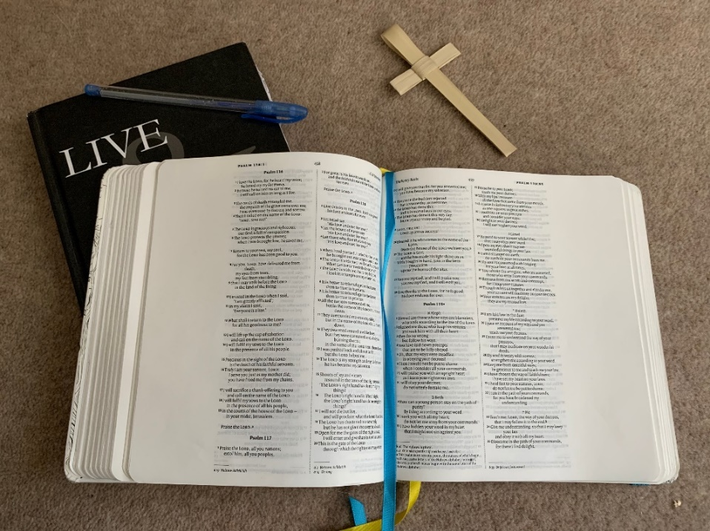

Do you feel like you don’t know much about the Bible? Would you like to find out more?
Join us on zoom on Monday 7th, 14th, 21st and 28th June at 10:30am (sessions will last approximately an hour and a half).
Looking at topics such as:
- What is the Bible anyway?
- Why do we need an “old” Testament?
- Four Gospels? Why?
- What do these letters say to us?

This course is for people who want to know the very basics of what the Bible is about.
For more information and to register contact Revd Dan or I.

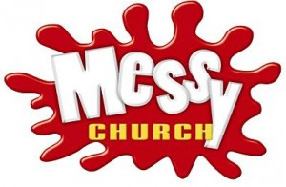
Messy Church

We are looking to start two Messy Churches within the Circuit in September at Grange Park Methodist Church and Ponders End Methodist Church. But you might be thinking what is Messy Church?
Messy Church...
- is a church that helps people encounter Jesus as Lord and Saviour.
- Is for adults and children to enjoy together. Every element aims to be relevant and accessible to all ages.
- reflects the creativity of God in its imaginative hands-on approach to being church together.
- is outward facing, welcoming everybody to enjoy the hospitality and unconditional love of God.
- is about hospitality, expressed most evidently by eating together.
- reflects a God of joy who wants his people to have life in all its fullness.
- values are about being Christ-centred, for all ages, based on creativity, hospitality and celebration.
- is primarily for people who don’t already belong to another form of church.
- is fun.

Messy Church is an all-age fresh expression of church that offers counter-cultural transformation of family life through families coming together to be, to make, to eat and to celebrate God.
Grange Park are looking to start Messy Church on Friday 17th September. We will have more information about the Ponders End Messy Church soon.
We are currently gathering teams together to develop Messy Church in both churches. If you are interested in joining the team please speak to me for Grange Park or Deacon Jacqueline for Ponders End

Prayer Walks
I am working on some prayer walks to encourage church members to walk around the local community and pray for people. Currently I am working on a prayer walk for Trinity and Grange Park and will be producing a map to follow that will start and finish at the church. Along the route will be places to stop and pray for different parts of the local community.
Joshua 1:3 says ‘I will give you every place where you set your foot.’ In faith we walk, believing that as the soles of our feet hit the ground we are stepping out in Jesus name. Prayer walking takes us out of the church building and makes us engage all of our senses and causing us to call out to God as we walk spreading hope into our communities.
As we walk we
- Worship as we have our eyes on Jesus
- Ask for God’s spirit to fall on the community
- Listen to what God is saying to us
- get to Know our community and what is going on around us.
Let us walk and pray and ask God to make our communities a blessing beyond the border of our church building.

Death Café
Grange Park are looking at starting a Death Café. You might not have come across this idea, but Death Cafés are places where people can gather to talk about death and dying – things that are universally shared across humanity. A place for people to gather together to eat cake, drink tea and talk about death. The purpose of a death café is to increase awareness of death with a view of helping people make the most of their (finite) lives.
If you want to know more about any of the exciting things that are being planned, please contact me.

Helen Lunn helen.lunn76@gmail.com or 07545571480

Communion Meals in their West African Cultural Context by Rev. Dr Valentin Dedji
(This article was first published in the Methodist Recorder,19 March 2021)
I am a British Methodist minister, originally from Benin in West Africa. West Africa is synonymous of hospitality. A generous hospitality. A tasty and spicy hospitality. An exuberant hospitality that tastes and smells food. This hospitality, not only gathers and connects members of extended families and clans, but it also aims specially at welcoming ‘the stranger’ or ‘the visitor’. A meal is perhaps the most basic and most ancient symbol of friendship, love, and unity; food and drink taken in common are signs that life is shared. Eating a meal together is the most basic way of sharing common life; it restores what has been lost and gives strength for what lies ahead. The hills and the valleys, the mountains and the glades, the rivers, the deserts, the trees, the wild flowers, the meadows and forests in my native Benin are full of special ingredients needed for daily meals.

Cooking Meals for others as a Gratifying Satisfaction

In my household, not only do we love to eat, but we also love to cook, be it fried plantain, stirred fried rice, stewed goat meat or grilled fish, shrimp, pork, and lamb chops. My wife was taught as she grew up in a family of nine that, cooking and sharing meals together, seals the family bond. In my childhood, I enjoyed watching my mother cook simple but delicious meals. I started my cooking trial at the age of 8. I haven’t stopped since. So, in my family, everyone is good at cooking. Every weekend, there is always someone on cooking rota. On special occasions such as Christmas and New Year celebrations, we endeavour at cooking together. That’s when new tastes and recipes are explored. Whenever my colleagues come to our Manse for staff meetings, there is always a kind of rivalry among my children, offering to cook for them; they truly believe that there a special blessing in cooking for others, particularly members of the clergy. Common tastes on our dining table are the spice of chilli, red or white onions, turmeric, ginger, black pepper, garlic, ‘all-purpose seasoning’, coconut milk, vegetable oil and unprocessed palm oil. There is also savoury
flavour of vegetables and greens (spinach, parsley, coriander, oregano okra, sweet potato, cassava, cocoyam, lettuce, cabbage).

Spicy and Vibrant

Growing up in our native Benin, we were used to eating fresh fruits such as coconut, breadfruit, mango, avocados, oranges, bananas,
papaya and pineapple. But these delicious fruits aren’t just reserved for savoury dishes. My wife excels in cooking egusi soup (from sesame seeds), a perfect dinnertime meal from the boiled egusi seeds, seasoned with dried shrimp, crayfish, chilli peppers and 4 maggi cubes. With an addition of boneless goat meat, it is full of
spicy and vibrant flavour from a combination of leafy greens and seafood. It’s best served with a side of pounded yam. Besides, nothing is as satisfying as sizzling chewy plantain to a thin crisp coat in light oil and biting through the lightly browned skin to find a chewy, sweet centre. In very traditional dishes such as gari (fermented cassava) and bitter leaf soup, flavours can be on the sharper side. This is the case for banku balls (a Ghanaian delicacy made with fermented corn and cassava dough), kenkey (fermented maize dumplings), and shito (a tangy shrimp condiment).

Certain foods, Nigerian tapas for example, are explicitly designed for sharing, fitting perfectly into the casual dining trend. Here, there is a strong cultural emphasis on sharing and talking about food, which bridges the gap between home cuisine and the restaurant scene.

Sharing Meals as a Symbol in ‘Vital Participation’

During the first ten years of our marriage prior to our move to the UK, my wife and I used to eat from the same dish. Among the many symbols that exist in the African universe, the act of sharing food among members of a given community is of prime importance. Communion through food takes place between those who are, or wish to be, on peaceful, friendly or brotherly / sisterly terms. Eating from the same dish or drinking from the same straw, means entering into interaction with someone else, letting their vital influences be exchanged with one’s own. Among African communities, almost all ceremonies, e.g., marriages, naming ceremonies, funerals, etc., are concluded by a ‘communal meal’ (V. Dedji, Reconstruction and Renewal, 2003, p.245).

Sharing Meals as a Symbol of Covenant

For instance, at the investiture of the Oba (King of Ketu in Benin), and at the annual renewal ceremony, the Oba has a ‘communion meal’ sent to all the chiefs, sub-chiefs and notables under his jurisdiction; to be deprived of this would be a sign that one was about to fall from power (V. Dedji, ibid).
By sharing in a final meal with his disciples, Jesus united them in a covenant relationship with himself and with one another. Sharing in the sacred meal establishes unity and communion with the one Lord. Africans think of relationship in covenantal terms as well. When two or more persons eat or drink together from the same bowl they have entered into a covenant.
In the Eucharist, we affirm our covenant with Jesus Christ and with others. Practices that exclude Christian members of other denominations from partaking in the Eucharist are a serious hindrance to establishing authentic Christian community. This description reveals that the symbol of gathered assembly, with its accompanying notions of human community, divine-human communion, and thanksgiving to God, is deeply rooted in African consciousness. African spirituality may therefore contribute toward a more communal understanding of the Eucharist in the West. The covenantal dimension of the communal meal in African culture, of which the Igbo are but one example, speaks directly to contemporary ecumenical conversations on Eucharistic sharing.

A Crucial Reminder

It reminds Christians everywhere that we share in a communal meal at the Lord’s holy table, not the table of any particular church. Crucially, I am now converted in my personal understanding that, contrary to the belief of most West African Christians, because the Last Supper was originally set in a family context, therefore children have also their rightful seats around the Communion table.

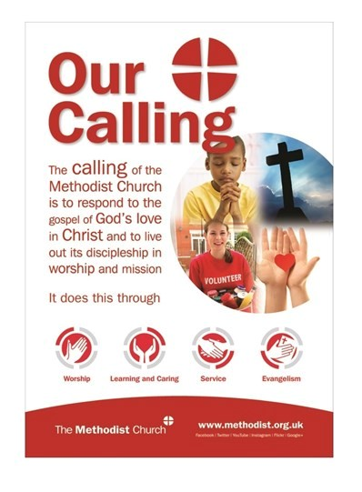
From Deacon Jacqueline Esama-John
Throughout the nine months I have been stationed here, I have been reflecting on “our calling”, categorised under the headings: Worship, Learning and Caring, Service and Evangelism - And the ways in which I have been enabled to exercise my ministry.

Worship
Over the last nine months, I have led worship in a number of different contexts ranging from special Sunday services such as Remembrance Day, All Saints, Mothering Sunday etc as well as engaging with the church’s liturgical calendar - Advent, Christmas, Lent, Easter and so on, using various platforms such as Zoom, live streaming, in person, the circuit online worship etc.
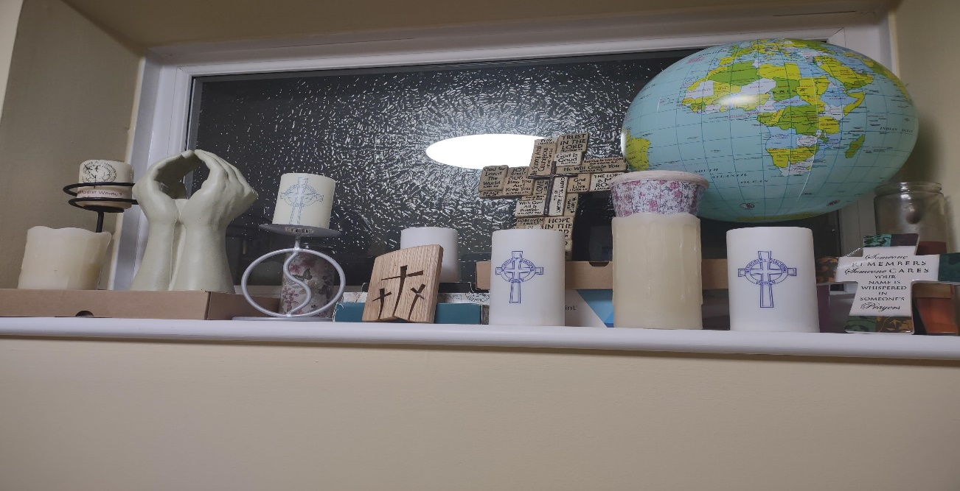
It has been lovely to have an opportunity to preach to people, to pray with them and to share in the various elements contained in an act of worship.

Learning and Caring
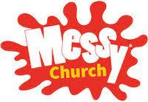
I have been really encouraged by the generosity of the circuit both financially and in terms of time and energy given to organising and supporting events and activities such as the Lent Course which I co- led, the Equality Diversity and Inclusion team which I am part of and the imminent start of a Confirmation class and Messy church which will be a good platform on which to keep building disciples.
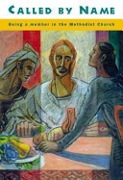

Another area where I felt that I needed to encourage deepening discipleship has been working with some of our young people at the PEMC food hub, helping them to learn more about their faith as they interact with people, to respond to the gospel of God’s love in Christ, looking at what it means to be faithful disciples not just at church but wherever we are. This has led to at least two tangible things: the production of a PEMC recipe book by Phoebe as well as encouragement of participation of our teenagers, helping them understand that this food hub is an outreach and a place where we make the church relevant to the wider community.

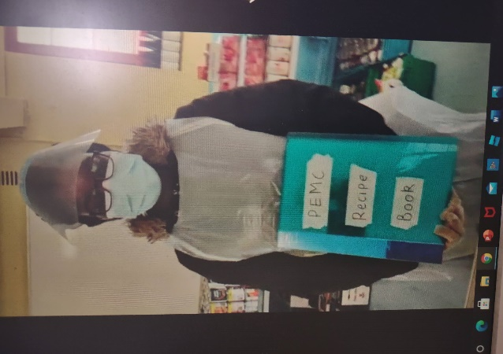

Distribution of Christmas and Easter gifts at the Space provided us with the opportunity both to reach out into the community of the Elsinge estate and to continue to build relationships with the preschool who are the main users of the St John’s church hall, even making available free use of the adjacent garden to help with their wellbeing during this pandemic.
It must be said that Kathleen’s amazing work and now retirement has left me with a huge challenge and privilege of stepping up to being the leader of the Space project. This period of transition is further enhanced by the recent announcement by architects to start the long-awaited building work soon.

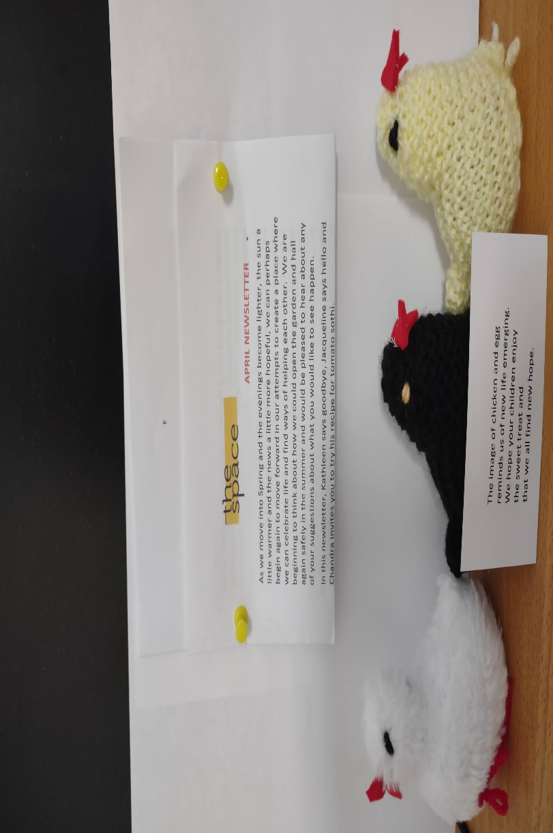

As lockdown restrictions are eased, we are beginning to welcome back other users of the hall such as the Brownies and Guides and the Lynmore singers. It has been a great opportunity to engage with them and offer ‘pastoral care’ as they deal with issues such as ‘cleaning’ or ‘parking’ disputes or the anxiety about the building project and what that would mean for them.
Again, Thanks to the generosity and commitment of Kathleen, the steering group and the Enfield circuit, a lot has been achieved both in the vision and in laying the foundation for the next steps of this project.
Service
In Matthew 20: 28 (NIV) It is written “just as the Son of Man did not come to be served but to serve……” Methodist deacons take this literally. We witness to the love of Christ through service to God and to our fellow human beings and this has been a great opportunity to extend my ministry here and to meet the needs of those whom society had sometimes forgotten.
Over the last seven (7) months, I have been working with a dedicated team of volunteers from Ponders End Methodist Church to serve that community in a practical way, putting together food parcels which also includes hygiene and sanitary products and some items of clothing.
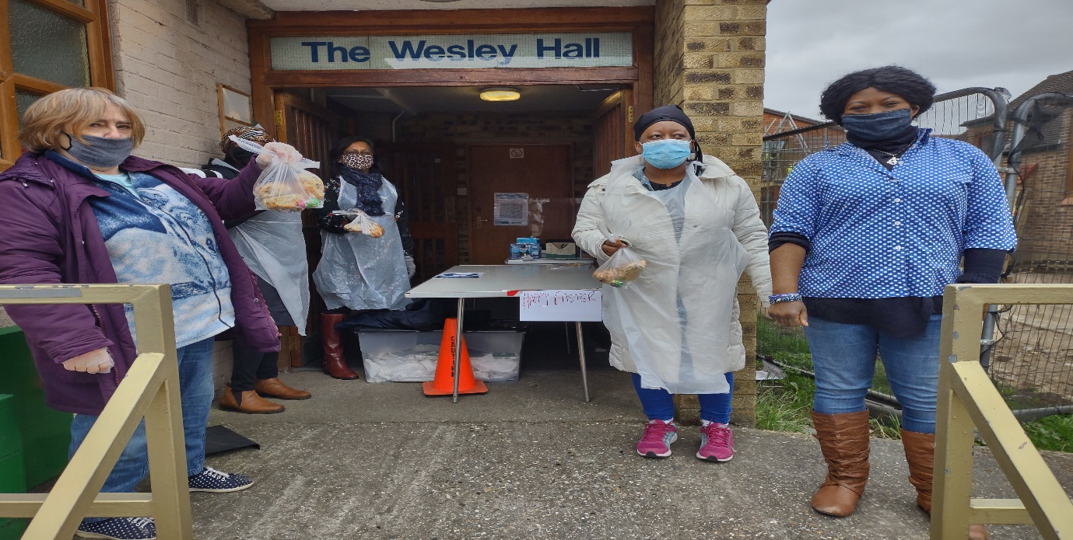
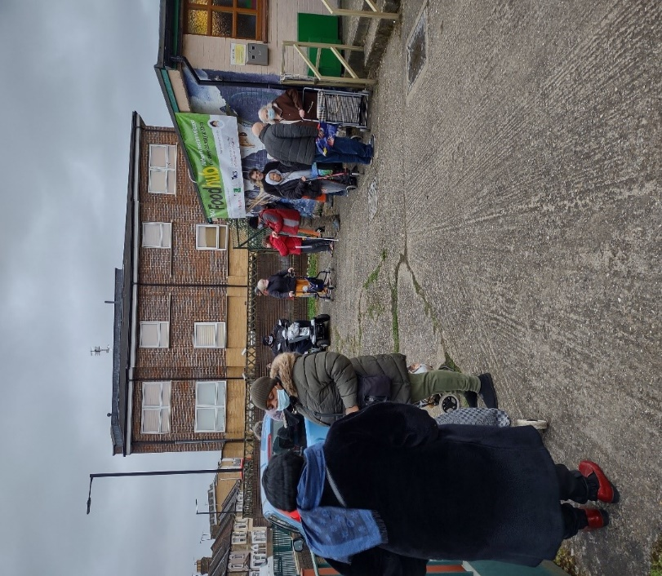
As I write, we have over 140 beneficiaries on our books and the numbers are growing weekly. A lot of people struggle to put food on the table and so this is a means by which the church responds to the gospel of God’s love in Christ reaching out to those on the margins including those who have been affected economically and financially by the pandemic. We are forming real friendships with those we serve as well as other churches in Enfield and other agencies as we form partnerships to enhance this work.
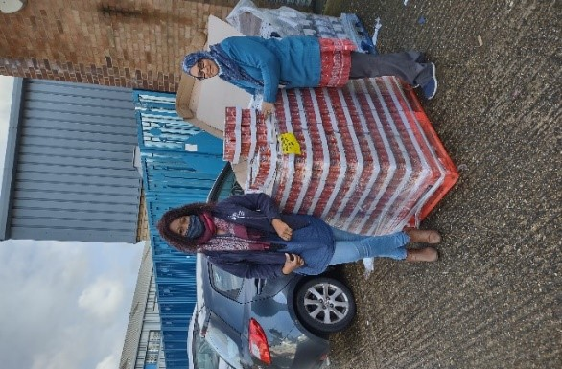
I would like to thank every individual and families from across our churches in the circuit who continue to support us both with monetary gifts and food and hygiene and sanitary products. I can assure you that our services are gratefully received, reflected from the long queues outside the hall even before we open our doors on any single day and from the feedback that we get from our guests each week.
In March, we were blessed to have the support of Enfield council who gave us a grant of £1975 to help us buy cultural foods for the diverse ethnic groups that make up our clientele. All of this is a testimony to the desperate need for serving our community. We are here, enabling people to understand what it means for a church to have a missional heart- to care, to listen, to serve and to show God's love to those in need for all sorts of reasons.
Evangelism… With a sharp focus on Evangelism and growth, by the Methodist Church, what better time than in this present age can we embrace that commission to “Go out and make disciples” … and spread the Good news of God in Jesus. (Matthew 28: 19)
It has been wonderful to reach out and share God’s love with people via telephone, email, podcasts, SMS text messages WhatsApp, Facebook, and other social media while at the same time meeting people physically. Turning up on people’s doorsteps to deliver gifts on behalf of the Space project has been a great opportunity to spread God’s love. I look forward to being able to support people further and build on this foundation.
Being present at the PEMC food hub is a great place for God’s love to be shown and an excellent opportunity to engage in conversations about faith and justice, to work in partnership with public health Enfield, distributing the Covid-19 PCR Test kits, encouraging the uptake of the vaccine and everything in-between.
APPEAL
We are looking for volunteer drivers at the PEMC food hub to help collect grocery items from a couple of venues on Monday and Friday afternoons.
For further details and if you would like to help,
Please contact Deacon Jacqueline Esama-John
Tel: 07930844989
Email: jesamajohn@yahoo.co.uk
Many thanks and God bless.

‘The pandemic changed everything’, but TLG pressed on, to stay connected to their schools and communities throughout the country.
At our monthly prayer meeting in February 2020, the Circuit TLG Team discussed upcoming events including an Early Intervention training day at Leicester, a conference in Swaffham and a meeting in a prospective partner school in Stanstead Abbotts. Well, our own Anne Pulford took her friend and recruit Maureen Freeman to the training in Leicester, and we had a successful meeting at the St. Andrew’s C of E Primary School in Stanstead Abbotts, both events taking place in early March last year. Then came lockdown and with it the cancellation of the conference and many other in- person TLG events including face-to-face mentoring.
TLG put together a package of resources and guidelines to allow coaching to continue remotely where possible. Helen Haylett magnificently completed her coaching cycle with her young person at the Chase Side Primary School. It was not possible to continue or start any others.
Janet Clipsham led the way in the latest technological ‘normal’, completing her Early Intervention coach training remotely. Prior to that Janet had also done the Emotional rollercoaster course, a free TLG online training, aimed at helping to spot and respond to signs of emotional distress in children and adults. Further recruitment of coaches had to be put on hold, meaning we could not redeem our promise to start up at the St John & St James C of E Primary School in Edmonton, for instance.
The annual TLG national conference took place online in March this year; stories were shared, of lives transformed and of hope inspired in young people and their families, as God continued to bless the work of TLG amongst communities up and down the country. However, the effects of lockdown on the general well-being of the population, including, and perhaps especially, the well-being of young people and their families, are strikingly evident! In my (pre-pandemic) report last year, I suggested that the harvest was plentiful; I leave you to imagine how much more that harvest has grown since!
Anne ‘’ can’t wait to start TLG coaching again’’ (this time at the St Andrew’s C of E Primary School in Stanstead Abbots), Christine is ready to resume, Janet is waiting to start, and Maureen feels ‘inspired and uplifted’.
May I implore you to keep the work of TLG firmly on your prayer list; furthermore, please prayerfully consider becoming an Early Intervention Coach if you can commit to an hour a week with one young person for three school terms. TLG will train and resource you; surely those whom God calls, He also qualifies and equips. Visit the TLG website, www.tlg.org.uk and/or speak to any of us or Rev Dan Haylett.
Richard Ockan Coordinator, Enfield Circuit TLG EI Centre

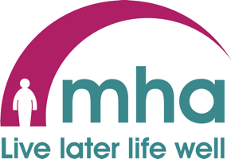

The past year has been one of change, with many challenges and restrictions transforming our life as we know it. However, here at MHA Communities North London we have used this time to pause, reflect and expand our service, offering new opportunities to help the older community of Enfield and North London live later life well.

Over the past year we have introduced and established a telephone befriending service, offering emotional support and a friendly voice to those who are feeling alone. We hope to continue this service once restrictions are lifted and look to expand this offering to include face to face befriending roles for those that are housebound or need help rebuilding their confidence for a post COVID19 life.

As we all became more tech savvy, we introduced two new zoom sessions which will become part of our core offering for those who do not yet feel comfortable or are unable to join us at our physical groups. During a time of restrictions, our members have continued to form new friendships and many look forward to meeting one another in person for the first time once it is safe to do so. Our virtual activities will also continue including an offering of; pub quizzes, craft sessions, baking tutorials and seated exercise videos which we hope you have enjoyed so far.
Here at MHA we are hoping to resume our face to face groups in July, once the Government road map is complete. We look forward to welcoming our members back to our lunch groups, coffee mornings and exercise classes and welcome new volunteers to join the scheme and be a part of our family. If you would like to be a telephone befriender or a volunteer at one of our groups please contact northlondon@mha.org.uk for more information.

As we begin to look forward to brighter times, we continue to welcome new members to our scheme. MHA is a place of fun, food and friendship and we welcome new ideas and suggestions on how we can evolve our activities and services. Please get in touch with any ideas you have and we will try our best to make them happen.
I would like to take this time to thank each of our volunteers for their dedication and hard work. They have each helped to make a difference to people’s lives during this time whether it’s been a regular friendly voice on the end of the phone, helping with shopping or joining us on a zoom, I am forever grateful to them for the time they have given to support us. We are continuously looking for new volunteers for our groups or befriending service, so if you would like to get involved, please email us!
Toni Fielding Scheme Manager, MHA Communities North London

Enfield Circuit preaching plan for June-August 2021
Please note that this is provisional and tentative - not all the dates have been agreed
 | June 6th | 13th | 20th | 27th
Circuit online | Haylett | Lunn | Richardson | Hands
Trinity 10.30am | Xxxx | Xxxx | Rose | Dakin
BHP | Xxx | Xxx | Haylett | Xxxx
Grange Park 11am | Haylett HC | Lunn | Adu | Haylett
Southgate 10.30am | Lunn | Haylett HC | Owusu | Adu
Edmonton Zoom (until July) 10.45am | V.Dedji | V.Dedji & Esama-John ACM | V.Dedji and Dakin | Davis
Edmonton 5.30pm | V. Dedji HC | Xx | V.Dedji | Xxx
Ordnance Road 11am | Esama-John | Owusu HC | Pulford | Rose
Ponders End 11am | * | * | * | *
OR and PE Zoom 11am | Dean | Adu | Esama-John | Owusu
Goffs Oak 10.15am | Owusu HC | Soulsby | Mead | Pulford

 | July 4th | 11th | 18th | 25th
Circuit online | Owusu | Dean | Haylett | V.Dedji
Trinity 10.30am | Haylett | Lunn | Hands | Soulsby
BHP | Xxx | Xxx | Lunn | Xxxx
Grange Park 11am | Esama-John | Dean | Haylett HC | Mead
Southgate 10.30am | Lunn | Haylett AFC | V.Dedji HC | Pulford
Edmonton Zoom (until July) 10.45am | V.Dedji HC | V.Dedji | Pulford | V.Dedji
Edmonton 5.30pm | Xxx | V.Dedji HC | Xxx | V.Dedji
Ordnance Road 11am | Soulsby | Owusu HC | Dakin | Haylett
Ponders End 11am | * | * | * | *
OR and PE Zoom 11am | Yeboah | Esama-John | Mead | Owusu
Goffs Oak 10.15am | Owusu HC | Adu | Owusu | Dakin

 | August 1st | 8th | 15th | 22nd | 29th
Circuit online | Lunn | Haylett | Esama-John | Haylett | Hands
Trinity 10.30am | Lunn | Haylett HC | Dean | Dakin | Owusu
BHP | Xxxx | Xxxx | Haylett HC | Xxxx | Xxxx
Grange Park 11am | Rose | Tba | Dakin | Rose | Mead
Southgate 10.30am | Soulsby | Lunn | Owusu | Haylett HC | Hands
Edmonton Zoom (until July) 10.45am | Simpe | Davis | Esama-John | V.Dedji HC | V.Dedji
Edmonton 5.30pm | L.A | Xxx | Xxx | Xxx | V.Dedji HC
Ordnance Road 11am | Esama-John | Owusu HC | Pulford | Mead | Rose
Ponders End 11am | * | * | * | * | *
OR and PE Zoom11am | Pulford | Esama-John | Rose | Owusu | Tba
Goffs Oak 10.15am | Owusu HC | Mead | Tba | Soulsby | Pulford Hol.Club

*Please note preachers for OR and PE zoom would become the preacher at Ponders End as and when Ponders decide to re-open the building. Exact date for Trinity reopening not yet known.

