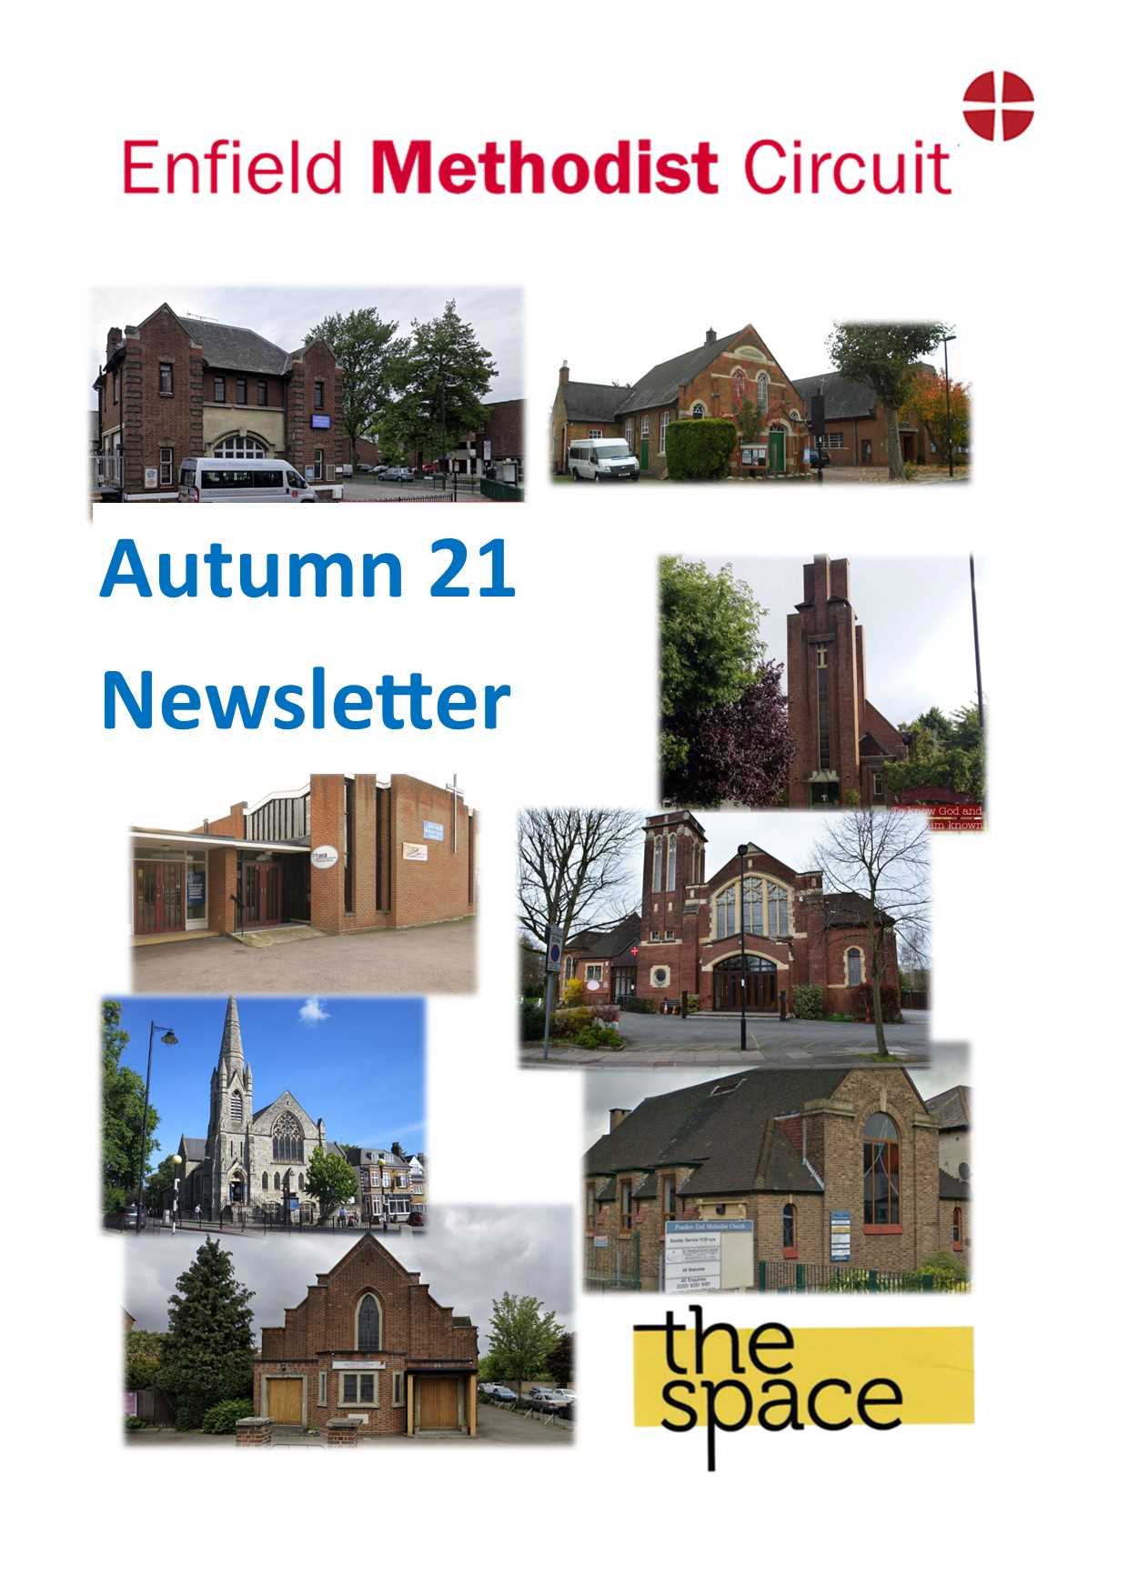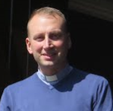**essage from Revd Dan Haylett,**

**Message from Revd Dan Haylett, Superintendent Minister**

*“Like good stewards of the manifold grace of God, serve one another with whatever gift each of you has received. Whoever speaks must do so as one speaking the very words of God; whoever serves must do so with the strength that God supplies, so that God may be glorified in all things through Jesus Christ. To him belong the glory and the power forever and ever. Amen.”* (1 Peter 4:10-11)

Dear friends,

The text of 1 Peter was written to encourage Christians who faced very real persecution and suffering. The Church were reminded then that Christ’s own suffering meant their own struggles and fears were not overlooked or ignored by God. I suppose if we were to apply this to our own context, the author shows the Church that our thinking, planning and entire lives need to be reorientated around a radical new normal.

As much as that offers a challenge to us, 1 Peter also gives some reassurance about what we might find in the new normal that is part of keeping in step with God. Far from throwing everything we know out of the window, 1 Peter encourages us with some basic home truths. In a time of suffering and profound uncertainty, what is the Church to do? 1 Peter gives some basic responses: serve with the gifts and strength that God has given you, and speak only those words God would be pleased with. It’s a basic reorientation that we can all benefit from as we enter a new season of our life together in Church and Circuit.

In this newsletter you will find several examples of how you might respond in serving with “whatever gift each of you has received”. You will also find that have been some important milestones reached over the summer, notably at Ponders End and the SPACE. There are some significant upcoming events too over this quarter: look out for the celebration of Black History Month across the Circuit as we seek to learn and celebrate more about the diversity God has gifted us with in this Circuit. By the end of the quarter, we will also be celebrating Confirmations as we work with those young people who are preparing to enter into Methodist membership.

Plenty to encourage us, and plenty to engage with. May your serving be through the strength that God gives, may your words be good news for all, and so may we all bring glory to God through Jesus Christ our Lord. Amen.

Peace



Circuit Services

Sunday 31st October 4pm at Ponders End. Concluding service of Black History Month, during which the multi-cultural and diverse heritage of our communities will be celebrated.

Sunday 28th November 4pm at Grange Park. Confirmation service.

**Reflections of the Connexional Treasurer!**

I have written here before about how the formal governing body of the Methodist Church in Great Britain, the “Methodist Conference”, comes together at the beginning of each summer to discuss our views on matters of theology, determine policy matters for the Church, and carry our various legal administrative matters. As we are a ‘conference’ we ‘confer’, we have ‘conversations’ and wherever possible we try to move forward together on a basis that is mutually agreeable to as many people as possible. Many years ago, the Methodist Church found that total agreement was not always possible and so it has long been held that we are a church that is willing and able to live together as a community of people with a broad range of views, and that that it is perfectly acceptable to disagree with someone, but still call them ‘brother’ or ‘sister’. We do that in our own families all the time. In the church we have a particular phrase that we use to describe this: we call it “**Living with contradictory convictions**”.

This idea of living together, and loving each other, but not necessarily always agreeing was especially relevant at this year’s Conference, particularly as we discussed relationships, discrimination, and justice for all within our Church.

It was difficult for us to have the usual conversations that take place around the main conference hall. Around 65 of us were gathered together physically (masked and socially distanced) in a conference centre in the West Midlands, whilst 250 others joined in online with their computers through the now familiar (to many of us) medium of “Zoom”. It was important, however, that everyone was able to contribute and engage fully whether they were in the conference centre or sitting on their bed at home. The technical team were magnificent in ensuring that this was the case.

This year’s agenda was exceptionally full as important pieces of business had been necessarily delayed from the 2020 meeting because of Covid-19. We had well over 1,000 pages of reports and other information to read and to discuss.

Important business coming to Conference this year included:

* **Changing Patterns of Ministry**: developing new ways in which the ministries of lay and ordained people within the Church may be appropriately recognised and celebrated.
* **The Theology of Safeguarding**: an in-depth examination of the basis on which we ensure that the Church is a safe place to be for everyone.
* **Strategy for Justice, Dignity and Solidarity – towards a fully inclusive Methodist Church**: a strategy that lives out our conviction that God’s love is for everyone and so aims to eradicate all forms of discrimination in the Church and allow all to participate equally.
* **Marriage and Relationships – God in Love Unites Us**: the Church’s approach to the many ways that people relate to each other in loving ways, recognising that there are diverse views, but allowing all those views to be celebrated within the life of the Church.
* **Climate Change and Fossil Fuels**: a radical response to the climate emergency that faces us, and consequently disinvesting from companies in the oil and gas sectors.
* **Transforming Lives – a Schools Educational Strategy**: establishing a 10-year approach to relating with schools that have a Methodist context.
* **Holy Communion and Online Worship**: entering into a 3-year period of reflection and development to explore how on-line life can be part of the worship life of the Church.
* **Pension Scheme Actuarial Valuations**: considering the implications of changing legal requirements and their financial impact on the Church.

You can imagine – this was a huge amount of ground to cover.

As Connexional Treasurer you may think that my role in all this was not particularly significant – and in many ways you would be absolutely right! However, all this important work has financial implications, and I had to work with Conference to prioritise our commitments making sure that we have the money to do what we really want to do.

When we look at the finances of the whole Methodist Church throughout Great Britain, we find that we are a wealthy church, however this wealth is very unevenly distributed. Some people think that much of our wealth lies in funds controlled by ‘Head Office’ in Marylebone, or by ‘Manchester’ (TMCP), but the reality is that most of the Church’s money is held in local accounts. Again, however, we know that while many churches are struggling financially, others have very significant sums in the bank.

A big issue for the whole Church at the moment is financing future pensions for our ministers and lay staff, and over the next couple of years we need to find £45million. That is a huge sum, but it might surprise you to find that it is ‘only’ about 15% of the funds that our churches hold. I therefore proposed, and Conference agreed, to ask all churches to look seriously at their reserves and give generously to a fund to support the Church’s pensions. I hope this is something that we can all think and pray about. We want our ministers and staff to have comfortable retirements.

Amongst all this other business, the real highlight was that we agreed that Rev’d Dan Haylett would become Chair of the Plymouth & Exeter District from September 2022. Congratulations Dan! Oh, and hidden in the small print somewhere, Conference also re-elected me as Connexional Treasurer for a further 2 years.

It was a busy Conference, but having done the talking, now the action begins!Revd Tim Swindell

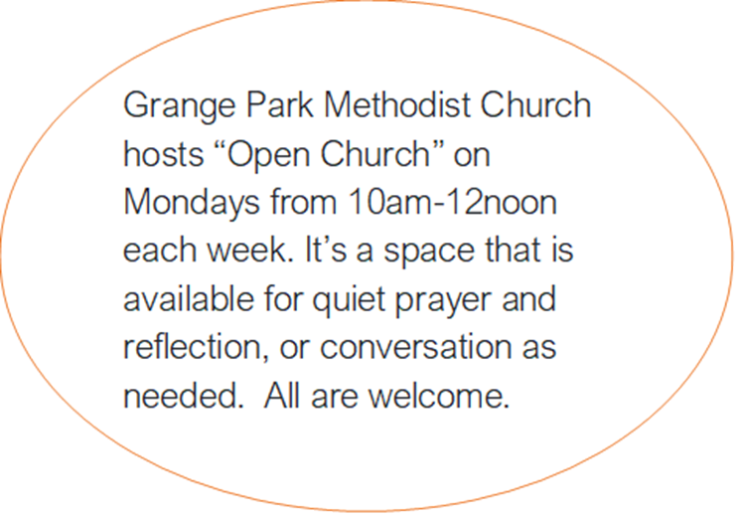

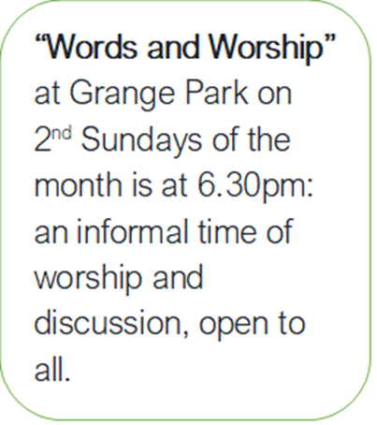

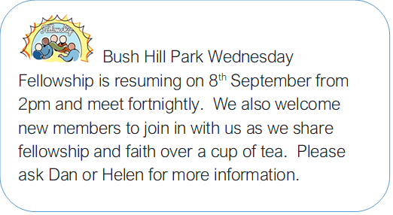

**Give me your Hand, My Friend: One Church, One Lord, One Human Race!**

**By Revd Dr Valentin Dedji**

Dear friends,

I write to you, in my capacity of the Chair of our Circuit’ steering group for ‘Equality, Diversity and Inclusion’ (E.D.I).

In his hymn ‘***What shall our greeting be?***’ the Late Methodist Minister, poet and hymn writer **Fred Pratt Green** formulates the refrain like this: ‘Give me your hand, my friend, one Church, one Lord’. The said hymn is one of Rev. Green’s most assertive texts in which, he both neatly adapts words attributed to St Paul in Ephesians 4: 4-5, and also alludes to John Wesley’s sermon called ‘A Catholic Spirit’. Wesley headed this sermon with a biblical quotation apt, among other occasions, for the Week of Prayer for Christian Unity: “Is your heart right, as my heart is with your heart?” “If it is, give me your hand.” (2Kings 10: 15).  
  
That’s the powerful and inspiring image that came to my mind, while thinking of the forthcoming activities of our Circuit’ EDI committee, planned for the month of October 2021.

***A Stimulating Webinar***

All will start on the 2nd October at 10AM with a stimulating webinar on our circuit’s Zoom and YouTube platforms. We are expecting to build on the amazing results that we achieved (both in terms of participation from all our churches and the quality of presentations) during our first event back in February this year. The general theme of the Webinar is: ‘***Belonging to Healthy Multi-Ethnic Congregations’***.

We have a lineup of world class keynote speakers for you:

* **Revd Canon Dr. Chigor Chike,** Executive Chair: Anglican Minority Ethnic Network (AMEN).
* **Rev. Dr Inderjit Bogal**, former President of the Methodist Church in Great Britain. First person from BAME background, elected as President of the Methodist Church, Great Britain (2000 – 2001).
* **Rev. Dr Steve Chalke**, Baptist Minister, founder and Chief Executive of Oasis Academy Education Trust.
* **Mrs Yogi Sutton,** originally South African Indian**.** Chair of Catholic Association for Racial Justice in the UK (CARJ)

***Engaging Educational Conversations***

In the follow up of the webinar, we expect and invite all our churches’ members of all ages to engage in fruitful conversations on what it means and what it takes to belong to a healthy multi-Ethnic congregation. This is to take place throughout the month of October 2021. Two resource study documents have been produced to facilitate those conversations:

* ‘***People like us: Strangers no more***’ (Junior Church)
* ‘***Belonging to Healthy Multi-Ethnic Congregations***’ (A six-week course for all-ages groups).

We suggest that Local Preachers, Worship Leaders and Ministers take inspiration from those study materials, especially the Bible passages set for each session, in order to continue the reflections and conversations during mid-week and Sunday services.

***Celebrating our multi-cultural heritage and Local Heroes***

The climax of our activities throughout the month of October, will be the Circuit’ closing service during, which the multi-cultural and diverse heritage of our communities will be celebrated. Above all, we’ll be invited to nominate humble members of our local churches who may not be known as VIPs, but who are inspirational in their contribution to the enhancement of mutual support and cohesion in their local communities.

To conclude, I would like to use the words of the English novelist and dramatist Gregory Lewis who wrote that: ‘***Diversity is like being invited to a party; Inclusion is being asked to dance; Belonging is dancing as no one’s watching***.’

That’s it: We have all been invited to our magnificent party set for October 2021. Let’s all come and join in. Specially, let’s feel free to dance like no one is watching…

Finding Faith

A Course That Can Lead

A Course That Can Lead To Confirmation

**For School Year 8 Upwards Who Want To Explore Their Next Step Of Faith**

Who is God, Jesus, and the Holy Spirit?

How to read the Bible?

What does it mean to pray and be part of the Church?

How do we live as Christians in today’s world and make a difference?

Saturday 6th November: 10am – 3.30pm

Saturday 13th November: 10am – 5pm **(including a trip to Wesley’s Chapel)** Saturday 20th November: 10am 3.30pm

To attend please contact Isata Jalloh – Enfield Circuit Youth Worker at enfieldyouthwork@yahoo.com 07930 255760

**Circuit Website** www.enfieldmethodistcircuit.co.uk

**Circuit Office** enfieldcircuitoffice@yahoo.com

020 8367 1338

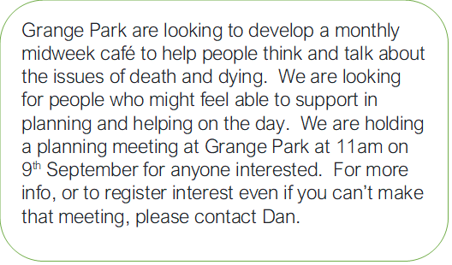



Grange Park’s Soup and Conversation starts again on 1st September, running each Wednesday from 12-2pm.  We are looking for people to come and help prepare and serve soup and also welcome any who want to come and share in soup and conversation.

**THE METHODIST CHURCH - ENFIELD CIRCUIT**

**PONDERS END METHODIST CHURCH**

**Celebration of the re-opening of the premises**

**5th September 2021**

**The re-building and renovation**

**of the premises begun at the start of September 2020**

**was completed in the last week of July 2021.**

**This coincided mostly with the long period of closure of church services due to the coronavirus epidemic**

**PONDERS END METHODIST CHURCH**

HISTORY OF THE BUILDING & ITS DEVELOPMENT

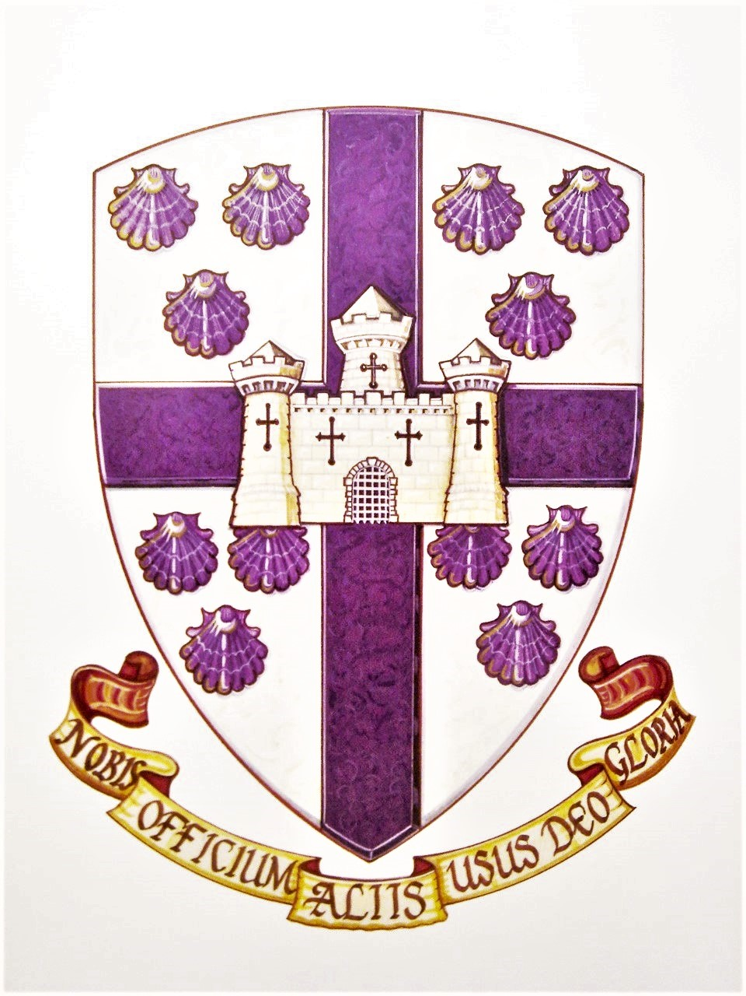

The first record of a Methodist society in Ponders End was around 1840. This was begun by John Mattinson Ferry, schoolmaster at Providence House in the High Street. Moving from Edmonton, he had not found a welcome by some in the Congregational church (now the URC) the only place of worship in Ponders End, so he opened his schoolroom to preachers of the Wesleyan Association. This was a movement which broke away from the Wesleyan Methodist Conference in 1836. A chapel was built in South Street and opened on Good Friday 1842.

In 1852, the Ferry family moved to South Australia on account of John’s poor health and by 1855 the chapel had ceased to meet. An outreach from the Tottenham circuit of the Wesleyan Methodist Church in the late 1870s resulted in the formation of a new society which built a tin chapel at the south end of Alma Road near the railway station in 1880. This chapel was sold in 1895 when the Wesleyans bought the former large brick Gothic-style Baptist chapel in South Street (built only in 1891).

The Baptists had run into severe financial difficulties due to a local recession which crippled them.relations between the Baptists and the Wesleyans, so when the problem arose, the Baptists approached the Wesleyans and asked them to buy the chapel. The Wesleyans, including a number of the former Baptist members, continued in that building until 1931, one year before Methodist Union, when they erected the present building in the High Street as a mission hall. The place where the Wesley Hall now stands was intended as the site of the chapel proper but the Second World War intervened and a public air-raid shelter was built on that site. That shelter is now the Wesley Hall.

Much has been done over the past few years to improve the fabric of our chapel and schoolrooms. The chapel was first redesigned in the 1980s in minister Peter Curry’s time. In 2010s the chapel was renovated with a new ceiling, new lighting, electrical wiring, platform and sound desk. In 2014 the large ‘Thanksgiving Window’ designed by Sarah Galloway was installed. The last improvement, in 2017, was a new floor covering and replacement of the chapel chairs.

This present re-development of the rest of the premises has been achieved through the agency of the Enfield Circuit which has underwritten the cost of the work – an extension of the rear hall, a large professional-style kitchen, a new roof with roof-lights on the former rooms 1, 2 & 3, two additional toilets, demolition of the old kitchen and the creation of a large entrance space giving eye-line view from the new lounge right through to the Thanksgiving Window at the front of the chapel. The redevelopment has opened up the interior and by this and the new roof lights allowed into the building an amazingly greater amount of light. With its large television screen, the new lounge, created from the former Rooms 1 & 2, can serve as a creche, meeting place or an overflow from the chapel. This concept of redevelopment began many years ago and sustained much delay and a number of failed schemes but has proceeded almost by stealth since 2005 with the removal of the organ and then the chapel renovation in the 2010s. We give thanks to the various ministers who, along the way, have undertaken a part in this process, encouraging and championing, not only with moral support but in some cases physical labours - namely The Revds. Mike Long, Phil Horner, Louise Morrissey, Alan Combes, Papa Owusu and others who have passed through since its long genesis. Thanks is due to our current Supt. Minister the Revd Dan Haylett and Anne Fairchild (Circuit Executive Officer) who have guided this programme along on behalf of the Enfield Circuit and to Len Ward (Property Manager) who has performed a similar function locally at the Ponders End church.

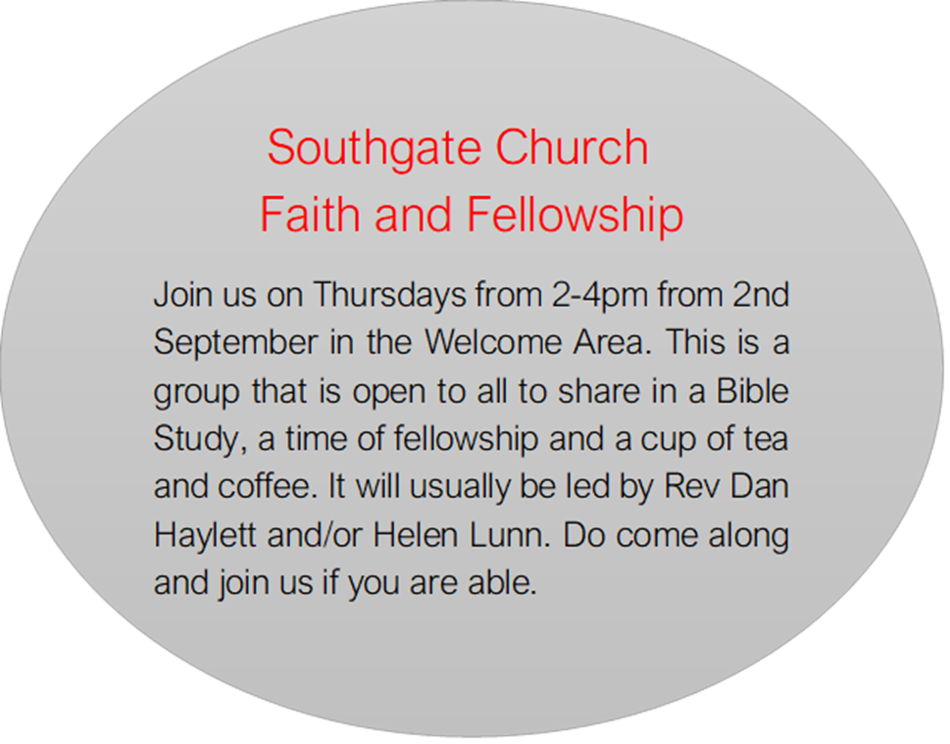

 The Space summer fete was a

great success, and it was a

 delight to see so many people came along and join us for an afternoon of fun, music, arts and crafts, games, and refreshments.

The weather forecast for Saturday 7th August was very bleak with a 90 % chance of rain, yet God graciously answered our prayers and after an initial heavy downpour of rain, out came the sunshine followed by a beautiful rainbow

Members of the Space steering committee did a great job of organising the fete and I would like to thank them as well as the members of the Space development committee who joined forces together to provide much needed support and celebrated with the Elsinge community.

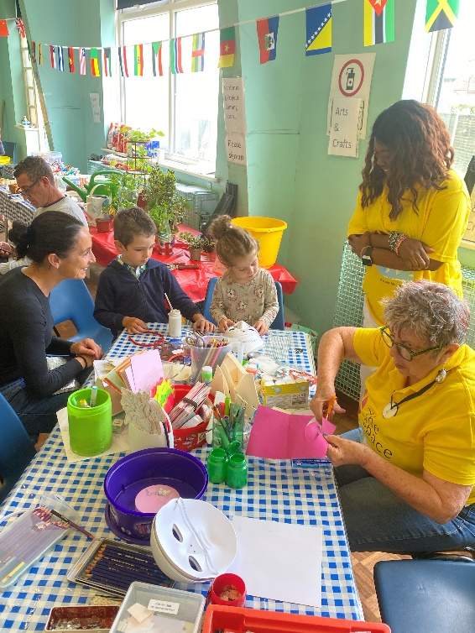Our stalls included Arts and Crafts, Gardening, Books, Cakes and Sweets, Tea and Coffee and cold soft drinks. We were blessed to have a BBQ, and served Chicken, Sausages, and Halal Burgers and corn on the cob. We also had Jollof Rice and a variety of savoury snacks. The Tombola and Raffle stalls were well visited having received a huge variety of quality donations from members of our congregations across the circuit. A massive thank you also to all those who donated the delicious cakes.

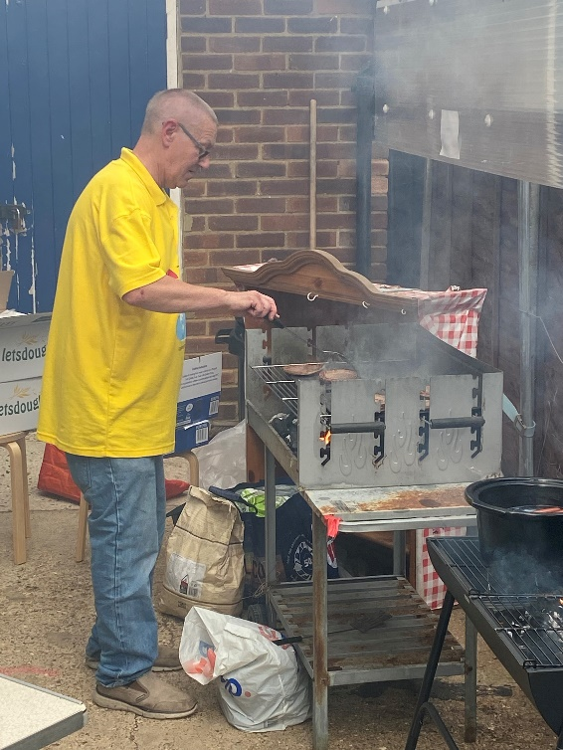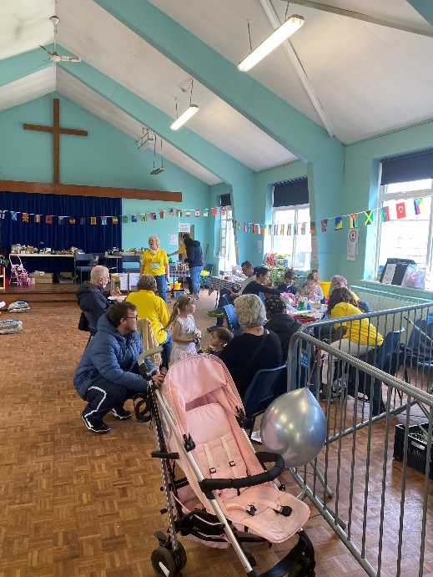

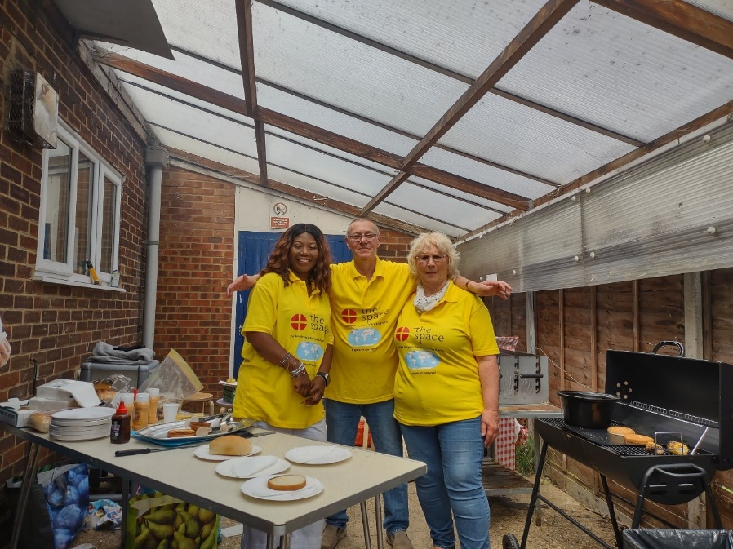

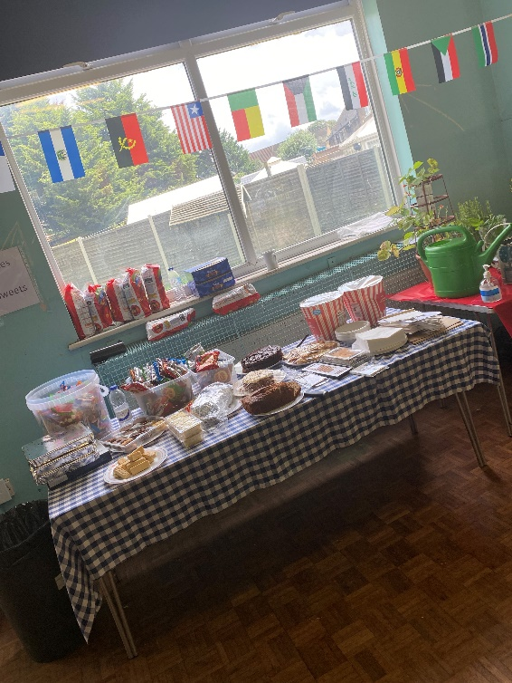

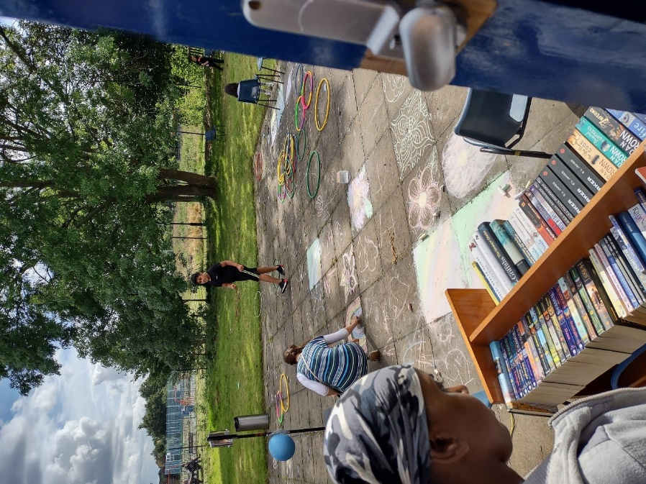

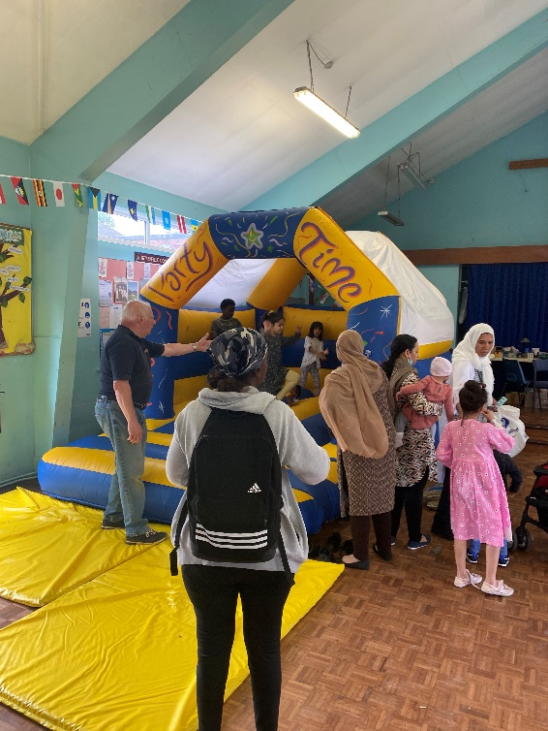

At the help and information stall, we were able to engage in conversations with people wanting to know more about the future of the Space and how they can be a part of it. We had lots of other leaflets and business cards which were very much appreciated.

We had world class music of all genres downloaded from Spotify, a giant bouncy castle, Sumo wrestling suits, Hula hoops, floor chalks, Legos, water bubbles and more.

It was great to see families coming together and enjoying themselves so much again after all the Lockdowns and social isolations. Everyone was delighted to be part of the community.

The fete was not a fund-raising event. It was about bringing the Elsinge community together and having fun. It was about saying goodbye to the present building and celebrating Kathleen’s hard work in bringing new life and opportunity to God’s people with a Space for Everyone. We felt really honoured that Kathleen was able to be there.

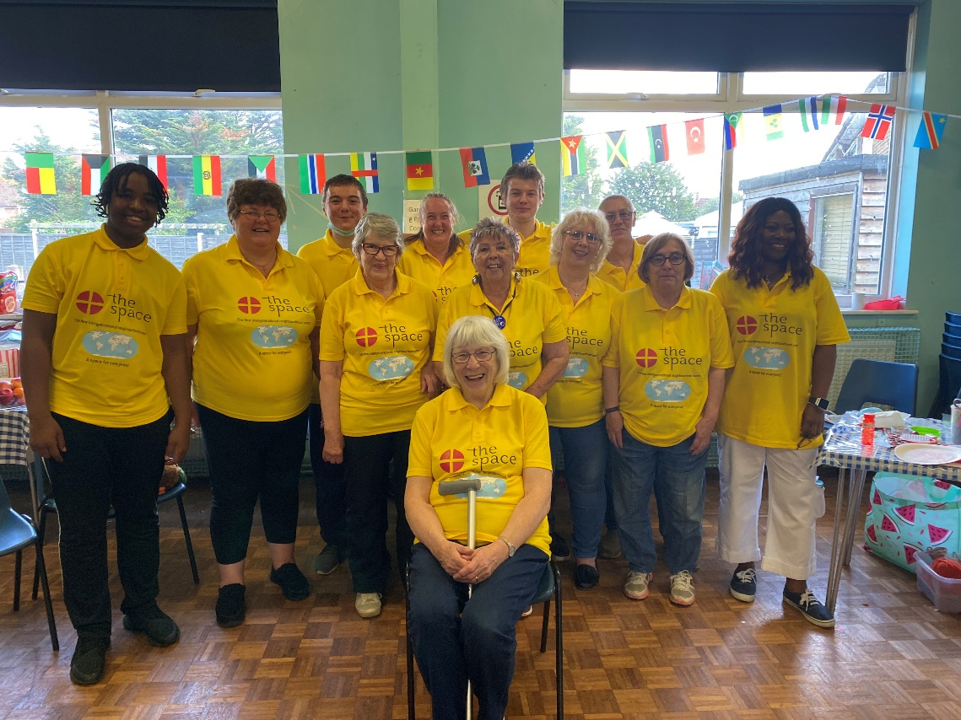

We ask for your continued prayers and support as we enter a new phase of the Space project.

Building work is scheduled to start at the end of August and I would like to take this opportunity to invite you to a short act of worship on site on Sunday 29th August 2021 at 3:00pm to mark this very important time in the history of the Enfield circuit.

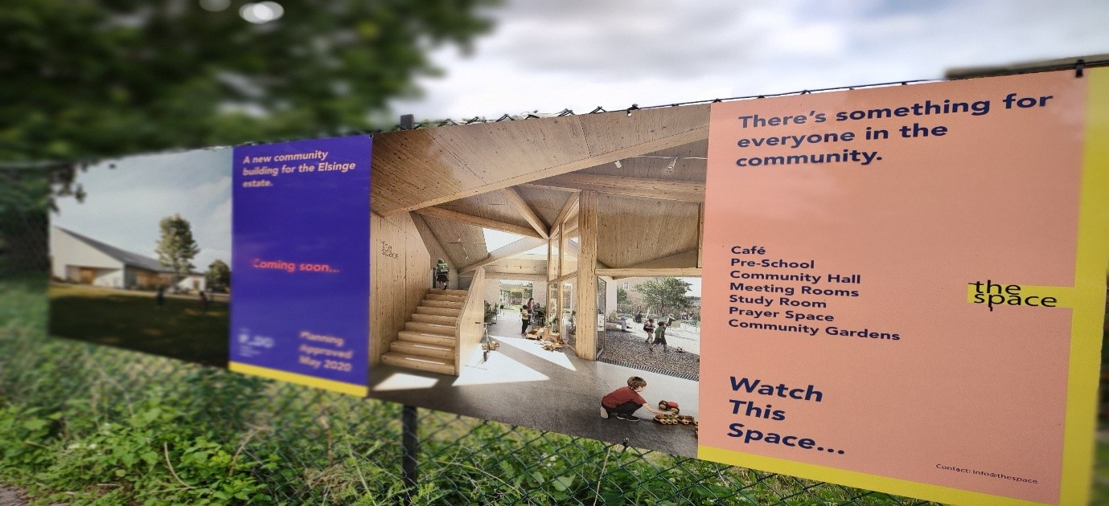Deacon Jacqueline Esama-John



Ghanaian Worship – 1st Sunday of the month from 3pm-5pm. First session at Edmonton, then Ponders End



**A weekly time of prayer in the Enfield Methodist Circuit**

“Let us pray”

Join us every Wednesday morning from the 1st September at 10.30am on Zoom for a half hour time of prayer.

Joining details: for zoom link please contact Dan or Helen.

Remember that you can join via your landline. Please contact Dan or Helen Lunn if you need further guidance or support to access this.

Each session will be a time of led prayer with an opportunity for you to offer your own prayers. In line with good pastoral practice, we ask that you share only that which you have obtained express permission to share publicly.

If you cannot attend the prayer time but would like to offer a specific prayer for yourself or for a situation that you have permission to share, please contact Dan: [revdanhaylett@hotmail.com](mailto:revdanhaylett@hotmail.com).

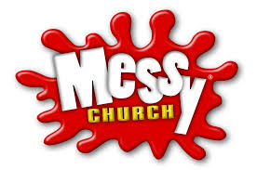

EVERYONE invited

Young & Old

*children must be accompanied by an adult*

*Messy fun*

-Arts & craft-

Refreshments

Bible Story

!Celebration!

**Launching**

Friday 17th September

Grange Park Methodist Church,

Old Park Ridings, N21 2EU

4:00 – 5:30pm

**For more information and to book a place contact Helen Lunn helen.lunn76@gmail.com**



It is excellent news to be able to report that the Circuit project to build a new community centre for the Elsinge Estate on the St John site is now entering dramatic new phase. After the excitements, but also frustrations, of over three years of planning and preparation we have reached the point of handing over to the contractors who will be starting work on the first stage of construction in September. On Saturday 7 August Deacon Jacqueline organised a very successful Summer Party for the community which was our farewell to the existing buildings. On Sunday 29 August (at 3.00pm) we will be holding a brief ceremony to mark the transition to the next phase. Kathleen Richardson, who conceived the whole project, and who inspired and led the earlier stages, will cut the first turf to prepare for the foundations of the new centre - The Space.

You are very welcome to join us for this historic occasion.



Bush Hill Park will again be hosting their monthly “Tea and Worship” service on the 1st Sunday of the month, commencing from October. We meet at 3pm for a short service and time of fellowship and followed with a cup of tea or coffee and light refreshments. All are welcome – do come along and join us.

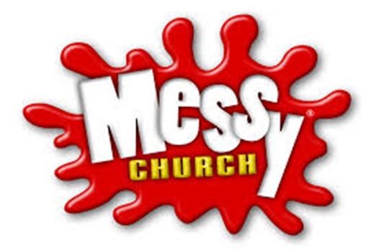**Ponders End Methodist Church (PEMC)**

**What is Messy Church?**

Messy church is a gathering for all ages, where we explore a Bible story or theme through art, craft, games, word searches, puzzles, and activities. There is a lot of creativity, and we enjoy a time of celebration together-listening, learning, singing, praying and then share a meal. Messy Church is a way of being church that has been growing over the last 10 years.

**Samples of Messy Church Activities**

Knotted String: Bringing our problems to God through Prayer



Bringing our sadness and sorrow to God through Prayer

**Bible Reference: Ephesians 2:1922**

**Build a Tower**

Can you build an Eiffel Tower from newspaper?

Can you build the Burj Khalifa from straws?

Get a picture of a real tower and see if you can build one that looks like it

**Malteser Tower**

**You will need:** Maltesers or similar; warm milk in small dishes; paper plates; wet wipes for cleaning chocolatey hands.

See how big you can build your Malteser tower by melting Maltesers with a little bit of milk and sticking them together. Yu can only have a base of three!

**Talk about:** How a bigger base would have made this easier- you could have built a pyramid and just kept adding Maltesers, couldn’t you? God’s power isn’t like Maltesers though- it’s never-ending so there are no limits to what you can do through him.

**Messy Prayer**



Dear God,  
Thank you for helping us to put on the armour love and peace and compassion.

We pray for all the children and families that come to Messy Church. We pray that you will bless them and help them to care for others. We thank you for this special time of coming together and sharing in the activities, eating together, and learning about your love for us. Help us to be good and loving and caring to each other. We pray these prayers in Jesus’ name. Amen.

**What’s happening now**

I am in the process of finalising arrangements for the commencement of Messy Church at PEMC.

Letters have been sent to a couple of schools in the area for community engagement. In September, leaflets and other adverts will be available to further promote this initiative. The hope is to build an intergenerational community…

We have a huge consignment of arts and crafts material donated to us by our lovely CEO, Anne Fairchild’s mum and we are very grateful for this! However, we will still value your donations of money or grocery items etc to support this project as we will be preparing and serving meals. Please contact the circuit office if you would like to donate.

**Volunteers wanted!**

Do you enjoy doing arts and crafts? Do you enjoy talking to families, or good at telling stories, or enjoy singing or dancing? One of the key values in Messy Church is that it is intergenerational. Everyone is encouraged and equipped and empowered to use their God given gifts and skills. Please contact Deacon Jacqueline on 07930844989.

**ENFIELD CIRCUIT GHANAIAN WORSHIP**

The Enfield Circuit is starting a Ghanaian Community worship as part of its commitment to diversity in worship. This service is to enable the Ghanaian community within the circuit to worship in the traditional Ghanaian style which includes Singing, Drumming, and Dancing. Members of this community will be encouraged to participate fully in all aspect their local churches with this traditional worship as an add-on.

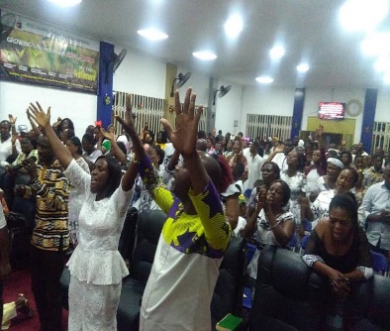This Circuit’s vision forms part of the bigger Connexional vision regarding language Fellowships which diverse features and worshipping practices are being encouraged. The Circuit Ghanaian worship will create and maintain cultural awareness to strengthen the cultural values among the community and by and large affect the bigger Christian community.

It is community that also values the importance of Prayer – both private and communal... It is open to anyone who loves Praying, Singing, Drumming and Dancing. The first service is on **Sunday, 5th September, from 3pm to 5pm at Edmonton Methodist Church.**

You're specially invited to this maiden worship. Be there as we worship the Lord unlimitedly. Come and experience the power of worship and praises. Spread the news. Tell a friend to tell a friend to be there!!

**Worship opportunities across the Circuit**

As well as the usual Sunday services, why not try some of these different opportunities for prayer, worship and fellowship across the Circuit?

Ghanaian Worship – 1st Sunday of each month 3pm- 5pm. First session at Edmonton, then at Ponders End

“Words & Worship” at Grange Park on the 2nd Sunday of each month at 6.30pm



Tea service at Bush Hill Park on the1st Sunday of each month at 3pm



“Open Church” at Grange Park Mondays 10am-12 noon for quiet prayer, reflection and conversation

Let Us Pray every Wednesday 10.30am via zoom



 Soup and conversation at Grange Park every

Wednesday 12noon-2pm

 Bush Hill Park Wednesday Fellowship fortnightly from

8th September at 2pm



Faith and Fellowship at Southgate Thursdays 2pm-4pm. Bible Study, Fellowship and Tea