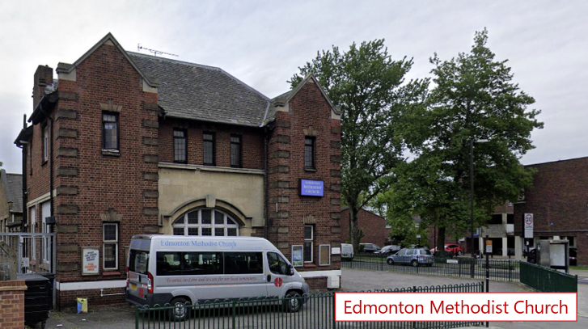
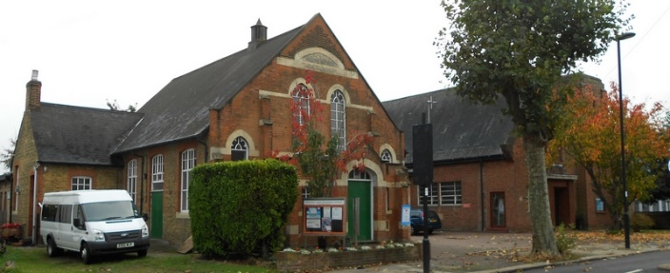
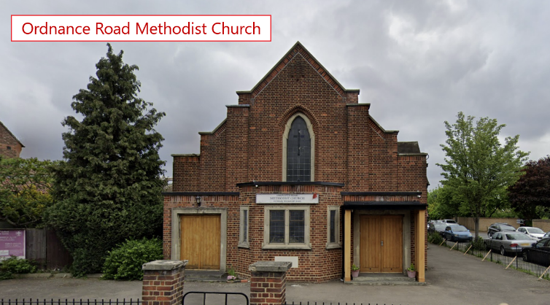
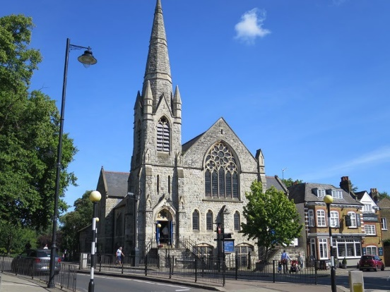
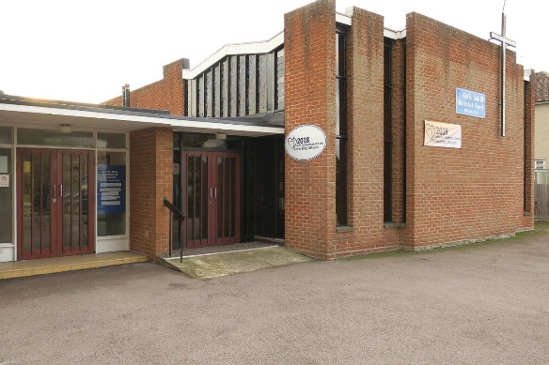
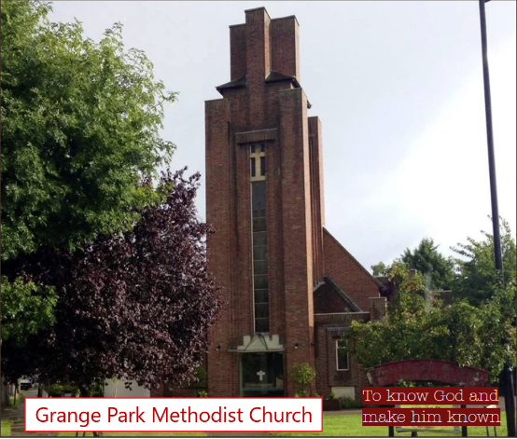
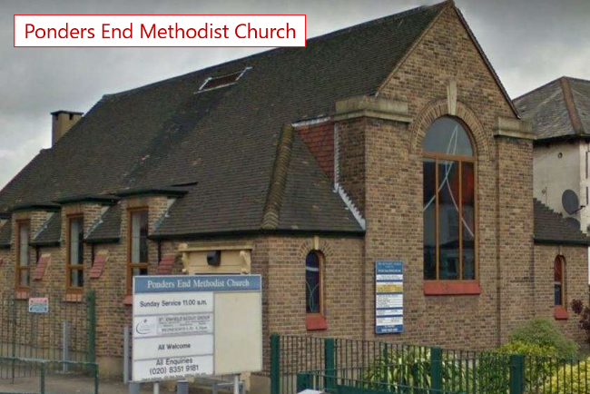
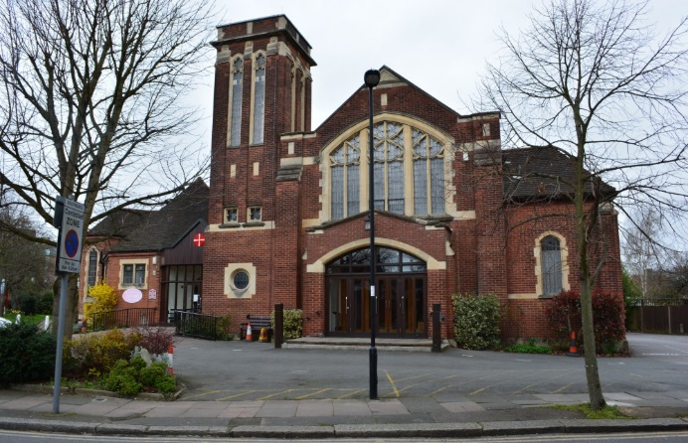

Winter 21/22 Newsletter

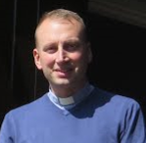
Message from Revd Dan Haylett, Superintendent Minister

Dear friends,
Near the end of Paul’s letter to the Church in Rome, he offers this prayer of blessing:
“May the God of hope fill you with all joy and peace in believing, so that you may abound in hope by the power of the Holy Spirit.” (Romans 15:13)
In Advent we open ourselves again to the potential and possibility of hope. Hope for ourselves and the Church; hope for our neighbourhoods and communities; hope for this and every nation. It is a crucial moment for us to receive from God the hope, imagination and courage we need to live faithfully today.
We may well feel our hope has taken a battering in these last years, and if so, Paul’s prayer takes on even more significance for us. It is not that he prays that we might have enough hope to get by, like having just enough petrol in the tank to cope with the queues and panic of last month! It is rather that we may “abound in hope”; where the power of God’s Spirit renews and inspires our hope.
Perhaps more than ever we are invited to recall in whom we are asked to base our trust. Christ comes to this world in our need and when we find ourselves without any other source of hope, and in Advent we celebrate that Coming, and anticipate the fulfilment of our Christian hope. It’s a time for filling: as God’s hope fills us “with all joy and peace in believing”. It’s a time for sharing that hope in its abundance.
In these days, may you find your hope in Christ renewed and restored, finding courage to live out of God’s abundance.

Peace

STOP PRESS!!
As you will be aware, we have been in the Stationing process seeking a Presbyter to join our Circuit as Superintendent in September 2022. We were very glad to have been matched with Revd Paul Weary, and following a successful visit to the Circuit with his wife Mary Ann, the Circuit Invitation Committee were pleased to offer Paul an invitation. Paul has accepted our invitation, and I invite you to hold Paul, Mary Ann and the whole family in your prayers as they prepare to move next year to join us in the Enfield Circuit. Thank you to all who have been involved in this process and for all your support and prayers.

Reflection on Black History Month material written by Nancy Hands
The aim of the course we have been following in the Enfield Circuit for Black History month, has been to stimulate and encourage conversation within and around our churches, on a subject that has been historically absent from discussion: how to become healthy and fully integrated multi-ethnic congregations. We are indebted to Rev Valentin for creating this resource for both adults and young people.

Ethnicity is something most white people in the western world never have to think about. Being white isn’t seen as “an issue”.
In Greater London, we live alongside and among people of all colour, but accepting that as normal, having friends and colleagues different to us, being comfortable with a racial mix, is not the same as learning about and understanding the degree of injustice, inequality and prejudice that people of colour encounter daily. It is not the same as learning about and understanding generations of hurt and belittling treatment, of individual potential stifled and opportunities blocked; of being picked on and suspected of crime; of growing up feeling defensive; of being constantly undervalued, with limited possibilities. It is not the same as affirming and positively valuing people’s culture, background and ethnicity. We have been prompted to think - of prejudice in all its forms, here and around the world, and of our own unconscious bias.

Our course has highlighted how God intends and treasures difference and diversity; how the roots of the Israelites were mixed from the beginning, how we are all members of only one race under heaven: the human race. Our congregations and group members have responded to the material with interest, acknowledging how much we are ignorant of, and how much this course was needed; of how white people are born with privilege they are largely unaware of. There has been enthusiasm in discussion, with participants feeling enlightened by the thought- provoking material and questions. It has been good to think about and recognise the influences that have shaped us, and listen to others’; to beware of making assumptions about those different to us, and to want to belong to churches where everyone feels at home and equally valued, where talents are nurtured, welcomed and benefitted from. We need to learn from Jesus, who sought out and befriended those who others shunned, whose Good News is the antithesis of Empire.

The message has been simple really: friends of Jesus are recognised by their love for one another. This month is just the first step in a mission to be catalysts for breaking down barriers, challenging unfairness and prejudice, and ensuring that all we do in our churches and communities reflects the love and grace of Christ.

Acorns of hope at Goffs Oak
With all the exciting things happening around the Circuit – Edmonton redevelopment, The Space and Ponders End, it’s perhaps easy to overlook Goffs Oak on the northern edge of the Circuit. We are one of the oldest churches in the Circuit, fast approaching our 153rd anniversary. Yet we’d like to believe that we are keeping up with the times!
Like the rest of the Circuit Churches, we were closed for half of 2020, with some restricted services in the summer and autumn. We were however allowed to remain open for our addiction recovery group, it has been heartening to hear of lives transformed.
During the summer of 2020, the roof over our sanctuary was replaced with the help of a grant from the Circuit. Then, thanks to loans from church members, the hall roof was also replaced. A series of quiz evenings (on Zoom) and generous donations means that two thirds of the loans have already been repaid and we will complete repayment during 21-22.
We were open for Christmas, but as the virus ran rampant through Broxbourne, this was mainly for those who couldn’t watch online. However, as vaccine doses were received, folk have returned to face-to-face worship. We were undaunted by the lack of singing, the need to wear masks and the distance between our chairs, and over time have adapted to a new normal. We continue to live-stream our services on YouTube.
Our fellowship has continued to progress. We’ve welcomed new faces, have fellowship time after the service, and have restarted coffee and chat time on a Wednesday morning with a view to making it a good opportunity for folk to come and enjoy light refreshments and some company.
Our Tuesday Prayers on Zoom has continued to meet faithfully, and those prayers are being answered. In July, as many churches were still tentatively reopening, we welcomed new families and restarted our Sunday Club. Our Holiday Club went ahead as planned in August and we had over 30 children through our doors. Sunday Club continues to grow and has outgrown its home in a meeting room, moving into the main hall instead. We’ve grown from hardly any children to a third of the congregation being under 10!
Our renewed determination is evident – with plans for new ways to worship and new ways to reach out to the community. So, we thank God for these Acorns of hope. Pray for us as we continue our shared journey together.

Joanne Mead
TLG News
Life under lockdown was stressful and difficult for many, children and adults alike; many children and young people have emerging from lockdown in confusion and anxiety over how to re-set. Many TLG coaches had to deal with such difficulties themselves, and yet they were ever so eager to return to in-person coaching in schools up and down the country; newly trained coaches couldn’t wait to translate their training into action.
At the start of the new academic year our two coaches in St. Andrews C of E Primary School in Stanstead Abbotts resumed working with their three coached children; and here is some of what they say. ‘‘I am really enjoying coaching my two students and both have completed one ‘make time’ project*… So lots of moulding and creative chat. Please keep these lovely boys in your prayers. The staff have seen some really positive results already; what an amazing God we have! ‘’
‘A delightful little boy who is bright, polite but very sad. I was very worried about taking on the work… However, my work with him has been very successful for us both… So, this rather symbiotic relationship has been good for me too, although this little boy has no idea about that, of course!...So, I thank God that the timing was so perfect for my agreeing to be a Governor, meeting Anne and becoming involved with TLG’
The school says ‘…the mentoring work is absolutely wonderful, and making a real difference for those children’.

Just before the end of the Summer Term, we visited Chase Side Primary School to make arrangements to re-start coaching there; Janet and I were received with very wide-open arms, such was the impact of TLG work there in the not too distant past! However, an
unforeseen delay in the processing of paperwork has held off our resumption of coaching in the school. We pray that this gets resolved soon, as our coaches and the school, are ready for the program to restart.
At our Circuit Service at the end of October, to celebrate Black History Month, I was given an award with regards to work with children and young people; I am extremely proud to dedicate this award to all TLG coaches in the Circuit, both serving and retired: Isata, Helen, Anne, Christine, Maureen and Janet.
May I renew my plea to you all, to continue praying for us coaches, our schools, the children and families we journey alongside; also, prayerfully consider volunteering to become a coach. ‘Like good stewards of the manifold grace of God, serve one another with whatever gift each of you has received’ (1 Peter 4:10)
Visit the TLG website, www.tlg.org.uk and/or speak to any of us or to your Minister.
Richard Ockan, Coordinator, Enfield Circuit TLG EI Centre
*These are projects recommended and well-resourced by TLG

This will be the last newsletter and plan produced by Hilary for the Circuit, as she prepares to take a well-earned rest in retirement. We are so grateful for the way she has worked to connect our churches and Circuit together, especially during the difficult last years through COVID19. We are going to miss her in so many ways in the Circuit Office, and we will be finding a way to mark her retirement well. Thank you, Hilary, for all you have done and our prayers are with you as you plan for the future in true retirement!

The Space building project
Vroom Vroom! Building works ……At Last!
I am delighted to report that the Space building works project has started and Philliam, the building contractor company are doing a fantastic job……. 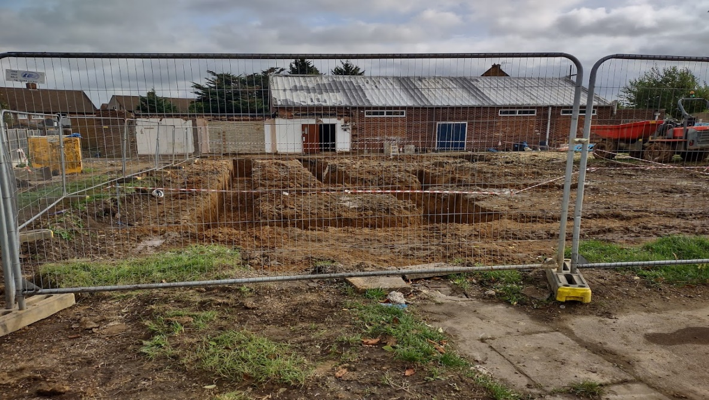
Work got underway on Monday 6th September 2021 for the demolition of the St John Methodist Church site and erection of a two-storey community building. The gates are wide open, the trucks are in and the sign says “Construction site Keep out”
Excavations are being done, pulling down walls, concrete and glass. What a sight to see concrete and steel turn to rubble.
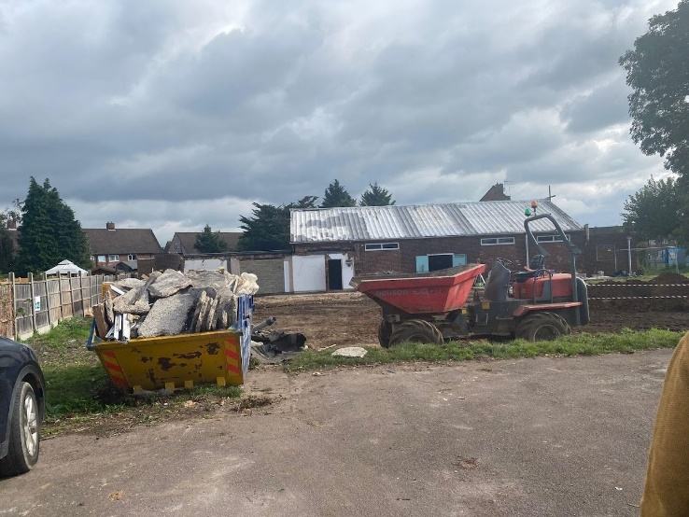
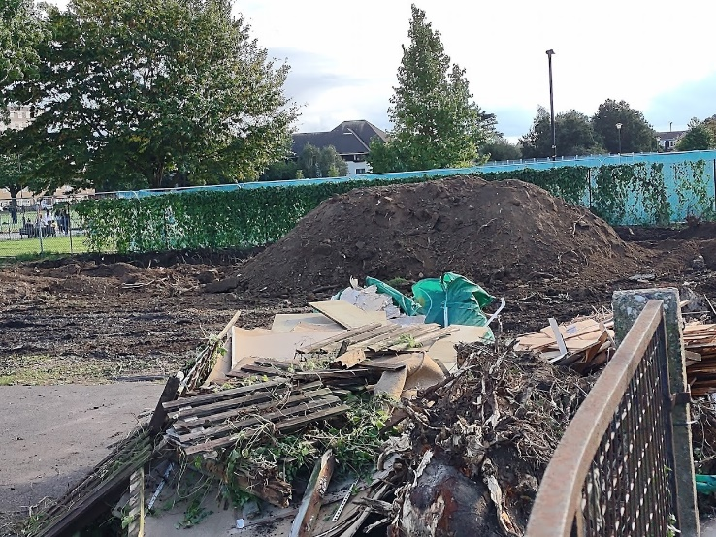
There is the dump truck on site and builders working hard hauling huge

loads from the yard, sorting out concrete, wood, and metal so that nothing good will get thrown out and they will be recycled and reused.
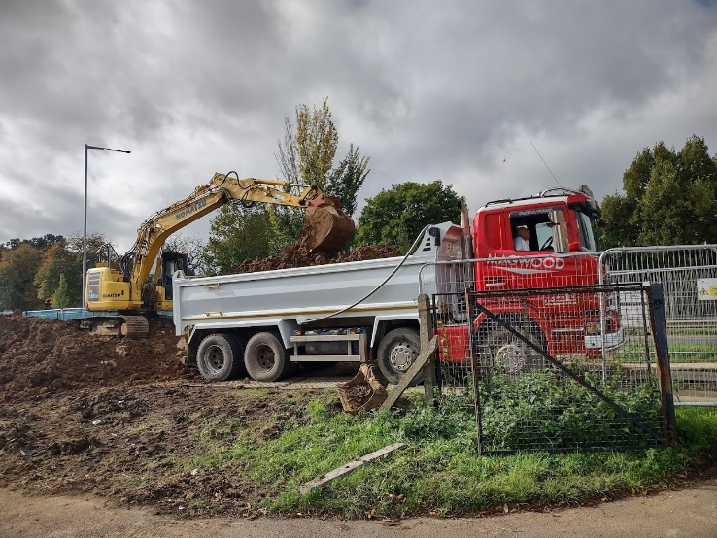
It is mesmerizing to see the digger going back and forth, the dust cloud rising, lifting up giant chunks of rubbles and then smashing them back into the ground until everything is completely bashed to pieces.
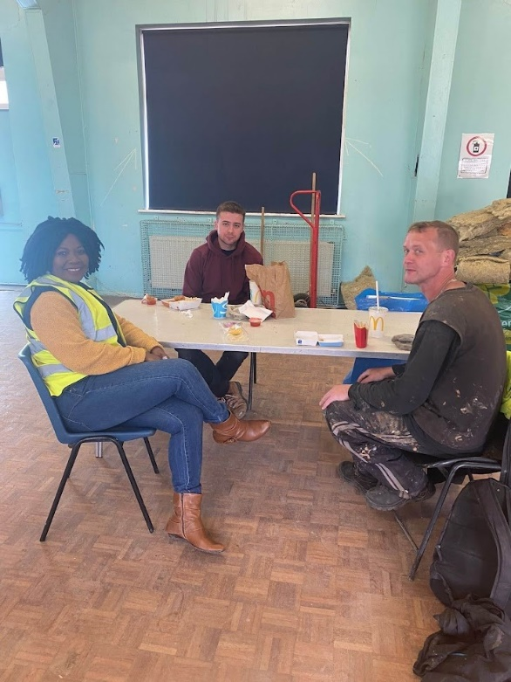
I am blessed to join the crew at various points, whether it’s getting an update of their work or bringing them Chocolate and water. It has been an opportunity to engage with the community who have been forced to pause, out of sheer curiosity to ask questions and to know what is going on.
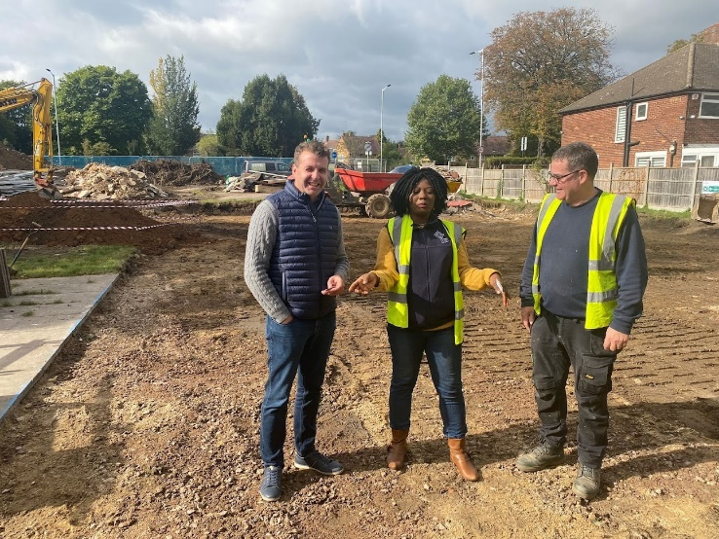
Our site manager Danny is fantastic and together with one of the contractors Fin, have been very proactive in helping me understand the language of the building world, talking me through the options we have for brick panels for example, that will match the colour of the mortar and the tones of the brick. Interesting stuff indeed.
They are working hard to clear the space so that something new can take its place. So much for now. Tomorrow there will be more work to do. I have been holding them in prayer- I ask you to pray for them too and for our circuit- That the building works will be completed and that the Space will be a place of promise and hope for this community.
Please look out for information about Prayer walks and other activies at the Space, in your churches notice sheets in the new year. Many thanks. Deacon Jacqueline Esama-John

The Space Christmas Share
Have you heard the phrase “Christmas is for sharing”?
Well at the Space, we are going to do just that!
On 10th December at 2:30 PM, we will be sharing greetings, treats, gifts and Christmas carols on the Green, outside Kempe Hall on the Elsinge Estate.
It will be the perfect space to welcome, meet and share conversations.
Why not join us and together let’s make a difference! We value your continued support and prayers, and we are asking for donations of any unused gifts, treats, toys, toiletries etc which will help us to bring some Christmas joy to those experiencing poverty and marginalisation.
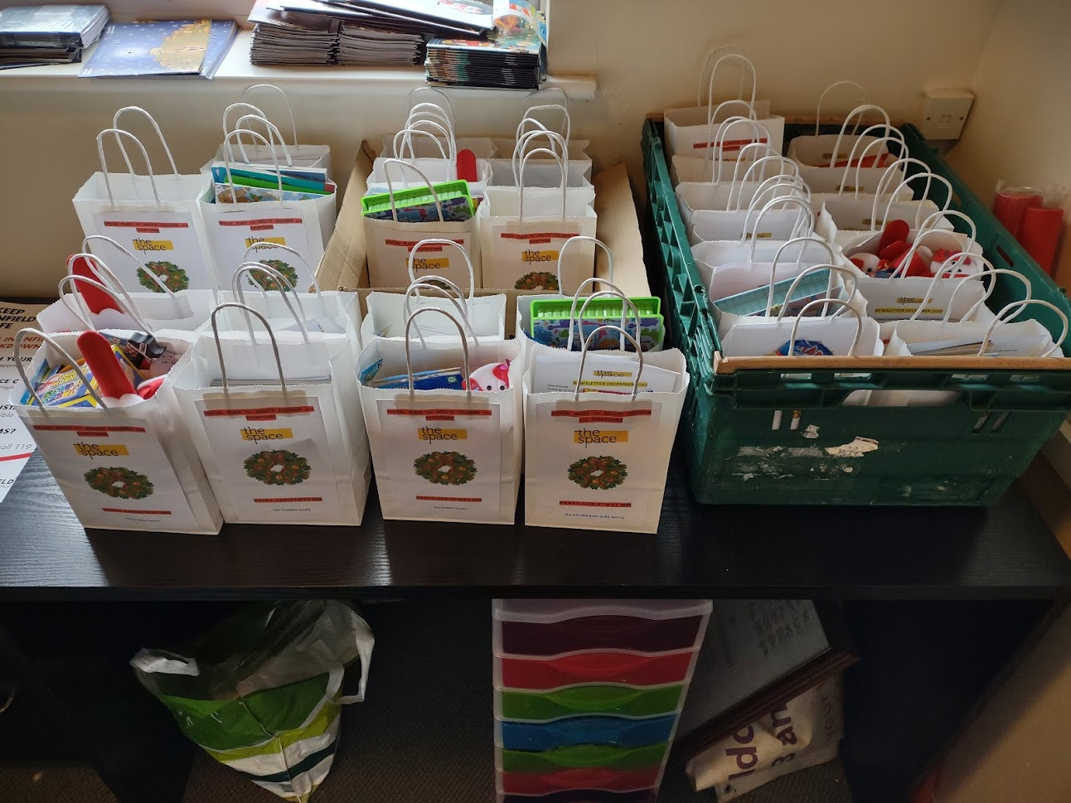
Please contact Deacon Jacqueline or Circuit office if you would like to donate

Trinity Prayer Wall
At the end of May Trinity turned the fence around the church into a prayer fence to encourage people within the community to pray. We put a bag of ribbons on the fence with a poster that said ‘we are inviting everyone to come and tie a ribbon on our prayer fence. Simply let the act of tying it on be your prayer in this moment.’
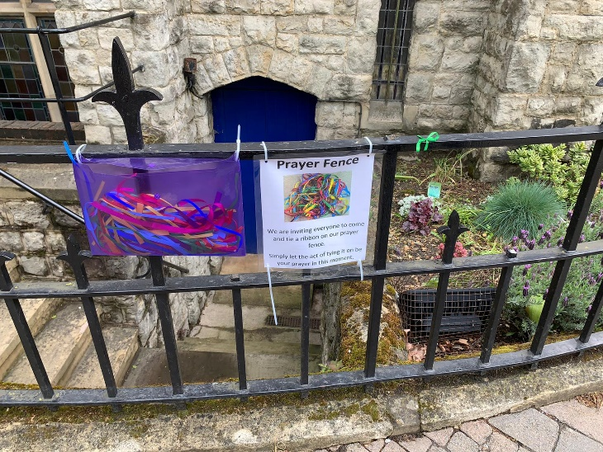
We didn’t know if people would want to participate but within four days of the prayer fence being up the bag of ribbons had run out. I don’t know how many times we filled the ribbons up but each time we had to replace them as people continued to pray. During this time lots of conversations were had with people in the community thanking us for giving them an opportunity to pray.
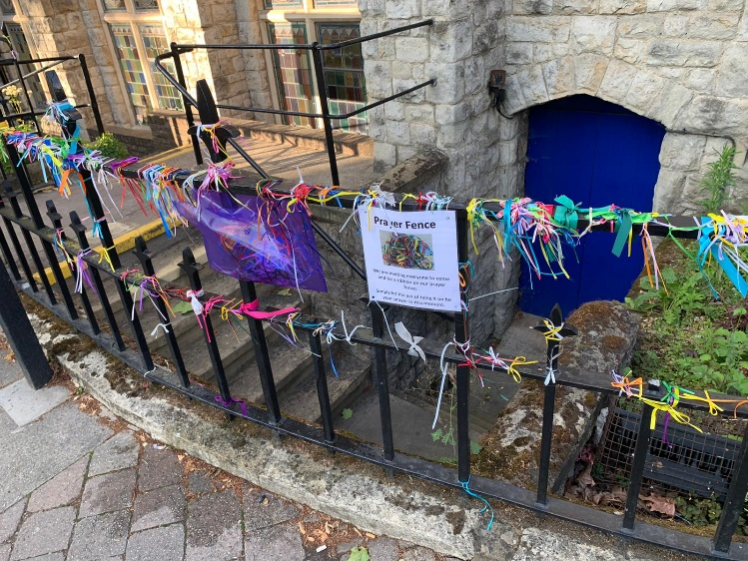
At the end of August we took the prayer ribbons down and we are going to turn all of the ribbons into a piece of art so that people will know that the prayers haven’t just been thrown away. When we had taken them down someone who had used the prayer wall donated a box of chocolates and a card to thank us for giving them the opportunity to pray and a lady came to the church to take a picture as she wanted to show her family the church that had prayed for them while they had been suffering from Covid.
So, what next? Well, we are working on our next prayer project. We are developing a prayer wall that people can pause and pray at. We are hoping that this will be available in the new year and will give people a place to pause and pray at the front of the church. So please pray for those who are preparing the wall and also the people who will welcome the opportunity to pause and pray.
Helen Lunn (Pastoral Worker)
--------------------------

Following the success of our Prayer Ribbons, we wanted to create something that would connect with those who pass our building. We came up with the idea of knitted poppies, so eight of us got our needles out! With pattern and wool from the Royal British Legion,
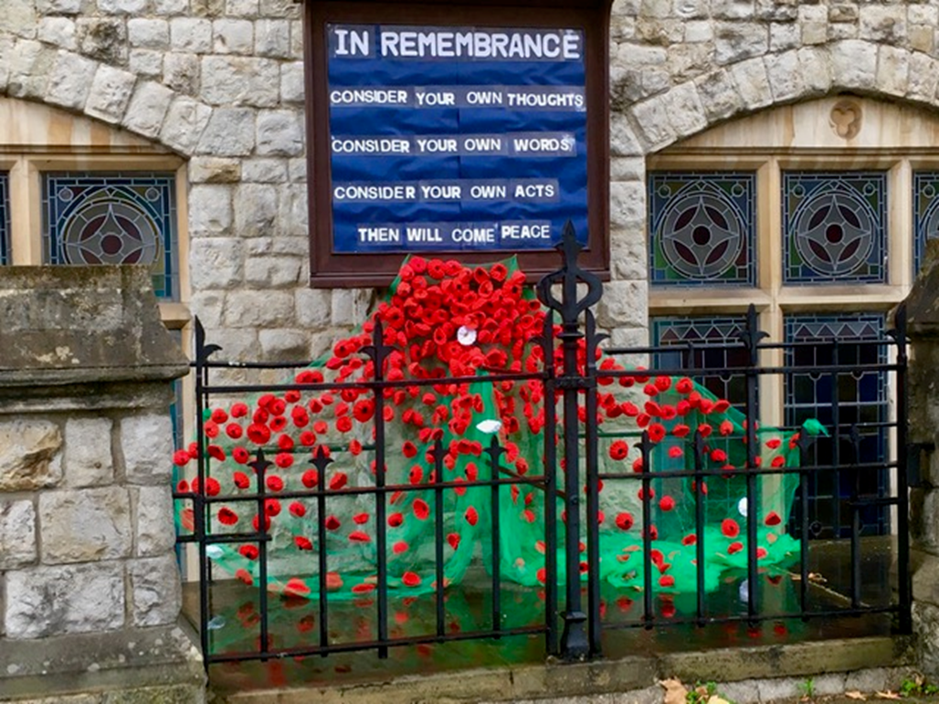
we felt happy about attaching brooch pins to those we didn’t need for the display, to sell at church and at Trinity’s Thursday MHA lunch/activity club. From that, we have raised £90 to date for the RBL, thanks to the generosity of members.
There have been touching and appreciative responses from the public and it even featured on ‘Enfield Matters’, after a resident sent a photograph.
It has been very rewarding to be part of and has drawn people to pause and take a moment.
Nancy Hands

Circuit Youth Club
TGiF (Thank God it’s Friday) the young people’s group that meet termly on a Friday, has been running for a year successfully on Zoom. This group was birthed during the 2020 lockdown as there was a great need to keep our young people engaged especially for the well-being of those within the ages of 11 – 16 (school year 6 – 11).
The positive feedbacks that we received about our summer holiday clubs in Edmonton & Goffs Oak especially from the Edmonton holiday club, was not only to have the holiday clubs run longer than a week, but that it is something that is much needed for the local area, to keep our young people engaged in activities.
Hearing what the community had to say, has ignited the idea of starting the circuit youth club project.
The circuit youth club will be the next step from the TGiF group and will be an additional opportunity for us to contribute to our community. By providing a space where not only our children from the circuit can attend, but also open to young people from our community, a place where they can attend after school and have fun, socialise, and have a holistic/Christian approach to their personal development and life skills.
To begin with, the youth club will run on Fridays (hopefully progressing to other days in the week depending on staffing/volunteers) for 4 hours and their time will consist of having something to eat, watching movies, group discussion/a time of prayer and a space to complete homework.
Due to this project being community based, there are legal requirements and policies that will need to be in place before we can open our first Christian Youth Club at Edmonton. Therefore, we hope it will be up and running before the summer of 2022.
Please keep this project in your prayers and if you can assist in anyway, please let me know as it will be greatly appreciated.
God bless, Isata Jalloh enfieldyouthwork@yahoo.com
07930255760
Worship opportunities across the Circuit
As well as the usual Sunday services, why not try some of these different opportunities for prayer, worship and fellowship across the Circuit?
Ghanaian Worship – 1st Sunday of each month 3pm- 5pm at Edmonton Methodist Church
“Words & Worship” at Grange Park on the 2nd Sunday of each month at 6.30pm
Tea service at Bush Hill Park on the1st Sunday of each month at 3pm

“Open Church” at Grange Park Mondays 10am-12 noon for quiet prayer, reflection and conversation

Let Us Pray every Wednesday 10.30am via zoom

Soup and conversation at Grange Park every
Wednesday 12noon-2pm

Bush Hill Park Wednesday Fellowship fortnightly from
8th September at 2pm

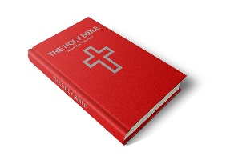
Faith and Fellowship at Southgate Thursdays 2pm-4pm. Bible Study, Fellowship and Tea

